CALVARY LUTHERAN CHURCH HUNGER WEEKEND
Saturday October 17 and Sunday, October 18, 2026
Evangelical Lutheran Church in America World Hunger ministry:

One in 11 people, about 720 million, are hungry. As ELCA members, we are called to respond, roll up our sleeves and get to work. We accompany neighbors near and far. God provides daily bread; together we help ensure it reaches every table, with compassion, courage, and faithful action.
ELCA World Hunger walks alongside congregations across the United States, Puerto Rico and the U.S. Virgin Islands, Lutheran churches worldwide and trusted partners. Your gifts fund clinics, microloans, clean water, livestock, meals and advocacy —sustainable solutions that address root causes of hunger. For more information visit https://www.elca.org/giving/elca-world-hunger
++++++++++++++++++++++++++++++++++++++++++++++++++
WELCOME AND GREETING
GATHERING SONG “We Are Called” ELW #720
CALL TO WORSHIP
L: We come together to worship the One who feeds our bodies and our souls.
A: We come to worship the One who provides enough and calls us to share.
L: We come together to give thanks for what we have been given.
A: And for wisdom to be good stewards of it.
L: We come together to worship the Bread of Life and ask for our daily bread.
A: We come together in our joy and in our need. Amen.
CONFESSION AND FORGIVENESS
L: We confess our sins in the name of the Father, Son and Holy Spirit. Gracious God:
A: We confess that we have hoarded more than we need and turned away from those
around us who are struggling. We have blamed our brother and sisters in need for their struggles. We have not trusted that you will provide for us if we share. Change us. Give us courage and generous hearts.
L: We know that Jesus renews us and forgives us each day. Trusting in that grace, we go out
to love and serve a world in need.

PRAYER OF THE DAY
A: Lord, we give you thanks for creating a world that produces food for us all. As we worship today, help us to remember those in our midst who are struggling and do not have what they need for today. Help us to have glad and generous hearts to share with those around us, and those across the world from us so that all may be fed. Help us to trust that we will have enough as we share with others. Give us wisdom and innovation as we consider ways to care for each other. Guide our discernment. Bless our worship and service together. Amen.
READINGS
Isaiah 58:1-12 L: Word of God. Word of Life A: Thanks be to God
Psalm 65
Matthew 25: 31-46 L: The Gospel of our Lord A: Praise to You, O Christ
CHILDREN’S MESSAGE
SERMON
SONG OF THE DAY “Canticle of the Turning” ELW #723
APOSTLE’S CREED
PRAYERS OF THE PEOPLE
GATHERING OF THE GIFTS
BRINGING FORWARD OF THE GIFTS “Create in Me a Clean Heart” ELW #186
OFFERING PRAYER
A: God of abundance, we thank you for providing all that we need in this world.
Thank you working through us to make ministry happen in this place, in our community and
throughout the world. Continue to lead us, bless us and inspire us as we serve. Amen.

WORDS OF INSTITUTION and the LORD’S PRAYER
COMMUNION MUSIC “We Come to the Hungry Feast” ELW #479
“For the Fruit of All Creation” ELW #679
”Lord, Whose Love in Humble Service” ELW #712
“Light Dawns in a Weary World” ELW #726
PRAYER AFTER COMMUNION
SENDING OF COMMUNION
Gracious God, loving all your family with a mother’s tender care: As you sent the angel to feed Elijah with heavenly bread, assist those who set forth to share your word and sacrament with those who are sick, homebound, and imprisoned. In your love and care, nourish and strengthen those who will receive this sacrament, and give us all the comfort of your abiding presence through the bod and blood of your Son, Jesus Christ, our Lord. Amen

TEMPLE TALK

ANNOUNCEMENTS

BLESSING
Fed, nourished, healed and forgiven, we go out to be Christ’s blessings to a hurting
world. Hear the words of Teresa of Avila:
“Christ has no body but yours,
No hands, no feet on earth but yours,
Yours are the eyes with which he looks compassion on this world,
Yours are the feet with which he walks to do good,
Yours are the hands, with which he blesses all the world.
Yours are the hands, yours are the feet,
Yours are the eyes; you are his body.
Christ has no body now but yours,
No hands, no feet on earth but yours,
Yours are the eyes with which he looks compassion on this world.
Christ has no body now on earth but yours.”

SENDING SONG “Let Justice Flow Like Streams” ELW #717
SENDING
L: Go In Peace. Christ goes with and within you.
A: Thanks be to God!
++++++++++++++++++++++++++++++++++++++++++++++++++
- TODAY’S BULLETIN IS SPONSORED IN HONOR OF DARRELL & PEGGY RUCH’S
50TH WEDDING ANNIVERSARY ON OCTOBER 16TH.

- TODAY’S RADIO BROADCAST IS SPONSORED IN MEMORY OF CRAIG CHRISTIANSON WHO PASSED AWAY OCTOBER 13, 2007, GIVEN BY HIS FAMILY.

TODAY WE ARE TAKING A SPECIAL OFFERING FOR DAWN CLOUSE FOR HOPE FOR OUR CITY. A BOX WILL BE PLACED IN THE CHAPEL FOR SATURDAY EVENING AND BACK OF THE SANCTUARY FOR SUNDAY.

TODAY DURING OUR COFFEE TIME, DAWN CLOUSE WILL BE OUR SPEAKER. SHE WILL BE SPEAKING ABOUT COMMUNITY BASICS, HOPE FOR OUR CITY, AND HOME TO HOME PROJECT.
Community Basics, Inc. is a non-profit 501(c)3 corporation (EIN #45-5234576) that is operated exclusively for charitable purposes. Specifically, Community Basics works in collaboration with charitable organizations located in Kandiyohi County and the surrounding areas to provide basic necessities such as food and essential household items to families and individuals who are, or have, experienced extreme hardships, effects of a natural disaster, hunger, or homelessness.

The Hope for Our City grocery distribution is open to anyone who eats and is not affiliated with any food shelf. Our average weekly total of all food shares given is between 850 and 1,000 food shares which are distributed to ALL the distribution sites. These sites include, yet are not limited to, Atwater, Olivia, Grove City, and of course Willmar.

The Home to Home Project is designed to provide family units with a one-stop place to obtain basic household items for free. They are allowed to come once in a lifetime, thus providing a “hand up” not a “hand out.”. So far in 2026 we have served 44 family units with basic household items.
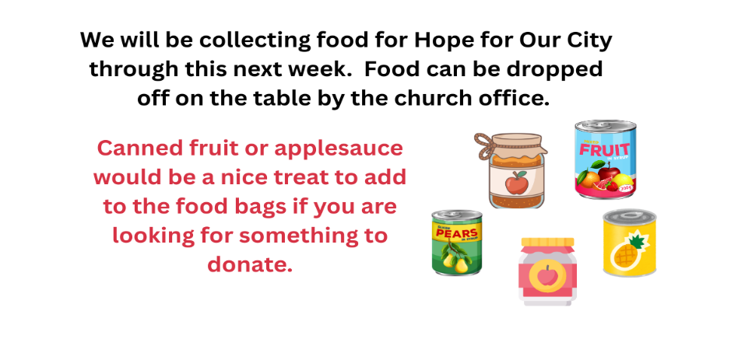
Reminder: The Book Club will be meeting in the Calvary Library at 6:30pm on Wednesday, October 21. Come join us to discuss Theo of Golden!

THIS WEEK AT CALVARY CHURCH
Tues, Oct 20 9:30am Gather Bible Study with Elsa – Koinonia Room
Wed, Oct 21 5:30pm BOOST Worship in the Sanctuary with Holy Communion
6:00pm BOOST – SALSA PARTY in Bethany Hall
6:30pm Confirmation and activities for ALL ages!
6:30pm Bell Choir (Music Room), Book Club (Library)
Thurs, Oct 22 9:30am Text Bible Study – Bethany Hall
1pm Quilting
Sat, Oct 24 5:30pm Chapel Worship
Sun, Oct 25 9am Worship – Reformation/Confirmation
10am Coffee with Council
10:15am Sunday School
Serving Sunday
Preaching: Pastor Amy Juel
Musician: Katie Steinhaus
Acolytes:
Communion: Mike Schroeder,
Lois Shaw, Sandra Bruns
Greeters: South: Dale & Linda Hanson
East: Joanne Milham
North: Odee & Alvina Henrickson
Lector: Kevin Christianson
Office: Nancy Fritz
Sound/Video: Mark Johnson/Jody Skindelien

Weekly Attendance
10/7/26: 64
10/10/26: 47
10/11/26: 154
10/11/26 SS: 32
You Tube: 109

Serving Saturday
Preaching: Pastor Amy Juel
Greeters: Bruce & Phillis DeBlieck
Musician: Deb Bremseth
Lector: Julie Neumann


Last Week’s Financials
IRA’s $ 7,498.73
Online Giving $ 1,266.88
Sat/Sun Giving $ 2,534.75
Total $11,300.36

A Steady Presence - Listening and Caring﻿ in the Midst of Trauma
Presenter: Julie Stender, LICSW, is a licensed clinical social worker, trainer, and consultant with extensive experience working with trauma. Calvary BeFrienders welcome you to join us for this virtual event on Monday, November 16, 2026, from 6:30 - 8:00pm in the Friendship Room. Please pre-register by calling the church office by November 11. Training costs covered by the BeFrienders Program.
Calvary BeFriender Leaders, Beth Bloomquist and Nancy Holt

Readings and Psalm for Oct 25
Leviticus 19:1-2, 15-18
Psalm 1
1 Thessalonians 2:1-8
Matthew 22:34-46

October Ministry of the Month is Board of Worship. Please check out their display in the Narthex.

Confirmation will be held on Sunday, October 25. Congratulations to: Greta Nelson, Raymond Opsal, and Houston Sorgatz.

