IMPORTANT TRAVEL ADVISORY: CHSAA STATE CROSS COUNTRY CHAMPIONSHIPS
Please read this information carefully and share it with all coaches, team members, parents, spectators, and other community members traveling to Norris Penrose Event Center on Saturday, October 31.
Due to major construction, road closures, and lane restrictions on routes leading to and around Norris Penrose Event Center, travelers should plan for significant delays and allow substantially more travel time than usual.
Additionally, a home Air Force Academy football game begins at 1:00 p.m. on Saturday, October 31, which is expected to add to traffic congestion in the area.
All school vehicles MUST follow the designated route provided by the CHSAA State Cross Country Site Director to help ensure timely arrival.
PLEASE PLAN ACCORDINGLY: If you do not account for the additional travel time needed, you risk arriving too late and missing your scheduled race. Schools, athletes, and spectators are responsible for planning ahead and departing earlier than they otherwise would anticipate.
Thank you for sharing this information and helping ensure a smooth and successful state championship meet.
School Vehicles: Buses, Suburban, Short Buses
I-25 to Tejon
Tejon South to Brookside
Brookside west to 8th Street
8th Street North to access road for Norris Penrose
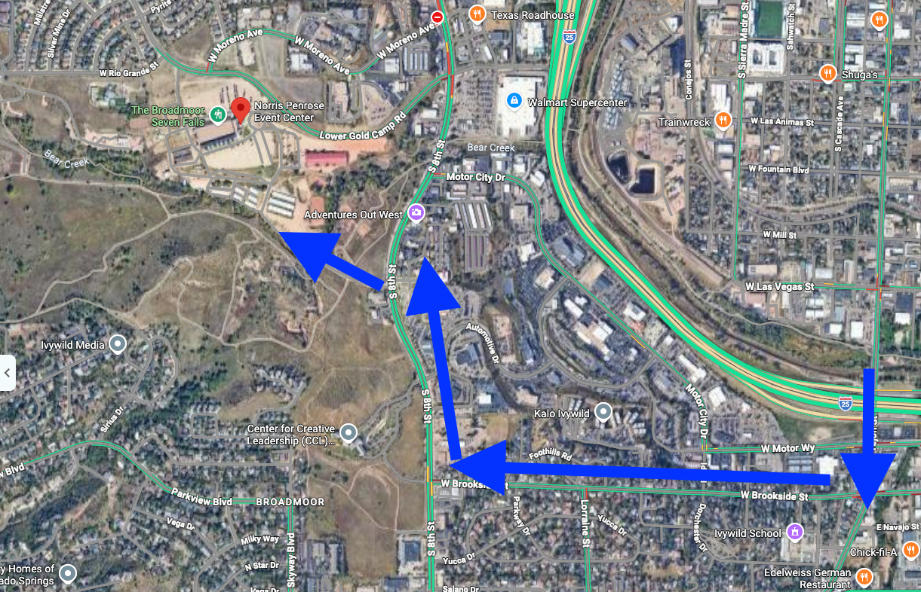

If students drive themselves

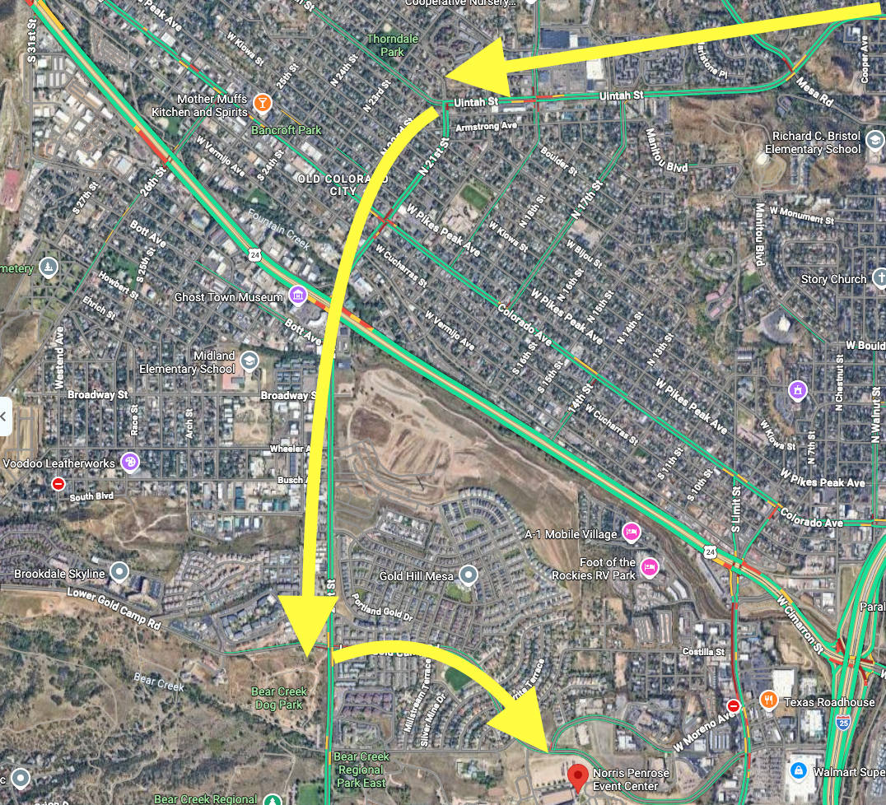
From the North
I-25 to Uintah
Uintah west to North 21st street
N. 21st Street south to Lower Gold Camp Road
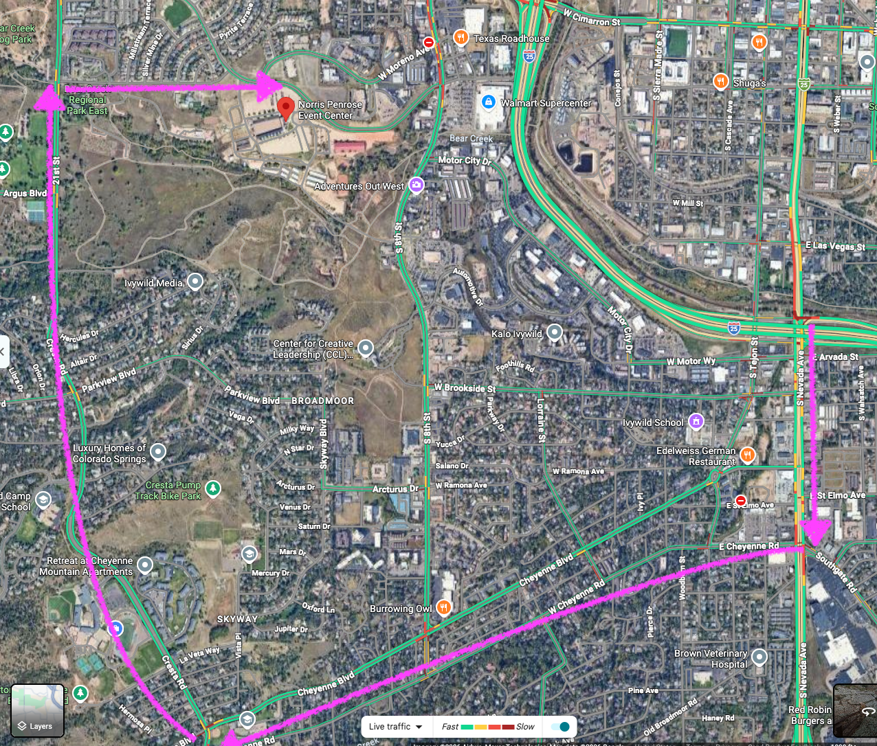
From the South
I-25 to Nevada
Nevada south to Cheyenne Road
Cheyenne Road west to Cresta
Cresta north to W Rio Grande Street
Rio Grand east to Lower Gold Camp Road

