Group Name: JASAD
CMPT 275 Assignment 5: Design Document
Instructor: Herbert Tsang

Simon Fraser University

Group Number: 4
Alexander Li (301138698)
Sen Luo (301145757)
De’en Gao (301187379)
Joshua Lim (301165484)
Amir Nabaei (301150696)

Contents
1.0 - Guidelines 3
2.0 - System Diagrams 4
2.1 - Context Model 4
2.2 - Interaction Model 5
2.3 - Structural Model: 6
2.4 - Behavioural Model 7
3.0 - Data Requirement 8
3.1- “Keyboard” input /touch/tap/slash 9
3.2 - Contacts Inputs/Files 9
3.3 - Voice/Audio Output 9
3.4 - Login Input 9
4.0 - Feature priority 10
4.1 - Dial 10
4.2 - Call 10
4.3 - Contact list & Quick Dial: 10
4.4 - Audio: 11
4.5 - Login: 11

1.0 - Guidelines
- Use Xcode as IDE in Object-C language
- Development platform is iOS
- Conform to OOP and MVC paradigm
- Adopt client-server architecture and server side infrastructure will be provided by Amazon Web Service
- No ethical issues, ensure protective of privacy with password
- No legal issues
- Design & Approval
- The software will be used as course project purposed

2.0 - System Diagrams

2.1 - Context Model
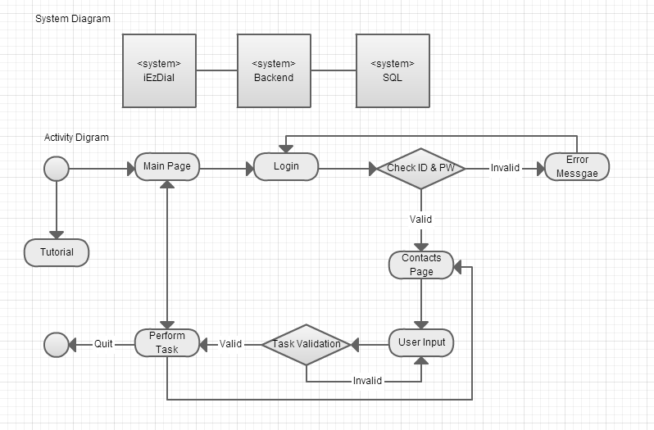
- System diagram & activity diagram

Figure 1

System and Activity Diagrams

System Diagram | The system includes three sub-systems in environment, one is the iEZDial system on iPhone, the other is back-end server system, which provides login and data accessing services, and the last one is SQL server which provides data to back-end server.
Activity Diagram | 1. Start iEZDial application  2. User chooses to see tutorial or go to main page.  3. User can make calls or go to login page.  4. Show login view, user inputs Username(number) and Password  5. Check user’s input. If valid goes to step 6, else goes to step 4  6. Show contact view, user perform certain task  7. If user exists, then application activity ends. Otherwise, perform the task, and goes back to step 5

2.2 - Interaction Model

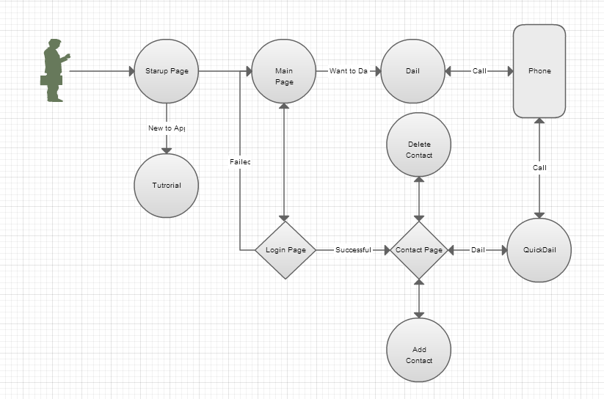
Figure 2
The interaction model shows how the user interacts with each process within the application, and how each sub-process is interacted with each other. The arrow shows a one-way function for interaction.

2.3 - Structural Model:
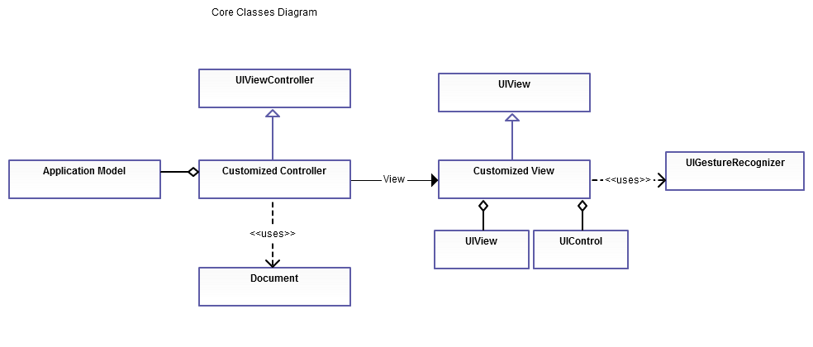
Figure 3.1 Core Classes Diagram

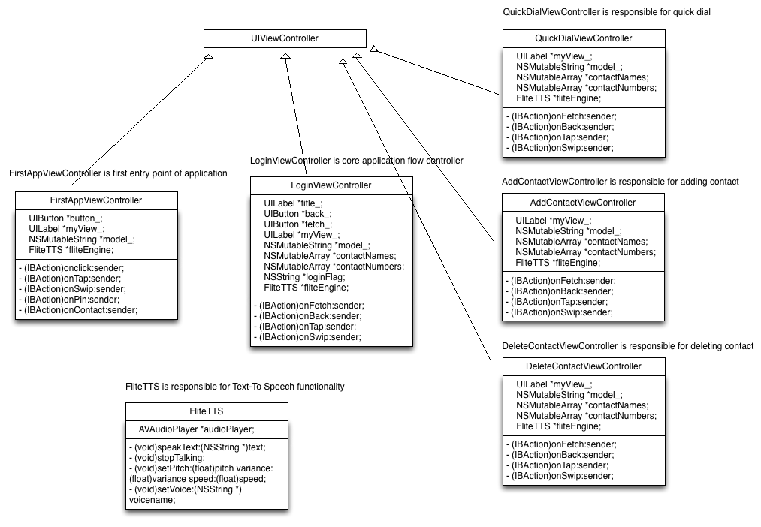
Figure 3.2 Class Hierarchy Diagram
Class Diagram |  | Description
Class Diagram | 1 | iEZDial customized controller extends UIViewController, with application logic  Examples are FirstAppViewController, LoginVIewController, QuickDialViewController, AddContactViewController and DeleteContactViewController.
Class Diagram | 2 | iEZDial customized view extends UIView, with application UI requirement  Examples are the touch area view and fade-in confirmation view.
Class Diagram | 3 | iEZDial customized controller has association relationship with customized view  Every customized viewController has ‘has-a’ relationship with touch area view and fade-in conformation view
Class Diagram | 4 | Customized view aggregates other sub-views and controls
Class Diagram | 5 | Customized view has dependency on UIGestureRecognizer, to detect motions  All customized teach area views have been attached with UIGestureRecognizer for tapping, swiping.
Class Diagram | 6 | Customized controller aggregates application model  All extended viewControllers have a model, which includes the numbers and contacts on manipulation.
Class Diagram | 7 | Customized controller uses document interface to access local and remote data  Examples are LoginViewController has access to Network through document interface

2.4 - Behavioural Model
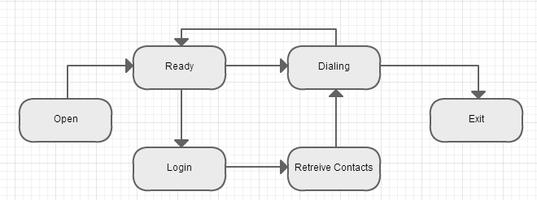 Figure 4
The state transition model shows the program changes from one state from another and the arrow shows the state transition.
1: Launch App will have it sets to Open state, then to Ready State
2: Calling will set to Dialing State
3: Login to the server will set it to login state/wait
4: Login successfully will set to retrieve contacts state.
5: After have contacts, it can call which go to Dialing state again

3.0 - Data Requirement
- Database:
MySQL, provided by Amazon’s RDS
User Account & Contact tables definition:
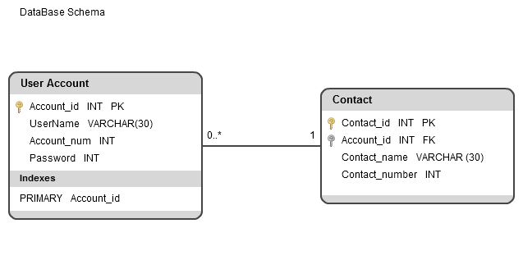
Figure5
Image of the Database Schema

3.1- “Keyboard” input /touch/tap/slash
- 1 touch represents 1
- 2 touches represents number 2
- 3 touches represents number 3
- 1 finger swipe to left represents 4
- 2 fingers swipe to left represents 5
- 3 fingers swipe to left represents 6
- 1 finger swipe to down represents 7
- 2 fingers swipe to down represents 8
- 3 fingers swipe to down represents 9
- 1 finger swipe to up represents 0
- 2 fingers swipe to left represents delete a digit
- 3 fingers swipe to left is special function like, tutorial

3.2 - Contacts Inputs/Files
Contacts are represents by objects in the program, and persists as files in local environment or on server side. Contacts transferring between local and server will be in JSON format.

3.3 - Voice/Audio Output
Audio sound information will be pre-recorded and saved as mp3 format files, which are played when user navigating the app and need feedbacks.

3.4 - Login Input
User login information is stored at database. Database schema is referenced to figure 5. User input are String type, and transferred in JSON format between local and server.

4.0 - Feature priority

4.1 - Dial
Dialling functionality will be implemented in the first version to ensure user can use taps and swipes to input number correctly. Since it’s the foundation of the application, it has the highest priority.

4.2 - Call
Calling functionality will be implemented in the first version to ensure after user dialing number, he/she can make a phone call. Since it’s the core function of the application, it also has the highest priority.
4.3 - Contact list & Quick Dial:
Contact feature will be implemented in second version. This feature ensures user to have custom contact for speed dial, for example, emergence numbers. To facilitate the quick dial, user easily uses tap/swipes to interact with the system and accomplish quick dial. This feature comes to second high priority.

4.4 - Audio:
Audio feature will be implemented in second version, which gives audio feedback to user’s input. This feature can improve visual impaired people’s user experiences of the application, so it has second high priority.
4.5 - Login:
Login feature lets users to access more customized services and helps application keep track of users’ information. Login feature involves network connections, and this has third high priority of all features.

4.6 –Fade-in Confirmation:
Fade-in confirmation will remove all the unnecessary buttons out of the app so that user just need swipe to confirm and cancel. This feature comes to 3rd priority.

