Group Name: JASAD
CMPT 275 Assignment 5: Requirement Document
Instructor: Herbert Tsang
Simon Fraser University

Group Number: 4
Alexander Li
Sen Luo
De’en Gao
Joshua Lim
Amir Nabaei

Contents
1.0 - Introduction 4
2.0 - Intended Audience List 4
3.0 - Features/Functional Requirements 5
3.1-Vision-Free Dialling 5
3.2 - Dial Menu 5
3.3 - Calling from application 5
3.4 - Contacts Menu 5
3.5 - Contact List 6
3.6 - Speed-dial: 6
3.7 - Delete numbers 6
3.8 –Adding a New Contact Number 7
3.9 - Confirmation 7
3.10 – Login 7
3.12 - Features that we were not implemented due to a shortage of time 7
Security: Password 7
Register Accounts 7
4.0 - Non-Functional Requirement 8
4.1 - Availability 8
4.2 - Flexibility 8
4.3- Portability 8
4.4 - Integrity 8
4.5 - Robustness 8
4.6 - Loading Times 8
4.7 - The Size of the Application 8
4.8 – Speed 8
5.0 - Example Tutorials 9
5.1 – Making a phone call – phone number not stored in contact list 9
5.2 - Example 2 - Making a phone call – number stored in contact list 12
5.3 - Example 3 - Saving a contact to the contact list 16
5.4 - Example 4 - Deleting a contact in the contact list 19
6.0 - Glossary 22
Calling 22
Contact 22
Contact List 22
Contact Screen 22
Dial 22
Dial Screen 22
Key/Button 22
Keyboard 22
Saving 22
“Code Number” 22
Username 22
Interface 22
Login Menu 22
Deleting 22
Audible Tutorial 22
JASAD’s Numeric Alphabet 22

1.0 - Introduction
Low vision/impaired vision can be troublesome for those making calls using an iPhone. This is because accurately pinpointing a specific key can be difficult. This application approaches this problem by an alternate method of inputting the desired number. The iEZDial’s method of dialling numbers is influenced by the unistrokes alphabet. The buttons for numbers will be replaced with a pad that can read gestures. This method allows users to dial numbers without having to look at the screen, and to confirm or replay the number, iEZDial will have an audio playback feature integrated inside of it.

Vision-free dialling is helpful in many distinct cases. However, it would be tedious to type in a unique string of numbers every time a user wishes to call. The Contacts feature attached will allow storage for up to 10 phone numbers. The iEZDial allows the user to call the listed numbers with a single dial/gesture.

2.0 - Intended Audience List
The application intends to assist those with visual impairment. Every feature on the phone is designed to be used without having to look at the screen. There are at most two buttons that are available to the user at any given time. These buttons are large and accessible to those with limited vision. Furthermore, the application outputs an audible response every time the user selects an option. Because of the audible response, those using the application require hearing abilities. This is so the user can receive confirmation over the numbers they dial or the actions they perform/confirm. The application also requires the use of fingers to swipe and dial on the dial pad to dial in numbers. Some dexterity is required from the users; the ability to swipe with one to three fingers as well as tap using one to three fingers is required. If the user understands how to make a phone call with a smartphone, he or she will have no problem adjusting to the new style of dialling and calling with the iEZDial. The recommended age group for this application is 13 or older. However the application can be used by those younger, if the users are capable of dialling in phone numbers and making phone calls on smart phones.

3.0 - Features/Functional Requirements

3.1-Vision-Free Dialling:
The numbers 0 to 9 as well as the backspace key can be dialled by taps and swipes. This is used when dialling in a phone call
- 0: 1 finger swipe upwards
- 1: single tap with 1 finger
- 2: single tap with 2 fingers
- 3: single tap with 3 fingers
- 4: 1 finger swipe to right
- 5: 2 finger swipe to right
- 6: 3 finger swipe to right
- 7: 1 finger swipe down
- 8: 2 finger swipe down
- 9: 3 finger swipe down
- backspace: 2 finger swipe to left

3.2 - Dial Menu:
One of six menus of the application, the other being the “Contacts Menu” and “Login Menu”, “Speed-Dial Menu”, “Adding Menu” and “Deleting Menu”. In this menu, a phone numbers can be dialled. The menu features the dial pad where the user can swipe or tap to dial numbers. The dial pad functions as a display to show the numbers dialled as well. The two buttons on the bottom of the menu are “Dial” and “Contacts”. The “Dial” button allows the user to call the number shown in the display. The “Contacts” button switches to the “Login Menu” and depending if the user has already logged in or not to the application. It will switch over to the “Login Menu” or if the user has already previously logged in it will take you to the “Contacts Menu”.

3.3 - Calling from application:
After the phone number has been dialled and the “Dial” button is pushed, there will be a confirmation message that the application will say. This message will ask the user to swipe left to go back to the dialling screen and to swipe right to call the number. If the user proceeds with calling the phone number, the application will directly call that number. If the user swipes left it will return to the Dial Menu, without calling the phone number.

3.4 - Contacts Menu:
One of six menus of the application, the other being the “Contacts Menu” and “Login Menu”, “Speed-Dial Menu”, “Adding Menu” and “Deleting Menu”. This menu gives the user access to the contacts that have been previously saved, add new contacts and delete old contacts. This menu will give an audible recording of the features that will be provided, “the Speed Dial”, “Adding a New Contact”, and “Deleting a contact”. There will be 2 buttons at the bottom, the “Back” button and the “Logout” button. The ”Back” button will take the user back to the previous menu which is the “Dial Menu”. The “Logout” button will logout the current user, and take the user back to the “Login” page.

3.5 - Contact List:
Up to ten phone numbers can be stored on a user’s account. Numbers dialled in the “Adding Menu” can be saved, details are found under “Save” of the features document. Each phone number is assigned a single digit number from zero to nine (a “Code Number”) that can be used to select the number. Once a number is selected 2 options will be provided audibly to the user. The user can dial and call the number or delete the number by selecting and confirming the audible instructions.

3.6 - Speed-dial:
The first feature in the “Contact Menu” is the “Speed Dial” Menu. To access the “Speed Dial” Menu, use JASAD’s numeric alphabet for 1 on the Contact page. All numbers in the contact list can be called with a single dial (its “Code Number”). The user will dial the single digit number corresponding to the phone number to select the number he or she would like to dial in the Contact List. If the user makes an error a backspace and redial is possible. Afterwards the application will ask if the user a confirmation, which will say to swipe left to not call the contact at that Code the contact at that Code Number or swipe right to call that contact at that Code Number. If the user swipes right a pop up window will appear and ask you want to confirm the call or cancel the call. To continue calling, hit confirm and it will dial the phone number that is stored at that “Code Number” and if the user swipes left it will take the user back to the to the “Adding Menu”.

3.7 - Delete numbers:
This is the second feature on the “Contact List”, the others being “Speed Dial Menu” and “Adding Menu”. If the contact list is full, partially full, the user can delete any of the numbers that are on the contact list in order to make room for new contacts. This can be done by first inputting JASAD’s numeric alphabet for 3 to access the Delete Menu. The user will then select the number with the “Code Number” of the phone number that the user would like to delete in the Contact List. Once the “Code Number” is inputted the user, the application will repeat the number that is at that Code number. There are two buttons, the delete button or back button. By tapping the back button, it will return the user to the contact menu, and if the user taps the delete button it will proceed with the deletion. If the user proceeds with the deletion the application will then ask the user if they are sure that they want to delete the phone number that is currently at that “Code Number”. By swiping left the contact will not be deleted and it will return to the “Deleing Menu”. By swiping right the contact at that Code Number will be deleted and the application will return the user to the “Contact Menu”. If the user accepts the deletion of the contact, the application will delete the number stored in the “Code Number” and will leave the code number’s stored phone number blank (i.e. other code numbers will still refer to their own phone numbers and no other phone number will take the deleted number’s place). If successfully deleted the application will audibly say that the contact has been removed.

3.8 –Adding a New Contact Number:
The last feature on the “Contact Menu” is the Save/Adding a New Contact Number. The user can save a phone number to the contact list by first swiping 2 from JASAD’s numeric alphabet to move to the “Saving Menu”. By dialling the Code Number in the “Saving Menu” it will allow user to save a new contact at that “Code Number”. The user will input the new contact number and push the “Add” button to save the number in the contacts list. The contact will be saved in the first available spot of the list (i.e. if the user has previously deleted the number for Code Number 1 then the application will save the new phone number in Code Number 1). If the list is full then the application will notify the user and the user will have to delete a number (details for deleting can be found in the “delete” part of the features requirements). The phone will update the Contact List.

3.9 - Confirmation:
Because errors can occur when using a touch device anytime the user wishes to dial/call a number or save/delete a number confirmation will be asked. The user can confirm by swiping to the right or deny/cancel by swiping to the left on the slider that is provided.

3.10 – Login
The page that appears after the Dial menu is shown for security (see 3.12). The page has 2 buttons, “Login” and “Cack”. “Login” allows the user to access the “Contact List” that the user has saved in his or her account. “Back” allows the user to return to the “Dial Menu”. When the user pushes “Contacts” on the “Dial Menu” it will take the user either to the “Contact Menu” or the login page. If it is the case where the user has not logged in, then the application will take the user to the login page where the user must input a unique, numeric user-number. The process of inputting the usernumber is through the use of JASAD’s numeric alphabet. First the user swipes or taps using the numbers that he or she would like to use for his or her account. Then by pushing “Login” the application will take the user to the contact menu.

3.11 – Optional Tutorial
After the user opens the application, the user has a choice to hear the audible tutorial to the basic steps to using this application. To accept, the user will be asked to swipe with 3 fingers to the left.

4.0 - Non-Functional Requirement
4.1 - Availability:
If we propose it to the Apple store, it will have a downtime of at least 3 hours per month. This will ensure the balance and maximum efficiency of the availability of the application with the possible upgrades in the future.

4.2 - Flexibility:
Presently, the above specifications outline the current model iEZDial. Luxury specifications include
- Having a data base online that will keep track of more than ten contacts so you can switch between the contacts once they are set.
- Customizing the unique numbers for each key
- Importing numbers from an online website

4.3- Portability:
JASAD has decided that the only platform that the iEZDial will run on is the iPhone as the iPad cannot make phone calls.

4.4 - Integrity:
The user will be allowed to login with a distinct username as well as save/delete contacts, and dial/call numbers. JASAD will be able to monitor the data of the application and block off users that are abusing the system.

4.5 - Robustness:
A robust system is able to handle error conditions gracefully, without failure. This includes a tolerance of invalid data, software defects, and unexpected operating conditions.

4.6 - Loading Times:
Minimum loading time to start the application, as well as the contact list and audio playback.

4.7 - The Size of the Application:
5-10 MB

4.8 – Speed
Minimum time to start the application, uploading the speed dial list, and the audio playback. Also a minimum amount time to add and delete contacts.

5.0 - Example Tutorials

5.1 – Making a phone call – phone number not stored in contact list
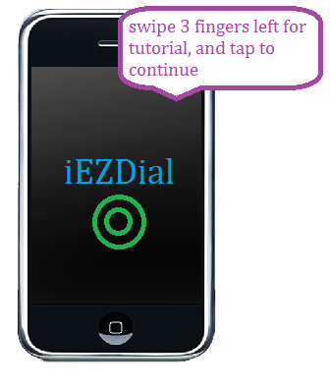

Figure 5.1.1
After opening the application, it comes to the intro Screen. Tap to continue to the Dial Menu

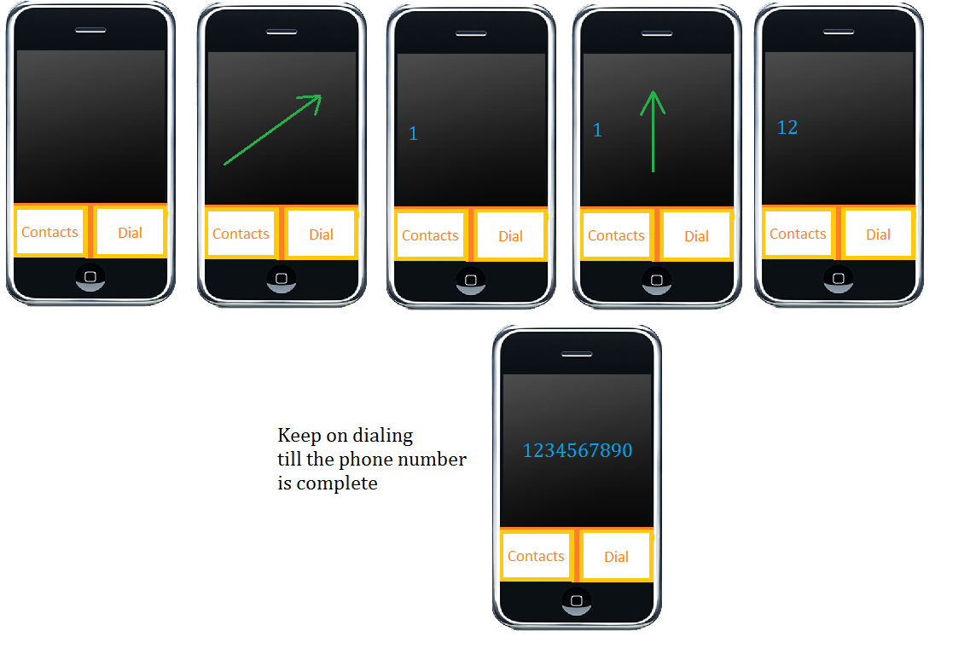
Figure 5.1.2
Dial in the numbers through the JASAD number alphabet

Figure 5.1.4
The application will ask the user to swipe right to call and left to go back to the Dialling Menu
Swipe right
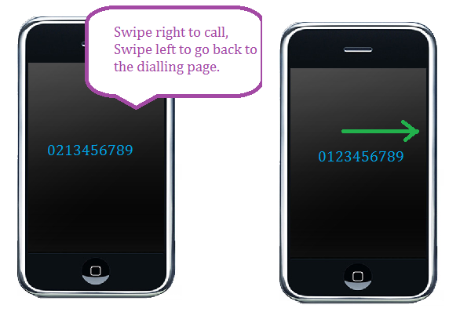
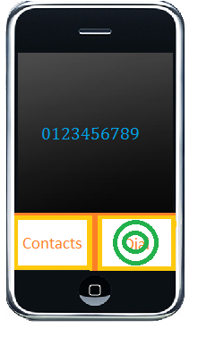
Figure 5.1.4
The application will ask the user to swipe right to call and swipe left to go back to the dialling page
Swipe right to call
Figure 5.1.3
Tap the Dial button to dial the number
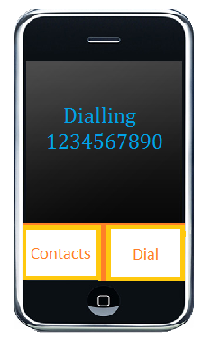
Figure 5.1.5
The application will now call that number

5.2 - Example 2 - Making a phone call – number stored in contact list

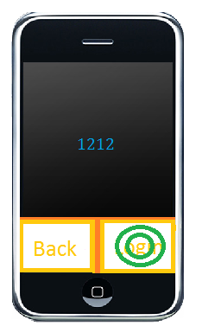
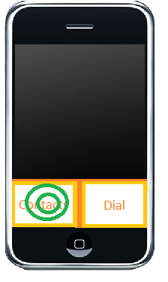
Figure 5.2.3
Input your login usernumber and tap the Login button
Figure 5.2.2
Tap the Contact Menu
Figure 5.2.1
After opening the application, it comes to the intro Screen. Tap to continue to the Dial Menu

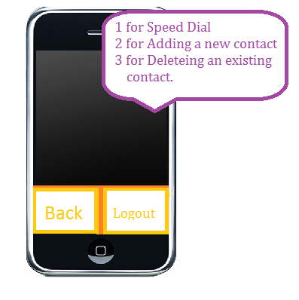
Figure 5.2.5
The application will ask the user to swipe 1 for speed dial, 2 for adding a new contact and 3 for deleting an existing contact.
Swipe 1 to go to the Speed Dial Menu
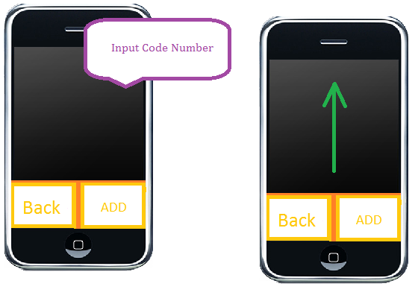
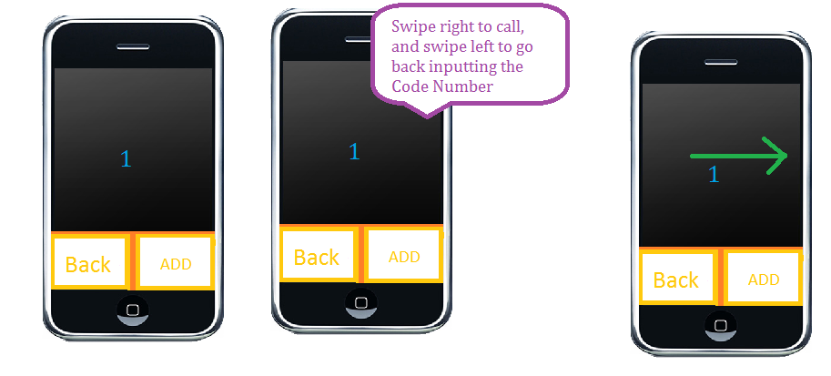
Figure 5.2.7
It will ask the user to swipe right to call and left to go back to inputting the Code Number
Swipe right
Figure 5.2.6
Input the Code Number that you wish to dial.

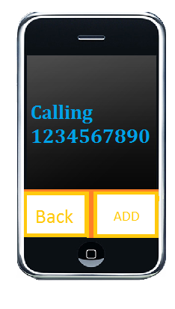
Figure 5.2.8
The application will then call that number that is stored at that Code Number

5.3 - Example 3 - Saving a contact to the contact list
Figure 5.3.3
Input your login usernumber and tap the Login button

Figure 5.3.2
Tap the Contact Menu

Figure 5.3.1
After opening the application, it comes to the intro Screen. Tap to continue to the Dial Menu

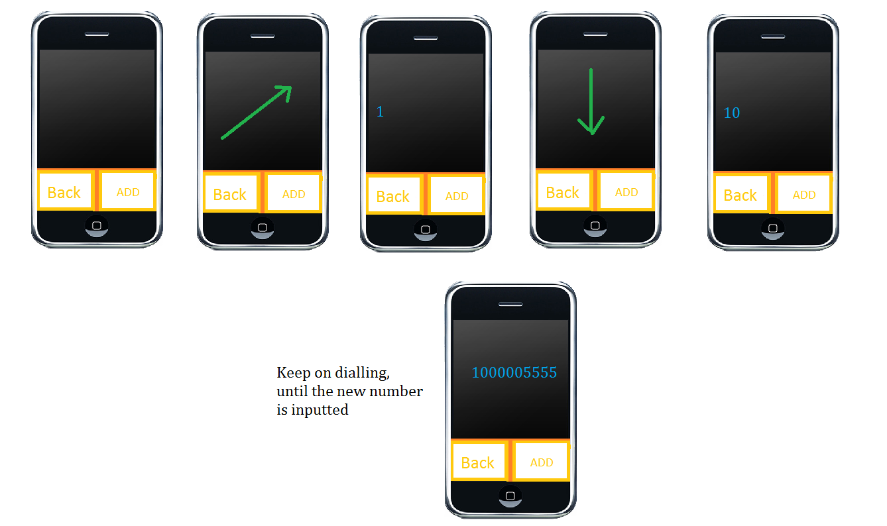
Figure 5.3.6
Use JASAD’s numeric alphabet to type in the new contact number
Figure 5.3.5
The application will ask the user to swipe 1 for speed dial, 2 for adding a new contact and 3 for deleting an existing contact.
Swipe 2 to go to the Adding Menu

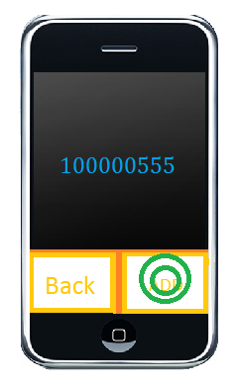
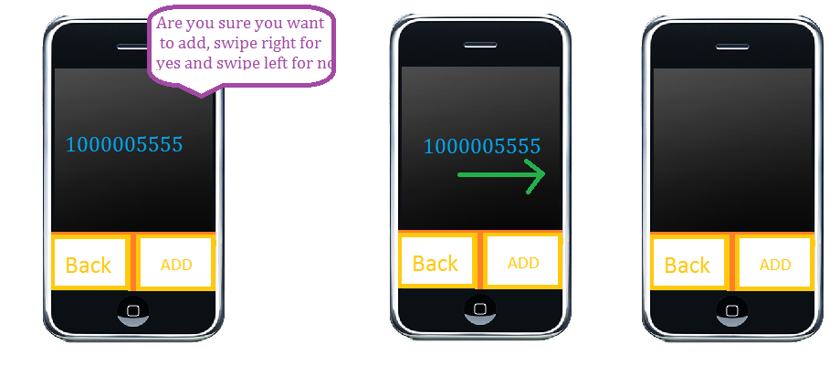
Figure 5.3.7
Press the Add button to add the number to Contact List
Figure 5.3.8
The application will ask the user to swipe right to add the contact to the Contact List and to swipe left to not add the new contact
Swipe right to add in the next available spot on the Contact List

5.4 - Example 4 - Deleting a contact in the contact list
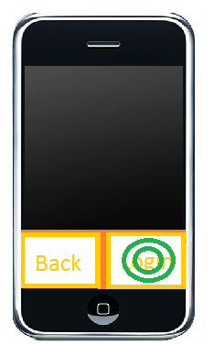
Figure 5.4.3
Input your login usernumber and tap the Login button

Figure 5.4.2
Tap the Contact Menu

Figure 5.4.1
After opening the application, it comes to the intro Screen. Tap to continue to the Dial Menu

Figure 5.4.5
Input the Code Number that you want the number stored at that Code Number you want to delete
Figure 5.4.5
The application will ask the user to swipe 1 for speed dial, 2 for adding a new contact and 3 for deleting an existing contact.
Swipe 3 to go to the Deleting Menu

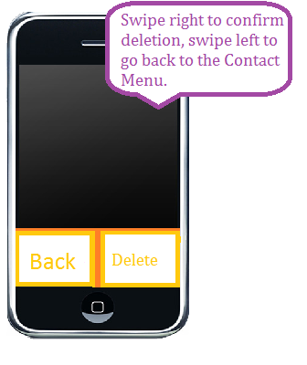
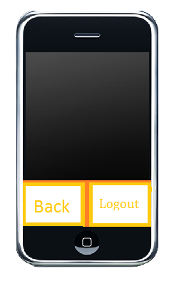
Figure 5.4.7
This will take back to the contact screen
Figure 5.4.6
The application will then ask the user to confirm the deletion. Swipe right to delete.

6.0 - Glossary
Calling | calling a phone number allowing a phone call to occur
Contact | a saved phone number
Contact List | a list of contacts (see “contact”)
Contact Screen | One of the main menus of the application, this is where the user can save, delete or call a contact.
Dial | the ability to input the designated number that the user inputs via the touchscreen/keyboard with certain symbols/movements
Dial Screen | One of two menus of the application, this is where the user can dial a phone number. The two buttons available on this menu are “Dial” and “Contacts”
Key/Button | the small sensitive patch that will provide a certain action with a single touch
Keyboard | the sensitive area on the main screen that will allow the user to dial in the numbers
Saving | the action of storing a phone number as a contact
“Code Number” | a unique single digit that represents a contact on the contact list
Username | unique numbers that will distinguish between different users
Interface | the screen that you interact with to access the features that
Login Menu | This menu allows the user to login with a numeric usernumber
Deleting | The act of deleting an existing contact
Audible Tutorial | An audible tutorial will lead you through the steps to using the basis of this application
JASAD’s Numeric Alphabet | 0: 1 finger swipe upwards  1: single tap with one finger  2: single tap with two finger  3: single tap with three finger  4: 1 finger swipe to the right  5: 2 fingers swipe to the right  6: 3 fingers swipe to the right  7: 1 finger swipe to the down  8: 2 fingers swipe to the down  9: 3 fingers swipe to the down  Backspace :2 fingers swipe to the left

