Group Name: JASAD
CMPT 275 Assignment 5: Tutorial Document
Instructor: Herbert Tsang
Simon Fraser University

Group Number: 4
Alexander Li
Sen Luo
De’en Gao
Joshua Lim
Amir Nabaei

Contents
Making a phone call – phone number not stored in contact list 3
Making a phone call – number stored in contact list 6
Saving a contact to the contact list 9
Deleting a contact in the contact list 12

iEZDial Tutorial
This document that will provide the user a tutorial that will help them learn the basis to how to use the application. It will describe in detail and provide pictures to help with the explanation. There are three main features that iEZDial provies: Speed Dial, Adding a contact, and Deleting a contact.

Making a phone call – phone number not stored in contact list
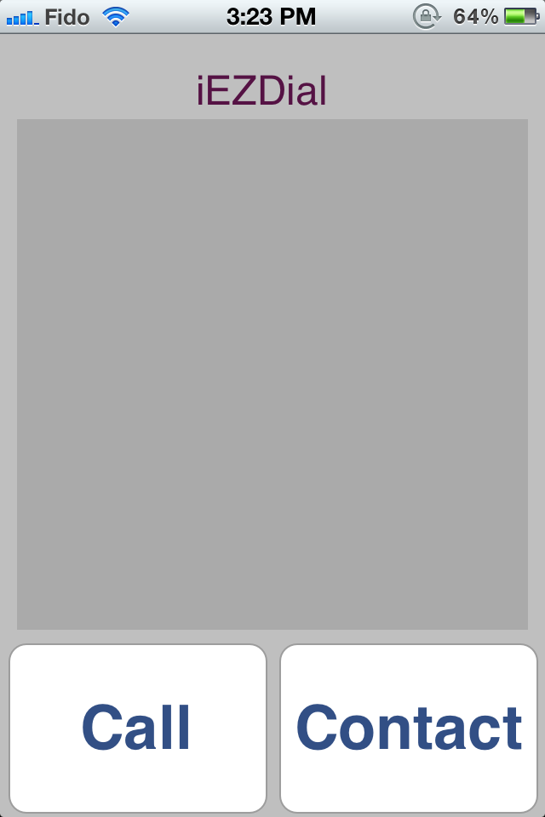

Figure 1.1
After opening the application, it comes to the intro Screen. Tap to continue to the Dial Menu

Figure 1.2
Dial in the phone, the numbers through the JASAD numeric alphabet to dial the user’s desired number

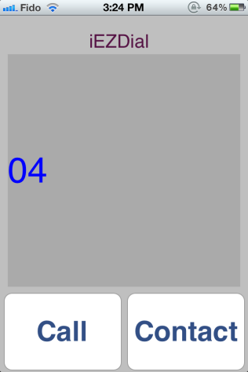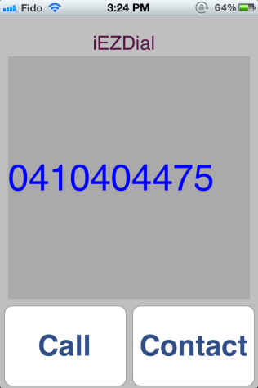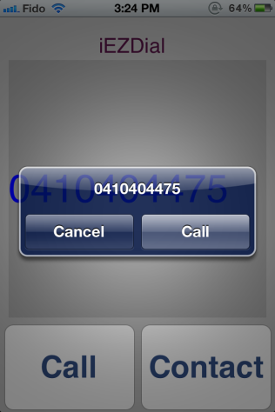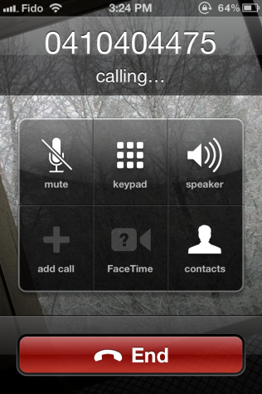

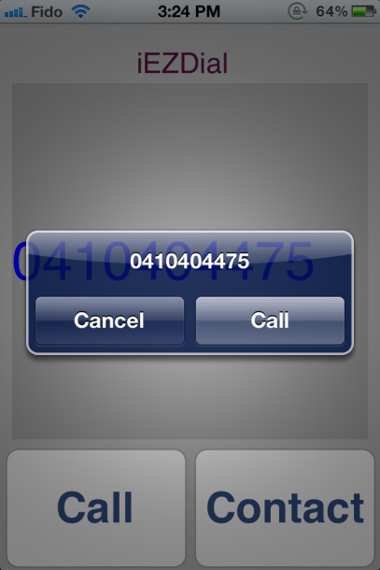
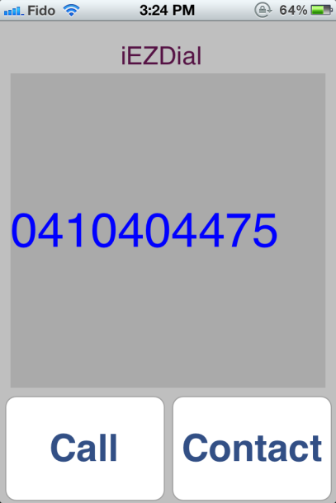
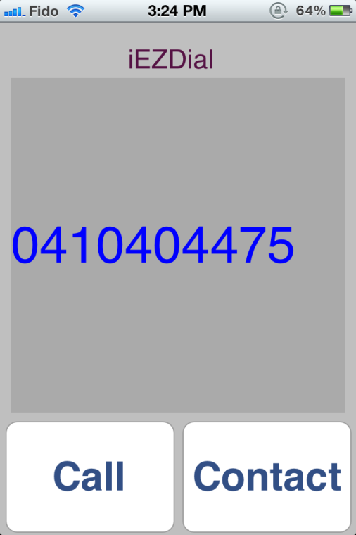
Figure 1.4
The application will ask the user to swipe right to call and left to go back to the Dialling Menu.
Swipe right to call the number.
Figure 1.3
Tap the Call button to dial the number
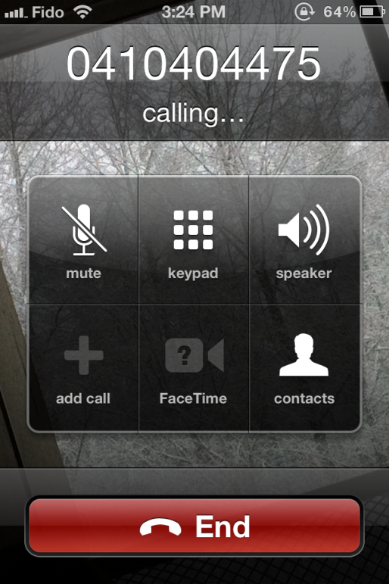
Figure 1.5
The application will now call that number

Making a phone call – number stored in contact list
Figure 2.1
After opening the application, it comes to the intro Screen. Tap to continue to the Dial Menu

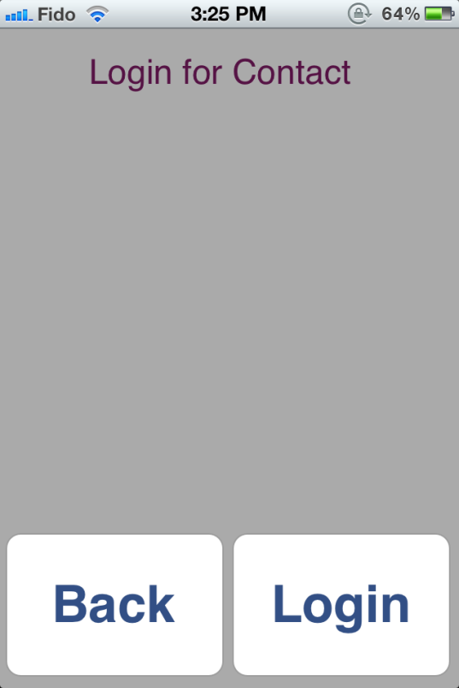
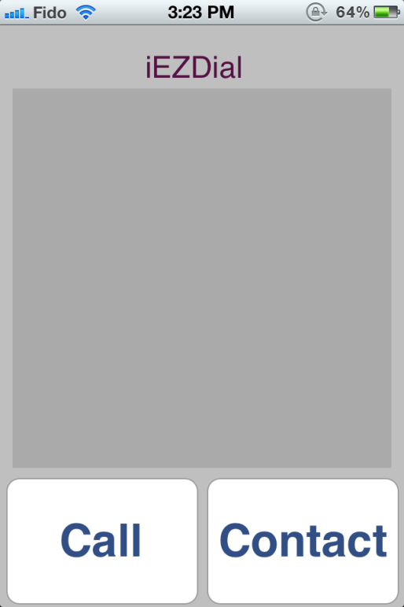
Figure 2.3
Input your login usernumber and tap the Login button
Figure 2.2
Tap the Contact Menu
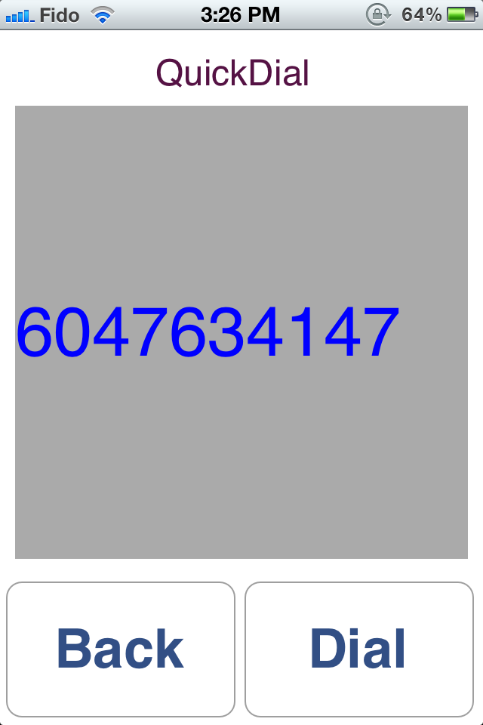
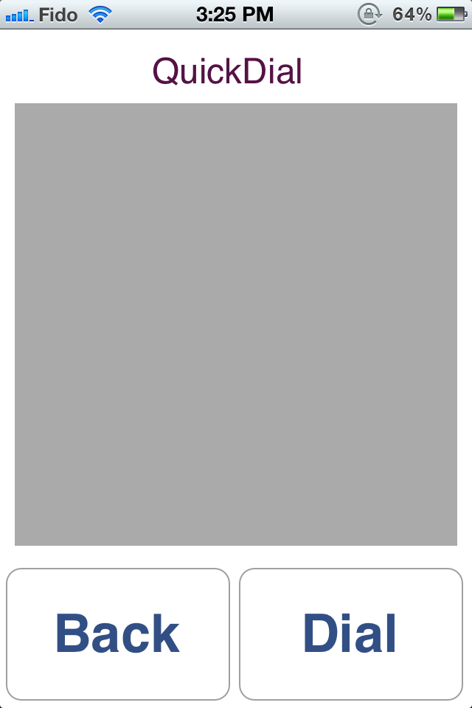
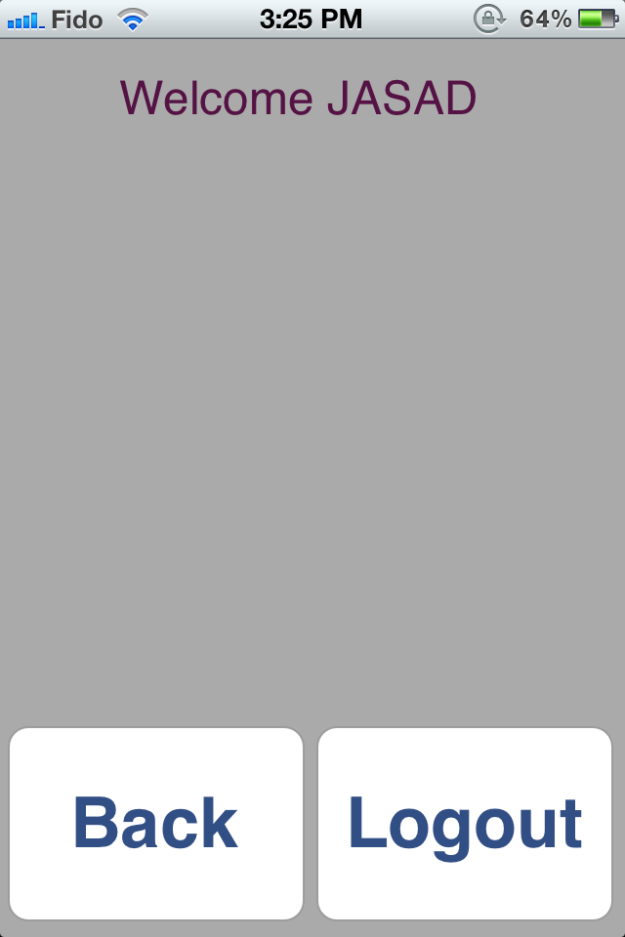
Figure 5.2.6
Input the Code Number that you wish to dial.
Figure 5.2.5
The application will ask the user to swipe 1 for speed dial, 2 for adding a new contact and 3 for deleting an existing contact.
Swipe 1 to go to the Speed Dial Menu
Figure 5.2.7
It will ask the user to swipe right to call and left to go back to inputting the Code Number
Swipe right
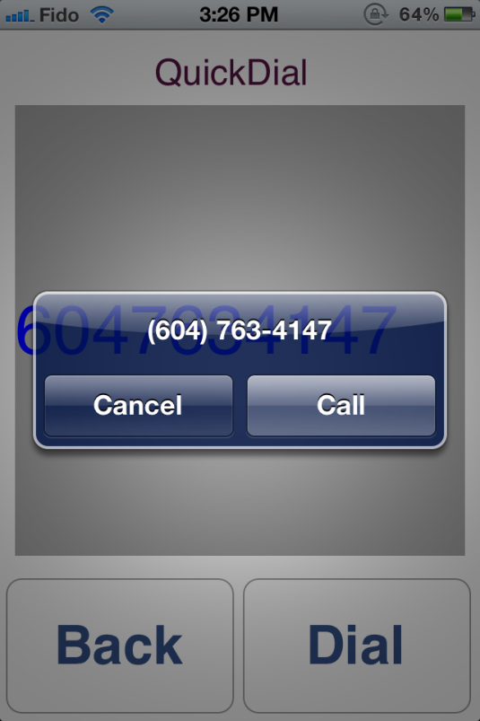
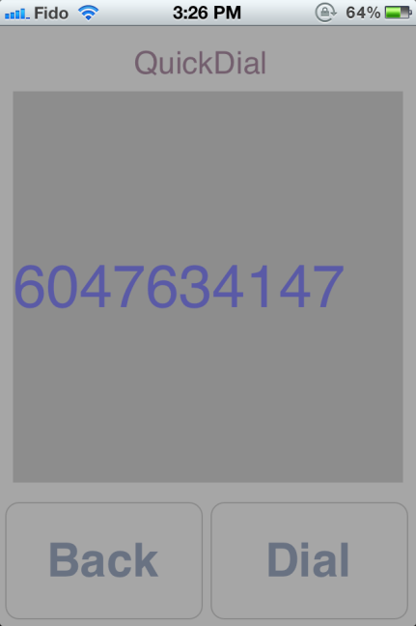
Figure 5.2.8
The application will then call that number that is stored at that Code Number

Saving a contact to the contact list

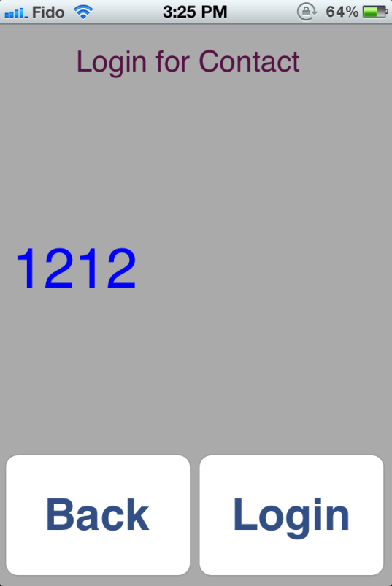
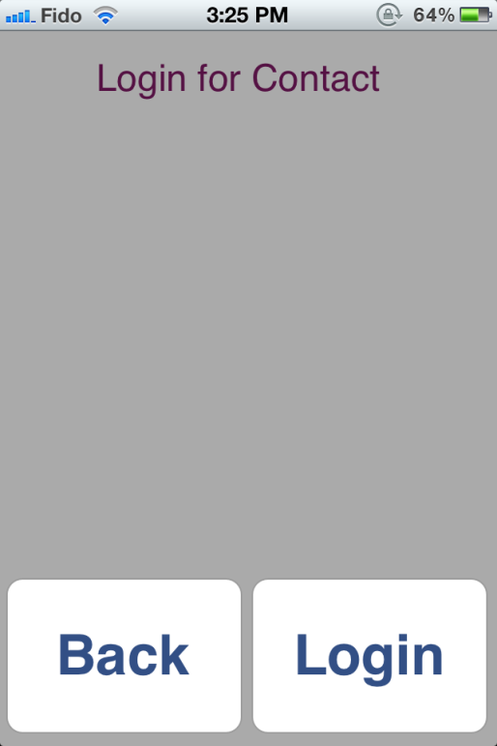
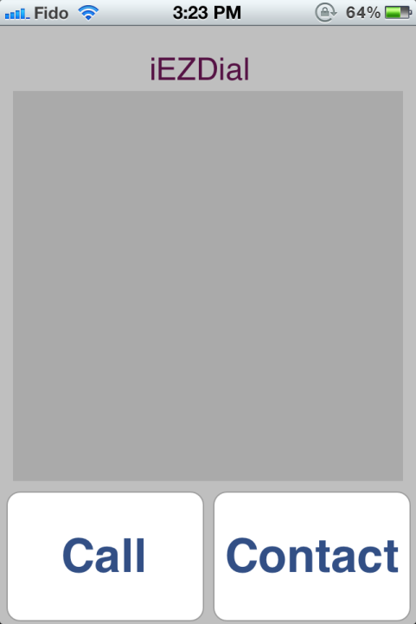
Figure 5.3.2
Tap the Contact Menu

Figure 5.3.1
After opening the application, it comes to the intro Screen. Tap to continue to the Dial Menu

Figure 5.3.3
Input your login usernumber and tap the Login button

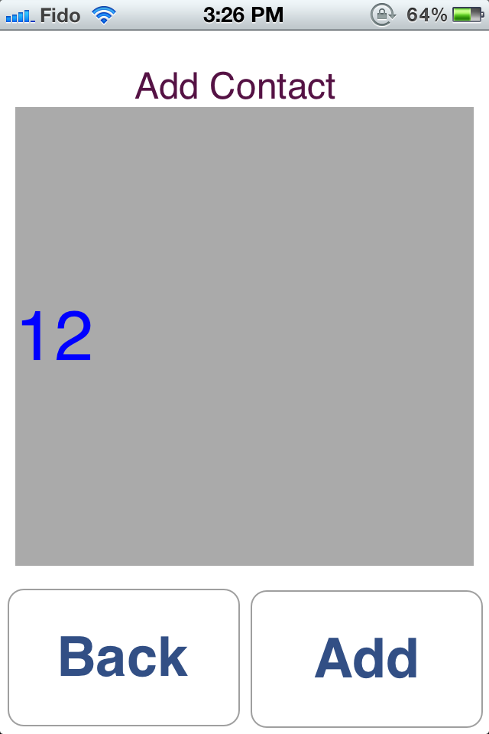
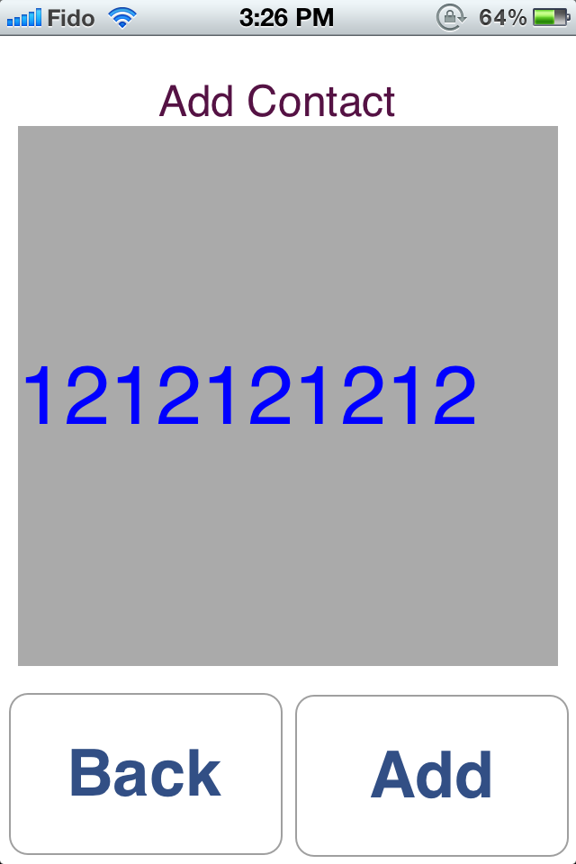
Figure 5.3.6
Use JASAD’s numeric alphabet to type in the new contact number
Figure 5.3.5
The application will ask the user to swipe 1 for speed dial, 2 for adding a new contact and 3 for deleting an existing contact.
Swipe 2 to go to the Adding Menu

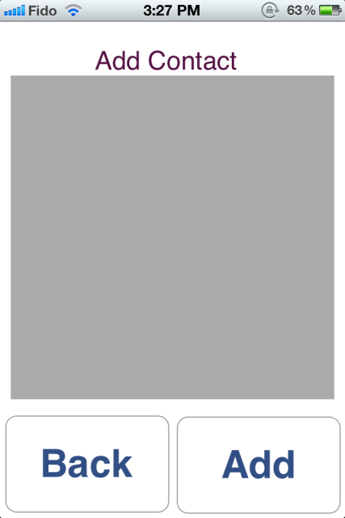
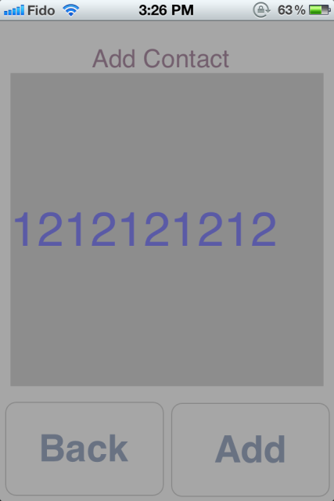
Figure 5.3.7
Press the Add button to add the number to Contact List
Figure 5.3.8
The application will ask the user to swipe right to add the contact to the Contact List and to swipe left to not add the new contact
Swipe right to add in the next available spot on the Contact List

Deleting a contact in the contact list
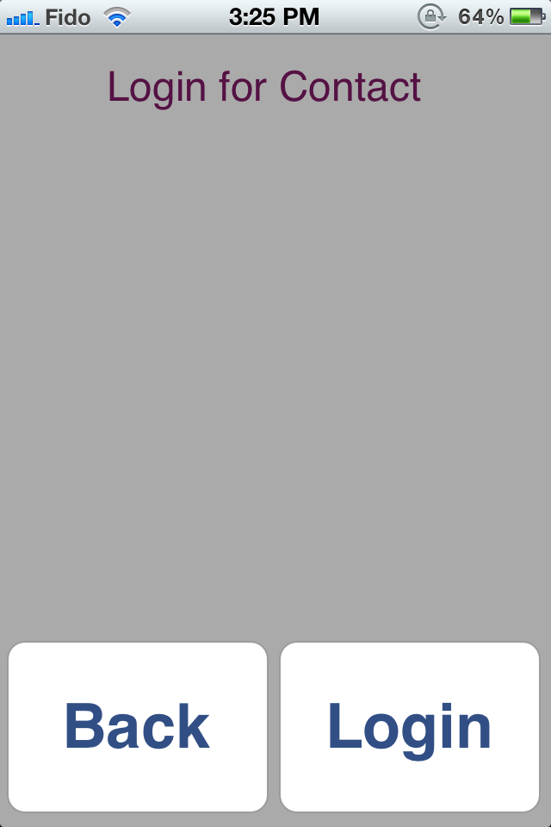
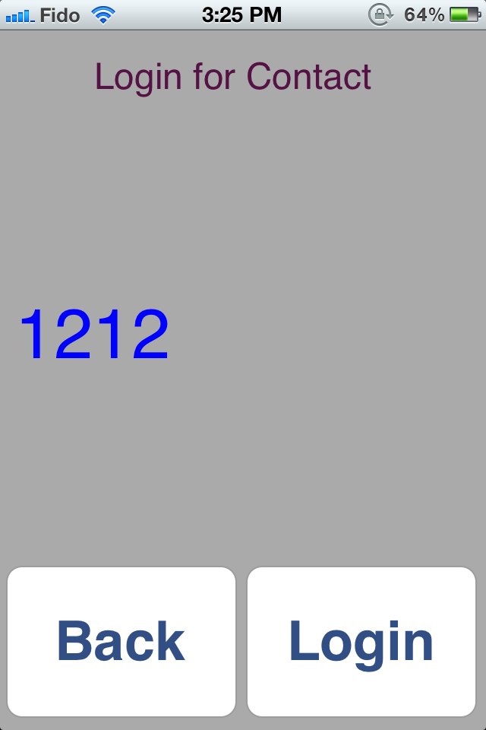
Figure 5.4.3
Input your login usernumber and tap the Login button

Figure 5.4.1
After opening the application, it comes to the intro Screen. Tap to continue to the Dial Menu

Figure 5.4.2
Tap the Contact Menu

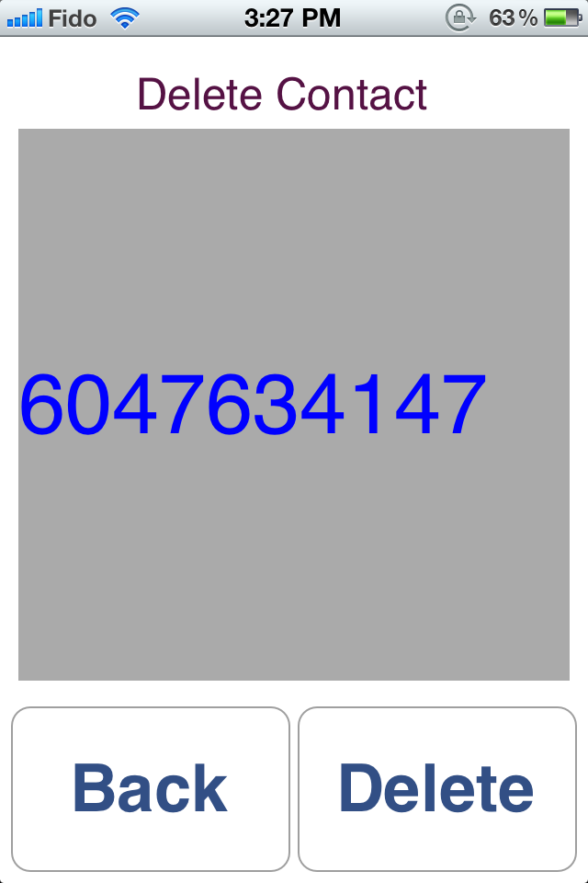
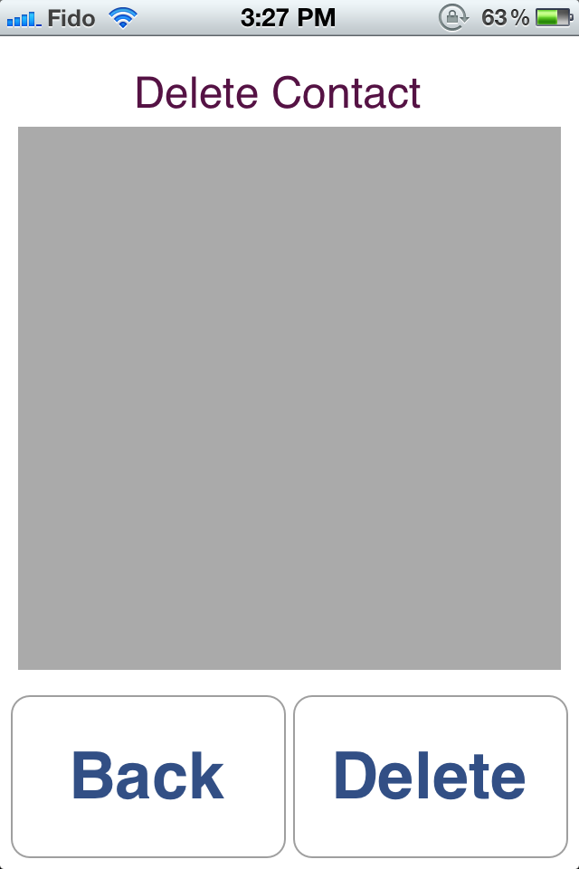
Figure 5.4.5
Input the Code Number that you want the number stored at that Code Number you want to delete
Figure 5.4.5
The application will ask the user to swipe 1 for speed dial, 2 for adding a new contact and 3 for deleting an existing contact.
Swipe 3 to go to the Deleting Menu

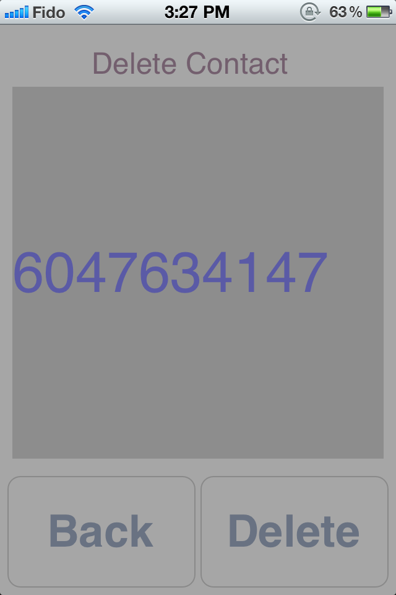
Figure 5.4.6
The application will then ask the user to confirm the deletion. Swipe right to delete.
Figure 5.4.7
This will take back to the contact screen

