ENGI 4969YB: Electrical Engineering Degree Project

Wireless Energy Transfer and Control
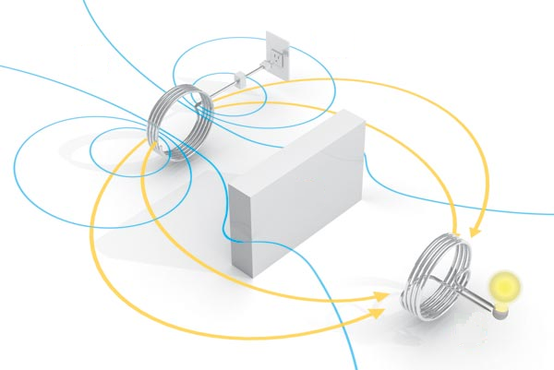
By:
Peter Luong
Paolo Meleca
Graham Dube
Troy Wideman

Date:
March 15th, 2012
Supervising Professor:
Dr. Alexandrov



Abstract

The purpose of our project is to create a wireless system that will be able to transmit power from one coil to another. This project can be broken down in to three basic categories; the creation of the oscillator circuit, the transmission of the power between the two coils, and the control circuit.

The oscillator is used to generate the signal that is to be transmitted. Utilizing a blocking oscillator the group was able to acquire a desired signal. Although the operation of the oscillator is complex, the group had chosen it because it required fewer components and therefore was a cost-effective solution.

For desired distance of 10cm, the coils where designed to transmit as much power as possible. Due to the distance between them and no magnetic core one can expect a poor coupling coefficient when doing the analysis and getting the results. To keep the desired voltage the coils where designed with a 1:1 ratio.

The last portion of our project was the controls. After extensive research the control that was chosen was the Arduino Duemilanove. This control was chosen because it was specifically designed to do electrical projects. The controller in this project is used in order to move the main base from left to right depending on where the user moves the adjustable base, so it can re-align the two coils for maximum power transfer. For this re-alignment of the coils limit switches where used to tell the controller where to move the platform and if it is centered or not.

In placing these components together the group was able to create a device which can power a LED light bulb though wireless induction. This design has great potential for future implementations such as having cells phones charge wirelessly just by entering a room or a building, and powering household electronics like televisions and computers.
Table of Contents
Abstract 2
Introduction 6
Application and Methodology 7
Block Diagrams of the Overall System 7
Diagrams of Apparatus 9
Oscillators 10
Theory 10
Blocking Oscillators 11
LC Tank Circuit 12
Theory of Operation 14
General Blocking Oscillator Operation 15
Usage of the Blocking Oscillator and Alternative Blocking Oscillator Design 18
Alternative Oscillator Theory of Operation 20
Blocking Oscillator Design 22
Circuit Analysis 22
Ampere-Turns 24
Secondary Current 24
Winding [2] Current 25
Transistor Gain and time 26
Blocking Oscillator Component Selection 27
Establishing Constants 27
Desired Frequency of Oscillation 27
LED Bulb Impedance 28
Transformer 29
Transistor 29
Power Source 29
Resistor 29
Starting to find the Capacitor Value 30
Impedance on Secondary Transformer Winding 31
Finding Capacitance 33
MOSFET Switching Oscillator 34
Spice Simulation 37
Schematic 1: Blocking Oscillator Spice Schematic 37
Code 1: Blocking Oscillator Spice Code 37
Power Measurements and Efficiency Analysis 40
Table 1: Power and Efficiency Measurements 40
Coils –Theory and Design 41
Magnetic Theory 41
Design 42
Application 45
Table 2: Measured and Calculated Values for the Transmitting and Receiving Coils 45
Sample Calculations: 45
Graph 1: Voltage on the secondary Coil with Respect to the Horizontal Distance Away From the Primary Coil 46
Coupling coefficient and Mutual inductance 47
Results and Measurements 48
Table 3: Measured Voltages and Currents of the Coils Using Resistive Load 49
Table 4: Coupling Coefficient and Mutual Inductance 49
Sample Calculations: 49
Resonant Frequency, and Inductor/Capacitor values 50
Table 5: Resonant Capacitance 50
Transmitting Efficiency 50
Table 5A: Transmitting Efficiency 50
Controls 51
Controller 51
Programming Block Diagram 52
H-Bridge 53
Limit switches 53
Arduino Code 54
Original 54
Modified Arduino Code 55
Power Supply design 57
Power Supply 57
Transformer 57
Rectifier 58
Filter 60
Voltage Regulator 60
Problems Encountered with the Power Supply 61
Cost Analysis 63
Future considerations 64
Advantages of a PLC over a microcontroller 64
Safety Limit switches 65
Variable Motor 65
Battery Charging 65
Sociological Impact 66
Heath Issues 66
Table 6: Range of Frequencies 67
Applications in Industry 69
Conclusion 72
Bibliography 74
Appendix A: PLC Proposal 75
Appendix B: Electrical Schematic Diagram of Wireless System 77
Blocking Oscillator 77
Position Control System 78
Appendix C: Specification Sheets 79

Introduction
This report documents the design, analysis and construction of a wireless energy transfer device with several specific features. The device will be designed to transfer energy from one coil to another, through induction, in order to supply power to a load on the second coil. The design will also allow for a control aspect in which the first coil will sense when the second coil has moved and will change its position to match the second coil’s position.
The goal will be to create enough power on the secondary coil tolight up an LED light bulb with a distance of 10cm between the coils. There are three main parts of this device; the oscillator, the coils, and the coil position control. This report will outline the design, analysis and testing of each part individually and then as a whole.

Application and Methodology

Block Diagrams of the Overall System
Wireless Power System
The Wireless Power system will be set up as follows:
- A 12 volt supply will be used by an oscillation circuit.
- The oscillator circuit’s signal will go to the primary coil, where a magnetic field is created.
- The magnetic field will induce voltage on the secondary coil.
- The induced secondary coil voltage will be used to power an LED light bulb.
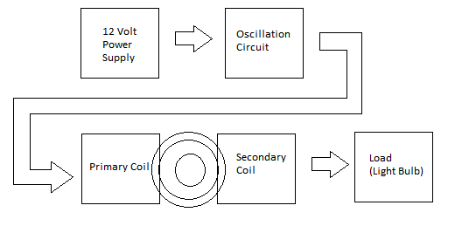
Figure 1.0: Wireless Power System Block Diagram

Motor/Tray Position Control System
The position control system is set up as follows:
- A 12 volt power supply will be used by the motor.
- Two separate 5 volt supplies will power the Arduino controller’s inputs.
- A motor will be able to move a metallic tray backwards and forwards.
- The transmitting primary coil is in a fixed position, while the receiving secondary coil is on the movable tray.
- The motor is controlled by the Arduino microcontroller.
- The Motor moves in one direction until limit switches are both contacted, closing the relays and signaling the controller to stop moving the motor.
- Limit switches are positioned so that the secondary coil on the tray will stop directly in front of the fixed primary coil position.

Arduino Micro-controller

DC Motor
H Bridge Relay logic
Right Limit Switch
motor forward or motor reverse
Main Platform Contact
Reset

Left Limit Switch
Main Platform Contact

Figure. 1.1: Position Control System, General Block Diagram

Diagrams of Apparatus
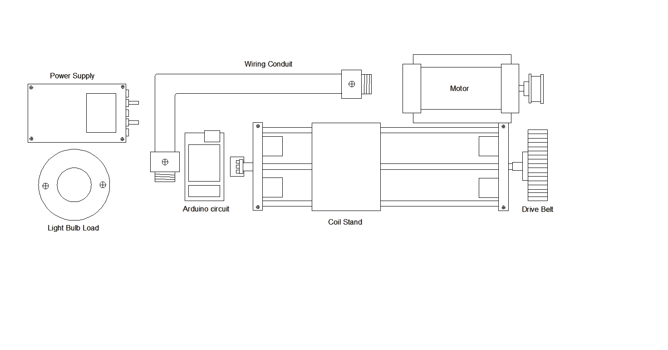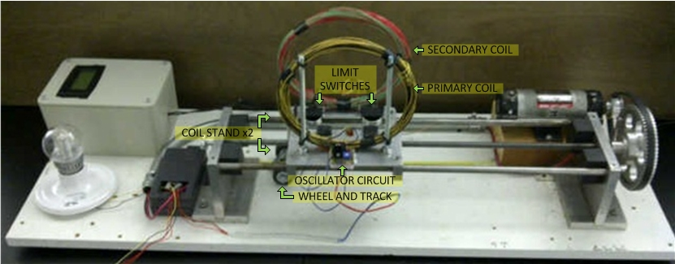
Figure 1.2: Project Apparatus

Oscillators

Theory
The objective of wireless power transfer is to transfer a certain amount of power over a specific distance without the use of wires. To accomplish this, an alternating current must be applied to the primary coil similar to that of a transformer. The oscillator is used to provide this alternating current. In designing an oscillator circuit for the optimum transfer of power, knowledge of electromagnetic theory must be applied. Biot-Savart’s law relates the differential magnetic field intensity (dH) to the differential current.
$$dH=\frac{Id\overset{⃑}{l}X{\overset{⃑}{a}}_{R}}{4πR^{2}}=\frac{Id\overset{⃑}{l}X\overset{⃑}{R}}{4πR^{3}}→where{\overset{⃑}{a}}_{R}=\frac{\overset{⃑}{R}}{R}$$
Applying Biot-Savart’s Law to a current loop, the magnetic field can be calculated at a certain point away from the loop.
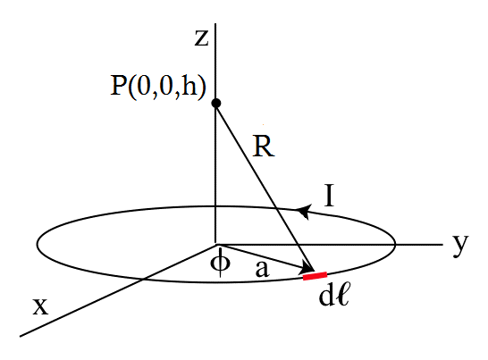
$$dH=\frac{Ia^{2}dφ{\overset{⃑}{a}}_{z}}{4π{\left[a^{2}+h^{2}\right]}^{\frac{3}{2}}}$$
$$H=\int{dH=\int_{0}^{2π}{\frac{Ia^{2}dφ{\overset{⃑}{a}}_{z}}{4π{\left[a^{2}+h^{2}\right]}^{\frac{3}{2}}}}}$$
$$H=\frac{Ia^{2}\left(2π\right){\overset{⃑}{a}}_{z}}{4π{\left[a^{2}+h^{2}\right]}^{\frac{3}{2}}}=\frac{Ia^{2}{\overset{⃑}{a}}_{z}}{2{\left[a^{2}+h^{2}\right]}^{\frac{3}{2}}}$$

From the equation above we can see that the magnetic field is dependent on the current flowing through the loop and the radius of the loop. For a fixed loop, the maximum magnetic field will occur when the current is at its maximum value. This means that the more current that is flowing through the loop the stronger the magnetic field will be.
Now looking at Faraday’s Law, it can be noticed that a voltage can be induced in a closed circuit by a time-varying magnetic field.
$$V_{emf}=\oint_{L}{\overset{⃑}{E}*d\overset{⃑}{l}}=-\frac{d}{dt}\oint_{S}{\overset{⃑}{B}*d\overset{⃑}{A}}$$
As this is the primary objective in the transfer of wireless power, it is observed that a time-varying field must be created. Going back to Biot-Savart’s Law, it is clear that to produce a time varying-field, a time varying-current must be present. This allows the radiated field to be controlled by the amount of change in the current, where the current with the greatest change in respect to time will create the largest magnetic field. Taking these laws into account, it can be seen that a waveform, which has a very good slew rate, will theoretically produce the largest magnetic field.

Blocking Oscillators
To transmit power wirelessly, a magnetic field is required. For some insight as to what creates a strong magnetic field, the properties of an inductor can be investigated. The voltage, or electric field, across an inductor depends on the change in current through it and is expressed as:
$$E_{L}=L\frac{di_{L}}{dt}$$
Where:
E_{L} = Electrical Field across the inductor (Volts)
L = Inductance (Henries)
I_{L} = Current across inductor (Amperes)

The electric field is related to a magnetic field by the following Maxwell equation:
$$∇×\overset{⃑}{E}=-\frac{∂\overset{⃑}{B}}{∂t}$$
Where:
$\overset{⃑}{E}$ = Electric Field vector (Volts)
$\overset{⃑}{B}$= Magnetic Field vector (Teslas)

With these relationships, it can be seen that the changing magnetic field is related to the slew rate, or change in current over a set period of time. With a very high slew rate, the corresponding magnetic field will be stronger as well.

The advantage of blocking oscillators is that this kind of oscillator can achieve very high slew rates while minimizing the power required. The amount of parts required is also reduced when compared to the Colpitts oscillator + MOSFET driven combination due to the efficiency of its design.

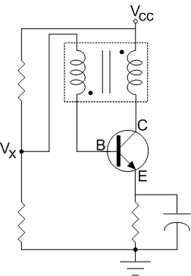
Figure 2.0: A Typical Blocking Oscillator

LC Tank Circuit
To fully understand how blocking oscillators work, it is a prerequisite to first understand what happens in an inductor when there is an increasing or decreasing magnetic field present.

The properties of the inductor are more easily demonstrated with an LC Tank Circuit Oscillator as shown below.
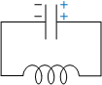
Figure 2.1: A Typical Blocking Oscillator

Initially it will be assumed that the wires are lossless (i.e.: wire resistance = 0) and capacitor is charged. The capacitor will first start to discharge. As the current goes through the inductor, a strong magnetic field is created.

According to Faraday’s Law:
$$V_{EMF}=-N\frac{dɸ_{B}}{dt}$$
Where:
$V_{EMF}$= Electromotive Force (Volts)
N = the number of turns on the inductor coil
$ɸ_{B}$= Magnetic flux through one turn of the coil (Webers)

According to this Law, the magnetic field induces a voltage across the inductor that opposes the flow of current, and therefore the inductor has an equivalent polarity as shown:

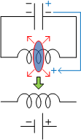
Figure 2.2: An Increasing Magnetic field

As more current discharges from the capacitor, the inductor’s magnetic field gets stronger, further increasing the opposing voltage.

When the capacitor is fully discharged, the lack of changing current in the inductor causes the magnetic field to collapse. Therefore the change in magnetic field is opposite to what it had been previously.

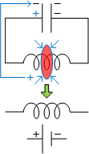
Figure 2.3: A Collapsing Magnetic Field

With this opposite change in the magnetic field, and in accordance to Faraday’s law, the voltage across the inductor will reverse in polarity, thereby releasing all the energy held up by the magnetic field to charge the opposite end of the capacitor.

As the magnetic field fully dissipates, the capacitor becomes fully charged with the opposite polarity, and starts discharging in the opposite direction.

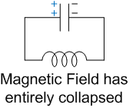
Figure 2.4: Resultant Polarity
Based on the LC tank operation above, the following facts will be of significance when analyzing the blocking oscillator:

(1) The polarity of the induced voltage changes depending on whether the induced magnetic field is increasing or decreasing.

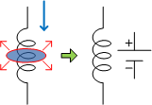
Figure 2.5: Polarity of an Expanding Magnetic Field
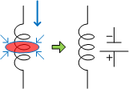
Figure 2.6: Polarity of a Collapsing Magnetic Field

(2) This polarity also transfers across the windings of a transformer due to magnetic coupling and therefore can induce current.

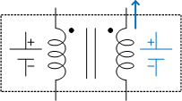
Figure 2.7: Equivalent Transformer Polarities

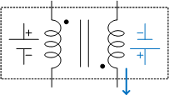
Figure 2.8: Equivalent Transformer Polarities, Secondary Winding Position Switched

Theory of Operation

In general, blocking oscillators require at least one transformer and transistor in order to achieve oscillation. It works on the basis of having the transistor allow changing currents through a primary transformer winding on its collector. The resultant magnetic field from the primary winding will induce a current on the secondary winding and cause the base current to increase.
Increases in base current will lead to increases in collector current until the transistor reaches a saturation point. As saturation is reached, the magnetic fields will decrease, and hence reversing the directions of the induced current on the secondary winding.

To demonstrate these modes of operation, a more detailed analysis will be made in the following section.

General Blocking Oscillator Operation
Figure 2.9:Typical Blocking Oscillator
Assume the circuit is as shown and the starting conditions are as follows: capacitor is charged, and capacitor’s voltage causes V_{X} to be less than V_{E}. The transistor switch is initially open.The capacitor drains through the resistor, until transistor has enough forward bias voltage across V_{X} and V_{E}. Therefore the transistor switch closes.

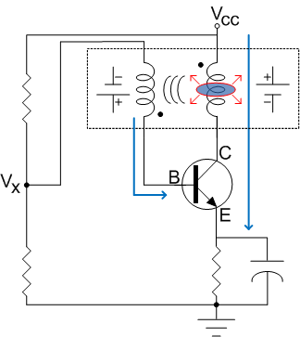
Figure 2.10: An Increasing Magnetic Field
When transistor is closed, a changing current will flow from Collector to Emitter. This changing CE current induces a magnetic field on the primary coil of the transformer that opposes the current flow from the source. It is important to also note that the capacitor charges at this time.

The magnetic field on the primary transformer coil then induces additional current to flow on the secondary winding into the base of the transistor.

The transistor’s base current and collector current during amplification are related by
I_{COLLECTOR} = h_{FE} * I_{BASE,} therefore as base current increases, so too does collector current.

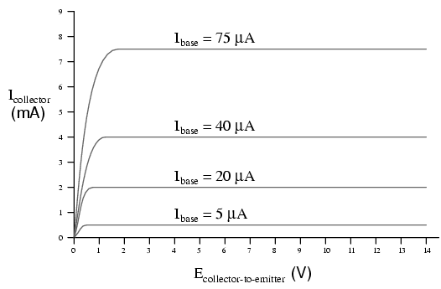
Figure 2.11: Typical Transistor Base/Collector current Relationships

As collector current increases, it creates an even stronger magnetic field on primary transformer winding, and therefore induces a higher base current to the transistor, leading to higher collector currents, and so on.The increases in collector current persist until the transistor starts to saturate. At this point, additional base current can still yield additional collector current, but this increase in collector current will progressively become less.

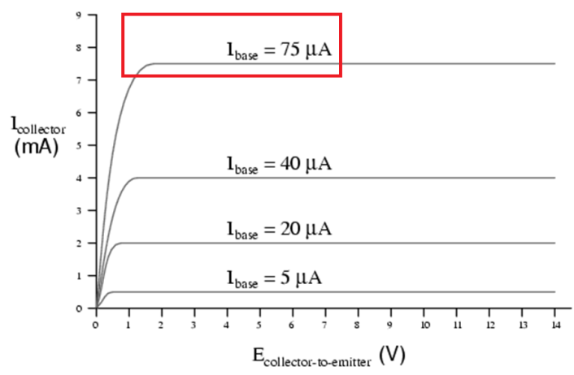
Figure 2.12: A Region where Increasing Base Current no longer Yields Increasing Collector Current
Eventually, the collectors current will no longer increase, causing magnetic fields in the transformer coils to collapse.

The collapse of the magnetic fields causes a change in the polarity of all the induced voltages. This polarity change causes the base current to flow away from the transistor base.

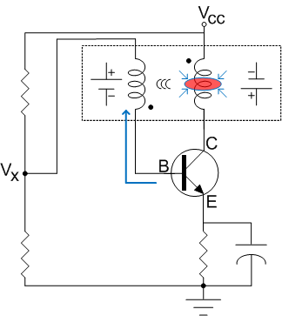
Figure 2.13: A Collapsing Magnetic Field
With no current in the base, the transistor switch then opens while the magnetic fields continue to collapse.Once the magnetic fields have fully collapsed, the circuit returns to its starting conditions. The capacitor, having previously been charged begins to discharge through the resistor again.This discharge eventually allows V_{X}to have enough forward biased voltage with respect to V_{E}allowing the transistor switch to close again.

Usage of the Blocking Oscillator and Alternative Blocking Oscillator Design
To use the above oscillator in wireless power transmission, a step up transformer could be connected in series with the existing transformer and the secondary winding of the step up transformer would then connect to the transmitting coils.
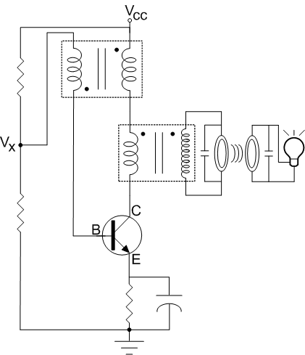
Figure 2.14: Possible Configuration Transformer in Series
This step-up transformer would be necessary since by experiment, it was observed that using the coil directly in series did not produce sufficient slew rates, and thus could not transmit power effectively.

Another way to use the blocking oscillator in wireless power transmission would be to use a single transformer with three windings. The third winding would be a step-up winding.

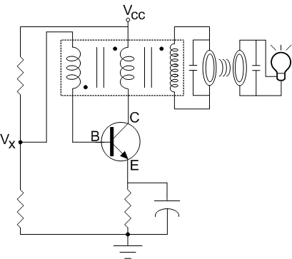
Figure 2.15: Possible Configuration – Three-Winding Transformer

There are some practical disadvantages however, with the above two designs. The three coil transformer is not commonly available, and the other design requires an additional transformer, which means additional costs.To address the above problems, an alternative design that usesonly one commonly-available step-up transformer was considered. This one transformer is used for both oscillation and provides power to the transmitting coils simultaneously.

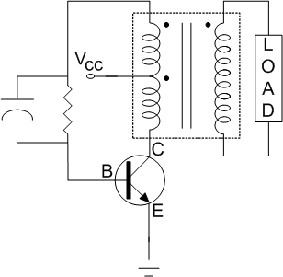
Figure 2.16Alternative Blocking Oscillator

For its minimal use of parts and commonly available components, we have chosen this oscillator design for use in wireless power transmission.

Alternative Oscillator Theory of Operation
As with any other blocking oscillator,this configuration relies on a transistor and a transformer to perform the oscillations. However the details differ significantly, and are important to understand prior to doing any design of the components involved.

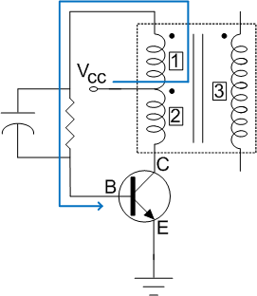
Figure 2.17: Starting Current
Assume that at the very start, the transistor switch is open, and the capacitor has no charge.

The current from the voltage passes through winding [1], charges the capacitor, and goes to the base of the transistor switch, therefore closing it. The purpose of the resistor is to control the amount of starting current that goes into the base.

A closed transistor causes changing current to pass through winding [2], inducing a magnetic field. This magnetic field induces current in winding [3].

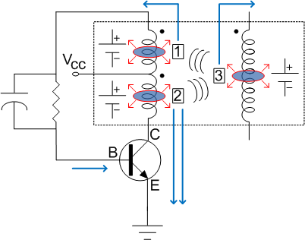
Figure 2.18: Increasing Magnetic Fields

The current in winding [3] in turn produces another magnetic field that is opposing the original magnetic field from winding [2]. Winding [3]’s magnetic field induces a voltage across winding [1]. This voltage increases the potential between the base and the emitter, and therefore increases the base current through the transistor.

As more current flows to the base, more current flows through the collector, thereby strengthening all the magnetic fields induced. Eventually, the transistor will reach a saturation point and will be increasingly unable to amplify the base current. Without a sufficient change in current, the magnetic fields start to collapse, and as per the theory outlined in the LC Tank Circuit theory, the voltage polarities across all the windings will reverse.

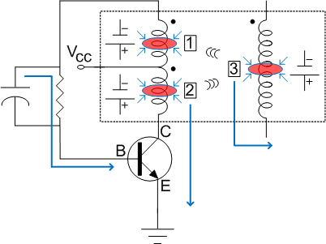
Figure 2.19: Collapsing Magnetic Fields
The reversal in voltage polarities blocks off any additional current that goes from the voltage source to the base. As the transistor switch does not open immediately, the capacitor will then discharge through the resistor into the ground, continuing to keep the transistor switch closed.

Provided that the magnetic fields of the coils are large enough, the capacitor will fully discharge and the transistor switch will then open. Therefore, the purpose of the capacitor is to influence how long the transistor switch remains closed upon saturation.Once the magnetic fields have entirely collapsed, the current from the voltage source is then able to flow to the transistor base and turn it on again.

Blocking Oscillator Design
To decide on the components used in this oscillator, certain analysis and calculations must first be done. Various factors such as equivalent circuits, magnetizing inductance, total Ampere-turns, and the winding currents are to be accounted for.

Circuit Analysis
Assuming that the blocking oscillator is in a state which the magnetic fields are increasing, the polarities of the primary and secondary coils are as shown in Figure 7.

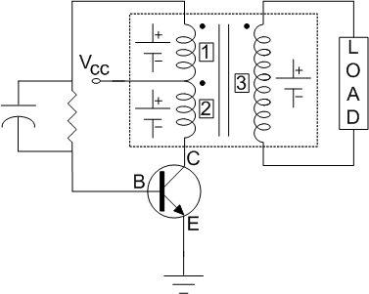
Figure 2.20: Equivalent Polarities while Magnetic Fields are Increasing
On the principle that when a transistor is active, the base current added to the collector current is the emitter current (I_{E} = I_{B} + I_{C}), an equivalent circuit can be drawn for the purposes of analysis as seen in Figure 2.

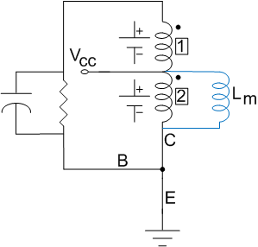
Figure 2.21: Equivalent Transistor Connections + Accounting for Magnetizing Inductance

In a real transformer, the secondary magnetic field partially negates the magnetic field generated at winding [2]. This negated field is equivalent to having a weaker overall inductance.
The weaker inductance is equivalent to including another inductor in parallel with the coil on winding [2], and is referred to as the magnetizing inductance, L_{M}. The effect of L_{M} will besignificant when calculating the collector current later on.

Considering only the primary windings, a further simplification can be made as seen in Figure 10.2.

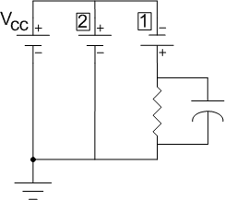
Figure 2.22: Equivalent Primary-Side Circuit
For a transformer, the amounts of voltage-turns on each of the primary windings are equivalent. Since the number of turns in winding [2] is the same as in winding [1], the voltages across both of these windings are the same.

It is apparent from Figure 10.2 that the voltage across winding [2] is the same as Vcc. Therefore, the voltage across winding [1] is also Vcc.

With the above facts in mind, analysis of the circuit yields:

$$Vcc+V\left[1\right]-i_{b}\left(R || Xc\right)=0$$
$$2Vcc-i_{b}\left(Z\right) =0$$

$$i_{b}=\frac{2Vcc}{Z}$$(EQ. 1)

Ampere-Turns
The sum of all Ampere-turns in a transformer is zero.

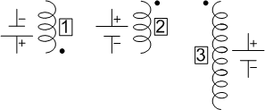
Figure 2.23: Polarities, Assuming Current Travels from Top to Bottom

Factoring in both the flow of current and the polarity of the coils,$i_{b}n ={-i}_{[2]}n-i_{s}n_{s}$. Then using the primary winding as a reference, where n = 1,

$$i_{b} =-i_{\left[2\right]}-i_{s}n_{s}$$(EQ. 2)
As base current is already known from EQ. 1, the secondary and winding [2]’s current remain to be determined.

Secondary Current
The secondary winding and load is as shown:

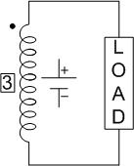
Figure 2.24: Secondary Winding and Load
From the analysis of the circuit on the secondary winding:
$$-i_{s}=\frac{n_{s}V_{CC}}{Z_{L}}$$
(EQ. 3)

Winding [2] Current
Considering only Winding [2] and the magnetizing inductance, the equivalent circuit is as shown:
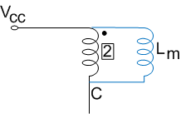
Figure 2.25: Winding 2 and Magnetizing Inductance

An analysis of the collector current shows that:

$$i_{c} =i_{[2]}+ i_{m}$$

Since, $V_{L}=L_{M}\frac{d}{dt}i_{m}$therefore,$i_{m}=\frac{V_{L}}{L_{M}}*t$

And thus,
$$i_{[2]} ={-i}_{c}+ \frac{V_{CC}}{L_{M}}*t$$
(EQ. 4)

Applying EQ. 4 and EQ. 3 into EQ. 2 yields:

$$i_{b}=\left(i_{c}-\frac{V_{CC}}{L_{M}}*t\right)-\frac{{n_{s}}^{2}V}{Z_{L}}$$
(EQ. 5)

As this is an expression for i_{b}, EQ. 5 is equivalent to the base current calculation done in EQ. 1.
Therefore:

$$\frac{2Vcc}{Z}=\left(i_{c}-\frac{V_{CC}}{L_{M}}*t\right)-\frac{{n_{s}}^{2}V_{CC}}{Z_{L}}$$

$$i_{c}=Vcc\left(\frac{2}{Z}+\frac{{n_{s}}^{2}}{Z_{L}}+\frac{t}{L_{M}}\right)$$
(EQ. 6)

Transistor Gain and time
Relating EQ. 6 with EQ. 1, the gain of the transistor, h_{FE}, can be calculated.

$$h_{FE}=\frac{i_{c}}{i_{b}}=\frac{Vcc\left(\frac{2}{Z}+\frac{{n_{s}}^{2}}{Z_{L}}+\frac{t}{L_{M}}\right)}{\frac{2Vcc}{Z}}=\frac{Z}{2}\left(\frac{2}{Z}+\frac{{n_{s}}^{2}}{Z_{L}}+\frac{t}{L_{M}}\right)$$

$$h_{FE}=1+\frac{Z}{2}\frac{{n_{s}}^{2}}{Z_{L}}+\frac{Z}{2}\frac{t}{L_{M}}$$(EQ. 7)
Rearranging for time yields:

$$t=\frac{2L_{M}}{Z}\left(h_{FE}-1-\frac{Z}{2}\frac{{n_{s}}^{2}}{Z_{L}}\right)$$
(EQ. 8)
As t cannot be negative, the following inequality must be true:

$$\frac{Z}{2}\frac{{n_{s}}^{2}}{Z_{L}}≤{(h}_{FE}-1)$$
(EQ. 9)
Where
Z = the parallel impedance of the resistor and capacitor
Z_{L} = the load connected to the secondary winding, which is the transmitting coil
n_{S=} the secondary winding ratio relative to the first winding
h_{FE}= the gain of the transistor

Hence, EQ. 9 incorporates all the circuit elements used in the Blocking Oscillator.

Blocking Oscillator Component Selection
The major components of the oscillator are as follows:
Transistor
Transformer
Resistor
Capacitor
Load Impedance

Establishing Constants
$$\frac{Z}{2}\frac{{n_{s}}^{2}}{Z_{L}}≤{(h}_{FE}-1)$$
(EQ. 9)

As EQ. 9 suggests, values associated with these components are heavily inter-connected, and therefore some constants must first be established. The first thing to consider is the load. The load consists of a transmitting and receiving coil, and the LED light bulb.

Based on the coil design and calculations(See Coils, Design), the resistance of the transmitting and receiving coils was 2.6Ω and 3.5Ω respectively. As will be evident later, the frequency of the oscillator must first be established in order to find the impedance of the LED light bulb.

Desired Frequency of Oscillation
The desired frequency of oscillation was decided to be 23kHz. A consideration taken in this choice of frequency was that it had to be within the transistor’s switching capability. Another more critical aspect was the possible health risk and interference of other wireless transmissions when using a higher frequency (See Sociological Impact, Health Issues).

LED Bulb Impedance
The impedance of the LED bulb could not be measured directly due to multiple unknown capacitances within the LED and its ballast. Thus, the bulb impedance varies depending on the frequency applied to it. As the frequency of 23 kHz was established, tests were conducted to find out the impedance of the LED bulb.
Due to the nature of p-n junctions of the LED which naturally hold electrons under zero-bias conditions, the LED bulb was considered to be capacitive, and hence it was assumed that the voltage lags the current. The impedance was calculated based on the peak voltage and current readings from a 23 kHz signal.
$$Z_{LED }=\frac{V_{{LED}_{PK}}}{I_{{LED}_{PK}}} ∠θ_{LAG}$$
Where:
$V_{{LED}_{PK}}$=peak voltage across the LED bulb
$I_{{LED}_{PK}}$ =peak voltage divided by the resistance of a 3.3Ω resistor in series with the LED bulb
$θ_{LAG}$ =angle at which $V_{LED}$ lags $I_{LED}$

Hence,
$$Z_{LED }=\frac{4.675V_{PK}}{1.5{mA}_{PK}}∠16.5°$$
$$Z_{LED }=3116.7Ω ∠16.5°$$
$$Z_{LED}=2988.35+j885.2$$

Transformer
As was discussed in the theoretical sections, one requirement of strong magnetic fields is the ability to have a very rapid slew rate. To have a rapid slew rate on the load transmitting coil, a high step up transformer is desirable. Based on cost and availability, the choice of transformer was one that had a ratio of 1:14 with a center-tapped primary coil.

Transistor
A transistor with a high power tolerance, and switching time would help ensure the currents going through the primary winding can be as high as possible. At the same time, the gain needs to be high enough to satisfy EQ. 9.For those considerations, an FJE3303 high power transistor was chosen. Its maximum h_{FE} value is 21 with turn-on and fall times at 1.1us or less.

Power Source
It has been decided that the voltage source will be 12Volts for power/safety considerations.

Resistor

Figure 2.26: Blocking Oscillator Circuit in its Entirety
The resistance R needs to be just large enough for the current to initially close the transistor. As this current information was unavailable on the spec sheet, it was found by experiment that the FJE3303 transistor required at least 680uA to the base in order to be driven at the desired h_{FE} value.

For analysis on the value of R, an equivalent circuit is shown.

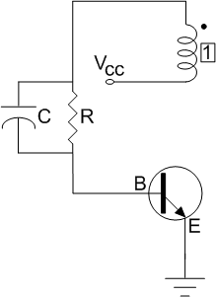
Figure 2.27: Sections Considered for Analysis
Since there is only the DC voltage source, the transformer coil effectively has no voltage drop due to a lack of change in current. The equivalent circuit can further be simplified as follows:

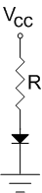
Figure 2.28: Sections Considered for Analysis, Equivalent Circuit
Assuming that the voltage drop across the p-n junction of the power transistor is 1.2V,the following equation holds true:
$$i_{B}=\frac{12V-1.2V}{R}$$

$$R≤\frac{12V-1.2V}{680uA}$$

$$R≤15.882kΩ$$

However, the base-emitter junction of the transistor and DC sources may not be ideal, since the base-emitter voltage drop may not be 1.2Vand the DC source may fluctuate enough to induce voltage on the coil winding. Hence, a potentiometer was implemented instead of any fixed resistance value.

This range of resistance values nevertheless remains significant in calculating the correct range of capacitor values. For purposes of calculations, a resistance value of 2kΩ shall be used.

Starting to find the Capacitor Value
The capacitance value can be deduced by substituting all known values into equation 9 as shown below:
$$\frac{Z}{2}\frac{{n_{s}}^{2}}{Z_{L}}≤{(h}_{FE}-1)$$

$$\frac{Z}{Z_{L}}\frac{{(14)}^{2}}{2}≤(21-1)$$

$$\frac{Z}{Z_{L}}≤0.2041$$
(EQ. 10)
Where
Z = Impedance of the oscillator’s resistor in parallel with its capacitor
$Z_{L}$ = The equivalent load impedance on the secondary winding of the transformer

Impedance on Secondary Transformer Winding
To find the impedance on the secondary transformer winding, the transmitting and receiving coils must be considered as a 1:1 air-core transformer as both the coils have the same number of windings.
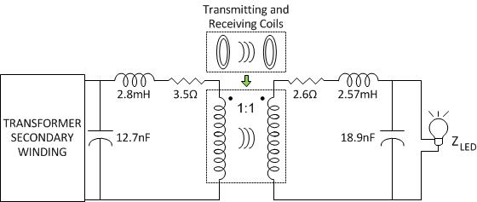
Figure 2.29: Equivalent Load Circuit

With the winding ratio being 1:1, the transmitting and receiving sections are effectively coupled together. For simplicity, the proceeding sections shall calculate the total impedance part by part.

It is worth noting where the resistance, inductance and capacitance values arrived from. The resistance values are based on the coil resistances, the inductance values are from the measured self-inductance of the coils, and the capacitors were designed for resonance at the chosen frequency of 23 kHz. More details and derivations of these values can be found in the Coils section.

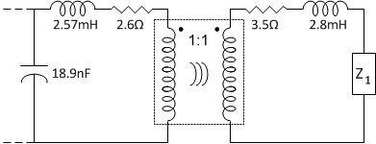
Figure 2.30: Equivalent Circuit

Starting from where the LED light bulb load is,
$$Z_{1}=Z_{LED }|| C_{R} = \frac{Z_{L}}{1+j2πfC_{R}Z_{L}}$$
$$Z_{1}= \frac{2988.35+j885.2}{1+j\left(2988.35+j885.2\right)\left(12nF\right)\left[2π\left(23kHz\right)\right]}$$
$$Z_{1}=98.1058-j556.0291$$
Then for the entire receiving side of the circuit:

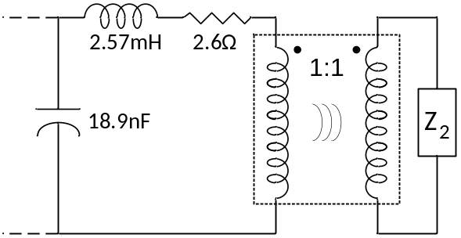
Figure 2.31: Equivalent Receiving-Side Circuit

$$Z_{2}=Z_{1}+3.5Ω+j\left(2.8mH\right)\left[2π\left(23kHz\right)\right]$$
$$Z_{2}=101.6058-j151.3920$$

Consider the diagram shown below:

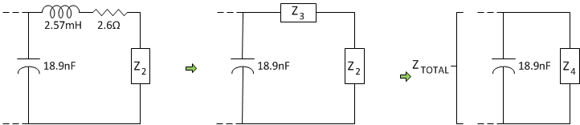
Figure 2.32: Remaining Impedance Simplifications

As the transformers are effectively coupled, Z₂ can be considered as being in series with Z₃to obtain a resulting impedance of Z₄. Z_{4 ,} in turn, is paralleled with the transmitting side’s capacitor. The resulting impedance is the total impedance across the secondary winding of the oscillator’s transformer. Calculations are as shown below:

$$Z_{4}=Z_{2}+Z_{3}$$
$$Z_{4}=\left(101.6058-j151.3920\right)+(2.6Ω+j\left(2.57mH\right)\left[2π\left(23kHz\right)\right])$$
$$Z_{4}=104.2058-j220.0071$$
$$Z_{L}=\frac{Z_{4}}{1+j2πfC_{T}Z_{4}}$$
$$Z_{L}= \frac{104.2058-j220.0071}{1+j\left(104.2058+j220.0071\right)\left(18.9nF\right)\left[2π\left(23kHz\right)\right]}$$
$$Z_{L}=433.6750+j242.0025$$
$$Z_{L}=496.6279∠29.1627°$$

Finding Capacitance
Utilizing Equation 10 and $Z_{L}$ , the capacitor’s value can finally be determined.
With the chosen resistance value of 2kΩ, which is within the resistance value limits specified previously (less than or equal to 15.588kΩ), Z is determined by:
$$Z= \frac{2k}{1+j0.289C}=\frac{2k}{\sqrt{1^{2}+{(0.289C)}^{2}}∠\tan^{-1}\left(\frac{0.289C}{1}\right)}$$
Where C is expressed in nF.

$$\frac{Z}{Z_{L}}≅\left|\frac{Z}{Z_{L}}\right|≤0.2041$$
$$\frac{2k}{\sqrt{1^{2}+{(0.289C)}^{2}}}*\frac{1}{\left(496.6279\right)}≤0.2041$$
$$\sqrt{1^{2}+C^{2}(0.08352)}≥19.7313$$
$$C≥68.1871nF$$

MOSFET Switching Oscillator
Before utilizing the blocking oscillator to generate our transmitting signal we designed a different oscillator circuit. We did not use this design due to the inefficiency of the oscillator compared to that of the blocking oscillator. To optimize the power transmission a square wave should be used because it has a faster change of current or voltage, better slew rate, compared to other waveforms. Our first prototype to create a waveform was a colpitts oscillator, which is commonly used to generate square waves.
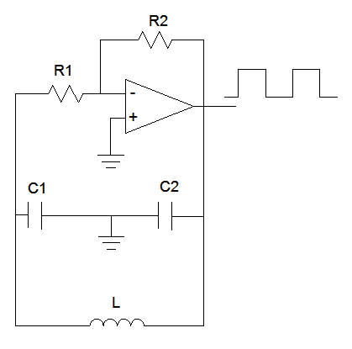
Figure 3.0: MOSFET Oscillator
The high gain that is produced with the opamp and resistors provides a good slew rate for the wave and the LC feedback loop determines the frequency of the wave. Applying this wave form through our transmitting coil, we found that both the magnitude and slew rate were not sufficient. Our next prototype utilized the colpitts oscillator from before to switch a power mosfet on and off rapidly through a gate driver. With a high voltage at the drain of the mosfet, the switching of the mosfet on and off will allow surges of voltages to flow through our transmitting coil and the mosfet.
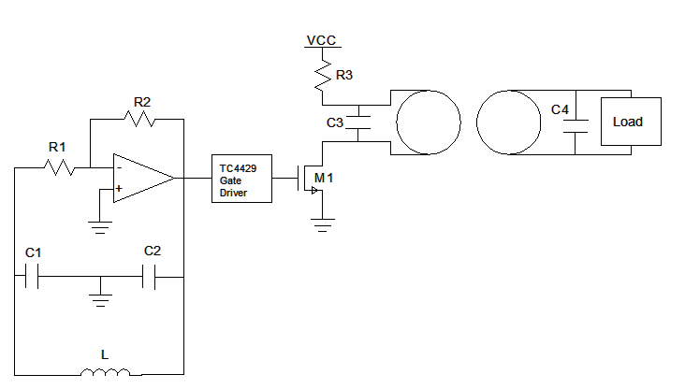
Figure 3.1:MOSFET Oscillator
This method of switching on and off a mosfet to induce a voltage in another wire is commonly used in measurement techniques although the induced voltage is relatively small. This method did transfer power to the receiving coil but it was not enough to achieve the desired power transfer to power a light bulb at the desired distance. To increase the amount of voltage induced we used a configuration using two mosfets and a center tapped transformer.
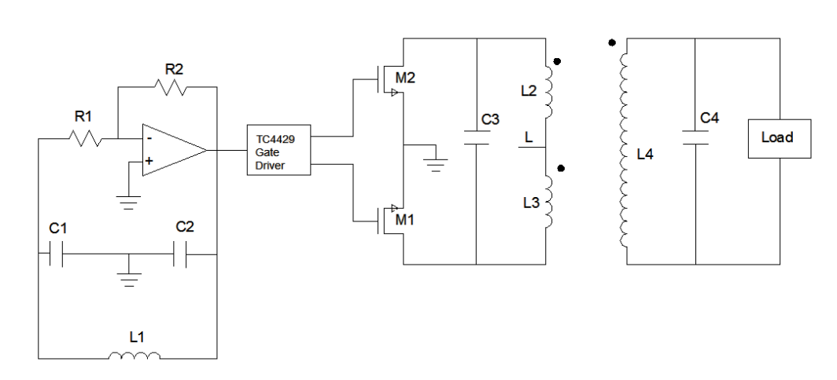
Figure 3.2: MOSFET Oscillator With Center tapped Transformer
One of the mosfets is controlled using a square wave and the other one is controlled using an inverted square wave. By putting these opposite waves at each of the mosfet gates we get a situation where one mosfet allows current to flow while the other one is off and then switches to allow the other mosfet to conduct. This switching between mosfets continues because of the square wave and its inverse wave controlling the mosfets. This increased our output power on the secondary coil enough to power the light at approximately the desired distance. To get the maximum power transfer the capacitors are chosen to resonate each coil at the same frequency that the mosfets are switching on and off at. As Vcc is increased we can achieve greater distance between the coils. Although this design was able to accomplish the power transfer, it was inefficient and had one issue. When L2 induces a voltage in L4to power the light bulb, both L2 and L4 also induced a voltage in L3. This is called the back emf voltage. This induced voltage across L3 causes a current to flow to the mosfet that is turned off. If this current is larger than the current allowable in the diode that is within the mosfet, then the diode will break down and damage the mosfet.
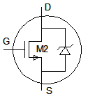
Figure 3.3: Current may flow to through diode when mosfet is off, resulting in break down
This back emf is also present in the first inductor (L2) when the mosfets switch from their current state to the opposite state. There is no way of preventing this back emf as this induction of power is what creates the wireless transmission. What can be done is to attempt to divert or limit the current that flows to the mosfet that’s not conducting. This is difficult as there may be large spikes of voltage that are induced. Although this problem could be fixed, this design is still inefficient compared to that of a blocking oscillator.

Spice Simulation

Schematic 1: Blocking Oscillator Spice Schematic

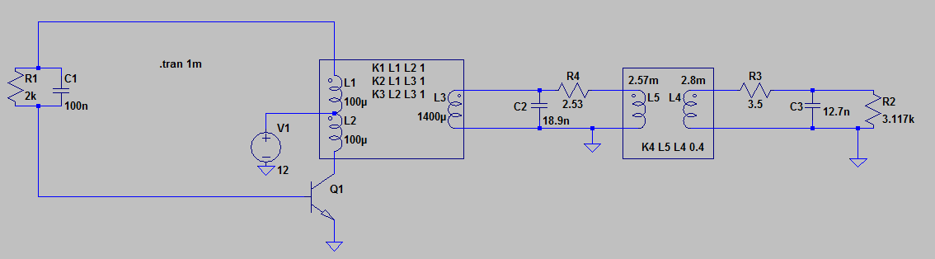
Code 1: Blocking Oscillator Spice Code
* G:\full oscillator.cir
Q1 N008 N006 0 0 FJE3303
L1 N007 N001 100u
L2 N008 N007 100u
L3 0 N002 1400u
R1 N001 N006 2k
C1 N001 N006 100n
V1 N007 0 12
L4 N004 0 2.8m
L5 0 N003 2.57m
C2 N002 0 18.9n
C3 N005 0 12.7n
R2 N005 0 3.117k
R4 N003 N002 2.53
R3 N005 N004 3.5
.MODEL FJE3303 NPN
+ IS = 1.449E-13 BF = 29.9 NF = 1
+ BR = 2.71001 NR = 1 ISE = 20.33E-15
+ NE = 1.5 ISC = 6.344E-15 NC = 1.5
+ VAF = 34.03 VAR = 20 IKF = .430295
+ IKR = 0.7249 RB = 0.62 RBM = 0.42
+ IRB = 2.51189E-5 RE = 0.018 RC = 0.43
+ CJE = 7.879424E-12 VJE = 0.6464066 MJE = 0.2596434
+ FC = 0.5 CJC = 4.291838E-12 VJC = 0.5
+ MJC = 0.1964945 TF = 3.012E-9 XTF = 2.0
+ ITF = 0.4 VTF = 4.0 TR = 2.395E-7
+ XTB = 1.6 EG = 1.127 XTI = 3
K1 L1 L2 1
K2 L1 L3 1
K3 L2 L3 1
K4 L5 L4 0.4
.tran 1m
.end

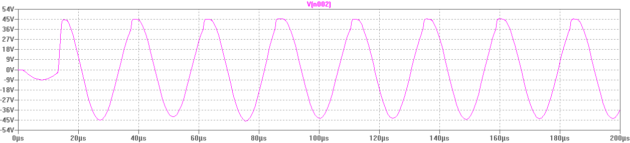
Figure 4.0: Output of Oscillator

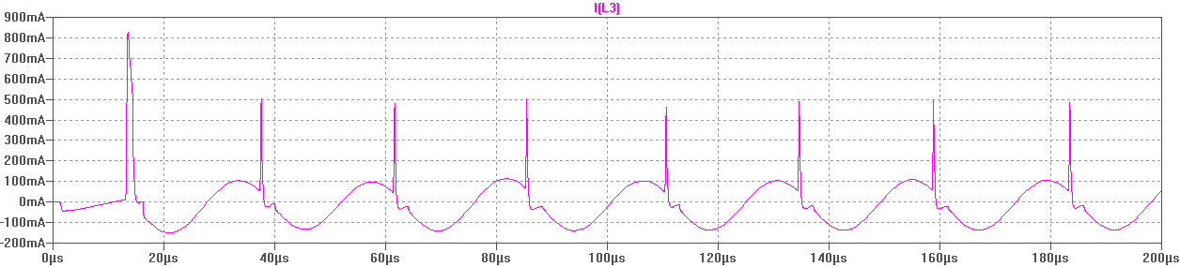
Figure 4.1:Current on Output of Oscillator 0.107A_{RMS}

From the output waveforms above we can see that we have a sine wave which is expected. The peak voltage is only 45 volts, although the blocking oscillator depends on the nonlinearity effects of the inductors which cannot be properly depicted in spice simulations. The current wave form has large spikes which is also expected due to the collapsing magnetic fields of the blocking oscillator operation.

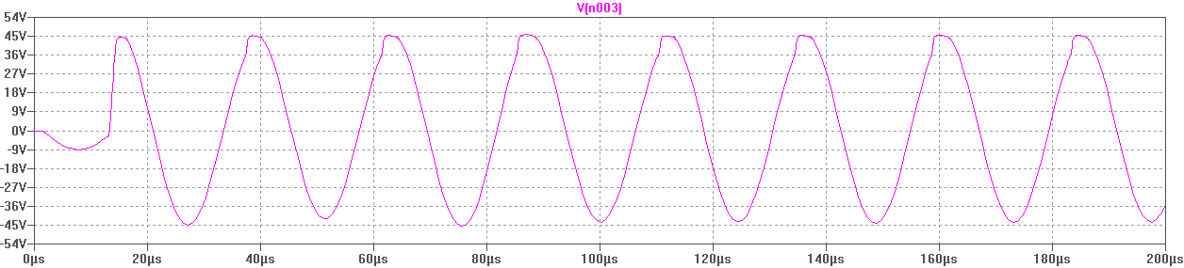
Figure 4.2:Voltage on Primary Coil 30.542V_{RMS}

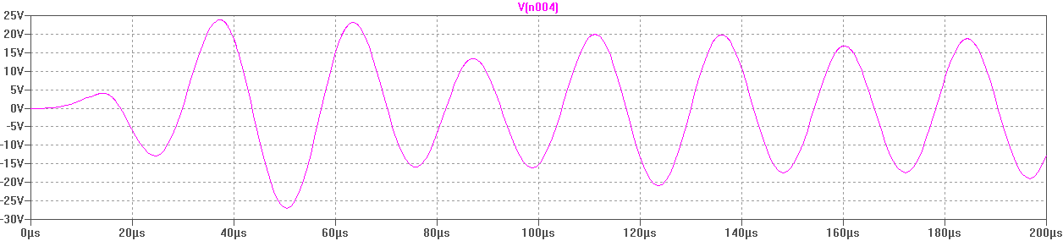
Figure 4.3:Voltage on Secondary Coil 13.084V_{RMS}

The voltages on the primary and second coils are shown and correspond to the expected shapes. The peak voltages are smaller, but this is due to spice not properly representing the inductor action in the oscillator. The frequency is at 41 KHz in the spice simulation while the frequency designed for is only 23 KHz. This inconsistency would be again due to spice using ideal values for the components in the circuit, which is expected in simulations.

Power Measurements and Efficiency Analysis
The blocking oscillator that is used takes a DC source and converts it to an AC source that is used to transmit power across the coils. Taking the power at the input and output of the oscillator we can calculate the efficiency at which the blocking oscillator converts DC power to AC power using equation 11.
$$η_{conversion}=\frac{P_{out}}{P_{in}}\left(100\right)$$
(EQ. 11)

We can also look at the efficiency at which the coils transmit power from one to the other. Due to the coupling coefficient of the coils being small we can estimate that the transmission efficiency of the coils will not be very good. If the coils however were closer together then both the coupling coefficient and the efficiency would increase.

Table 1: Power and Efficiency Measurements
 | Simulation |  | Measurements
 | Input | Output | Input | Output
Voltage (V) | 12 | 30.55 | 12 | 117
Current (A_{RMS}) | 0.412 | 0.107 | 0.364 | 0.0613
Power (W) | 4.944 | 3.269 | 4.364 | 7.17
Conversion Efficiency | 66.1% |  | ˃100%*

*In the table above we can see that for the measured values we have a conversion efficiency of greater than 100%. This value is wrong due to our inability to measure the current coming from the power supply. We measured the voltage across a 0.5Ω resistor and found the current flowing into and out of the oscillator. The current from the power supply is not simply DC current. The blocking oscillator causes the current to spike internally and accurate readings could not be achieved.

Coils –Theory and Design

Magnetic Theory

Inductance
The inductance (L) of a conductor can be defined as the ratios of the linking magnetic flux to the current producing the flux. This relationship can be better depicted mathematically:

$$L=\frac{N∅}{I}$$
Where I is the current, N is the number of turns contained in the coil and $∅$ is the magnetic flux. See figure below.
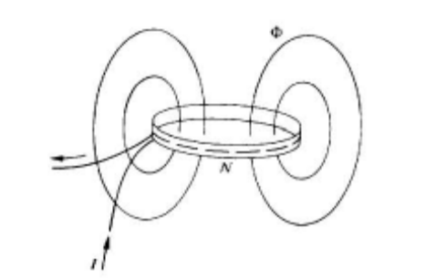

Mutual Inductance
Mutual inductance occurs when two circuits, usually wires or coils of wire, each with its own inductance are magnetically coupled. This coupling occurs when the magnetic flux, produced by the current, in the first coillinks with the second coil and induces a voltage in that coil.
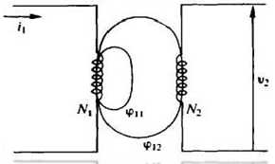
Knowing the current in the first coil, the amount of turns and the flux produced it is possible to calculate the induced voltage in the second coil, the mutual inductance and the relationship between them.
$$V_{2}=N_{2}\frac{d∅_{12}}{dt}=\frac{dλ_{2}}{dt}$$

$$M=N_{2}\frac{∅_{12}}{I_{1}}=\frac{λ_{2}}{I_{1}}$$
$$V_{2}=\frac{d\left(MI_{1}\right)}{dt}=M\frac{di1}{dt}$$

Design
The design of the coils is an important part of the design process. One key aspect that must be satisfied is that the frequency of operation must be below the self-resonant frequency of the coil. This resonant frequency is determined by the self-inductance and self-capacitance of the coil.
$$f_{resonance}=\frac{1}{2π\sqrt{LC}}$$
(EQ. 12)

The self-inductance of the coil can be calculated by Equation 13 for a circular loop air core coil, where d is the depth of the loop, N is the amount of turns, l is the length of the coil and r is the radius of the coil.
$$L=N^{2}μ_{o}r\left(\ln\left(\frac{8πr}{d}\right)-2.45\right)$$
(EQ. 13)

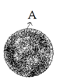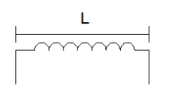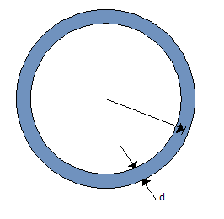
This means that with a longer solenoid and smaller diameter the self-inductance can be minimized. The self-capacitance of the coil must also be considered such that the inductance and capacitance will create a frequency greater than the operating frequency. The self-capacitance is much harder to estimate. The capacitance cannot be directly calculated. The resonant frequency of each must be measured by applying a sine wave through the coil and measuring the output across a resister in series with the coil. Once the resonant frequency is found we can use that frequency in equation 1 and find the self-capacitance of the coil.
One thing to consider if the operating frequency is in the megahertz range is the skin effect. The skin effect is a result of self-induced electro-magnetic force in a wire. This force is strongest at the center of the wire and opposes the flow of current in the wire. With this opposing force in the middle of the wire, the current is pushed to the edges of the conductor. This flow of current around the edges of a conductor and not in the middle is called the skin effect and this effect increases with frequency. As our operating frequency is well below megahertz we will ignore this effect.
We will also consider the gauge of the wire that is used to wind the coils. If the wire is too small then the coils will have a large resistance which will dissipate more power in the form of heat. We can calculate which gauge of wire we need by equation 14.
$$R=\frac{l}{σA}$$
(EQ. 14)

Where l is the length of the wire, A is the cross sectional area of the wire, σ is electrical conductivity and R is the resistance of the wire.

σ=6.0x10⁷ for copper

For a desired resistance we can solve for the area of the wire and convert it into a gauge using the table found in Appendix D. For our design we want the smallest power losses as possible so we will keep the resistance of the coils as low as possible. A value that is commonly used to classify inductors is the quality factor. This is an important measurement in inductors that shows the efficiency of an inductor. No inductor is ideal so there will be losses through the series resistance of the inductor. These losses cause the quality of the inductor to drop. The quality factor is the ratio of its inductance over its resistance at a certain frequency.

$$Q=\frac{ωL}{R}=\frac{2πfL}{R}$$
(EQ. 15)

We want to design for as high a quality factor as possible for both our transmitting and receiving coils. This allows for the minimization of power losses that are undesirable for power transfer applications. Also if it is required that a lower quality factor is desirable then it is very simple to added resistors in series with the inductor.

Lastly, we must also consider the mutual inductance between the coils and the coupling coefficient. The mutual inductance arises when two inductors are magnetically coupled together through magnetic flux linkage. This mutual inductance is not a real physical inductance but it is very important and is modeled as an inductor in theory. This mutual inductance changes the inductance of the coupled inductors positively or negatively depending on the orientation of the inductors. To show the way in which two inductors are affecting each other the dot notation method is commonly used.
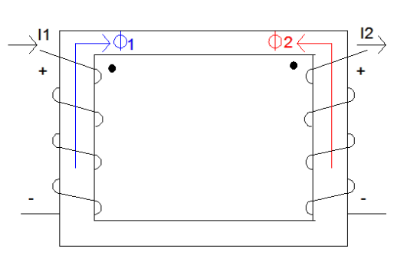
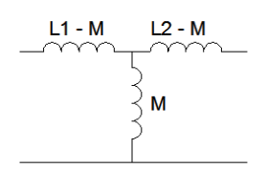
The mutual inductance between two inductors depends on how well the inductors are coupled; it is proportional to the coupling coefficient.

$$M=k\sqrt{L_{1}L_{2}}$$
(EQ. 16)

Where M is the mutual inductance, L₁is the inductance of the first inductor, L₂is the inductance of the second inductor and k is the coupling coefficient.The coupling coefficient of inductors is a measure of how well the flux of one inductor links with the second inductor. In our application of inductors, this measure will tell us how much voltage will be induced in the second coil compared to the amount of voltage in the first inductor. The coupling coefficient will be the highest when the inductors are wrapped around a common core, commonly ferrite, such as in transformers. With an air core, this coefficient is dependent on how close the inductors are to each other, so the farther away they are the smaller the coupling coefficient is and less voltage will be induced.

Application

Table 2: Measured and Calculated Values for the Transmitting and Receiving Coils
 | Primary Coil | Secondary Coil
Turns (N) | 100 | 100
Length (l) (m) | 0.01588 | 0.0143
Radius (r) (in) | 0.07889 | 0.08096
Depth (d) (in) | 0.0127 | 0.0111
Calculated Inductance (mH) | 2.58 | 2.81
Measured Inductance (mH) | 2.57 | 2.8
Calculated Resistance (Ω) | 2.36 | 2.42
Measured Resistance | 2.6 | 3.5
Calculated Quality Factor | 166823.89 | 174838.72
Resonant Frequency (MHz) | 2.3 | 2.2
Capacitance (pF) | 1.86 | 1.87

Sample Calculations:
$$L_{1}=N^{2}μ_{o}r\left(\ln\left(\frac{8πr}{d}\right)-2.45\right) ={100}^{2}μ_{o}(0.07889)\left(\ln{\frac{8π\left(0.07889\right)}{0.0127}}-2.45\right)= 2.58mH$$
$$R_{1}=\frac{l}{σA}=\frac{π\left(0.1476 meters\right)(100)}{\left(6x{10}^{7}\right)(π{0.0003226}^{2})}=2.36Ω$$
$$Q_{1}=\frac{ωL}{R}=\frac{2πfL}{R}=\frac{2π\left(26KHz\right)(2.41)}{2.36}=166823.89$$

When the receiving coil is perpendicular to the transmitting coil, most of the flux lines link with the receiving coil and induce the maximum amount of voltage. As one coil is moved right or left the coil moves out of the range of some of the magnetic field created by the transmitting coil. This causes less flux linkage and less induced voltage on the receiving coil. When the secondary coil is moved further away we can observe a point where the secondary voltage drops to zero and then increases again. This is a result of the receiving coil being in the center of the flux lines where all the flux travels around the coil. Then when the coil is moved further it will again link with some of the flux lines that are returning to the transmitting coil.

Graph 1: Voltage on the secondary Coil with Respect to the Horizontal Distance Away From the Primary Coil
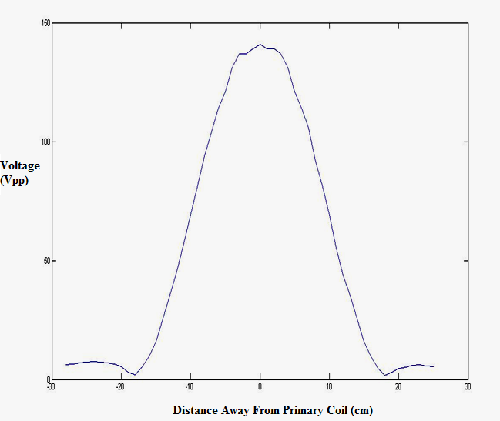
Where positive distance values refer to the distance to the right of the primary coil and negative distance values refer to distance to the left of the primary coil.We can observe from graph 1 that once the coil begins to leave the effective magnetic field, the voltage on the secondary coil drops rapidly. Once the coil comes out of the magnetic field dead zone we can see that the induced voltage is very small. This small voltage is due to the fact that at that distance the coil is now within only a small part of the magnetic field. This movement of the coil within the magnetic field is represented in the figure below.
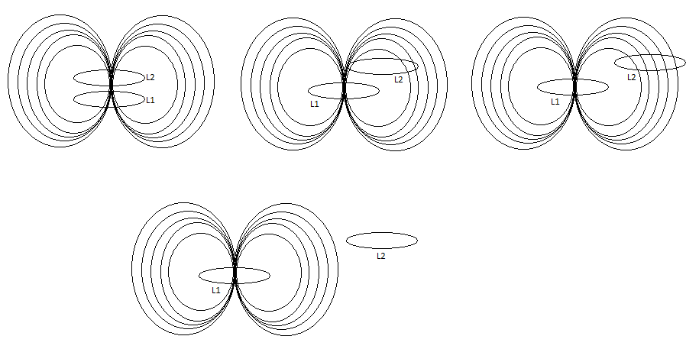
Figure 5.0: Coil Movement

Coupling coefficient and Mutual inductance
When one inductor is inducing a voltage in another inductor it is due to the magnetic field generated by the first inductor. This means that the inductors are coupled together. This coupling between the inductors is modeled by the coupling coefficient, a value between 0 and 1. The inductors inside transformers have a common magnetic core that provides a high coupling coefficient. In wireless power transmission, the transmitting and receiving coils can be modeled as an air core transformer. Without the magnetic core between the coils, we can expect the coupling between the coils to be very weak. This coupling coefficient is defined as K.
$$K=\frac{L_{12}}{\sqrt{L_{11}L_{22}}}$$
(EQ. 17)

Where L₁₂ is the mutual inductance, L₁₁ is the self-inductance of coil 1 and L₂₂ is the self-inductance of coil 2. From magnetic circuit theory we can relate the voltages and currents of the coils to the inductances.
$$V_{1}=L_{11}I_{1}+L_{12}I_{2}$$
$$V_{2}=L_{12}I_{1}+L_{22}I_{2}$$
Where V₁ is the voltage across coil 1, I₁ is the current in coil 1 and V₂ and I₂ are the voltage and current of coil 2. Putting these three equations together we can find the coupling coefficient with respect to the voltages and self-inductances of each coil.
$$\frac{V_{2}}{V_{1}}=K\sqrt{\frac{L_{2}}{L_{1}}}$$
(EQ. 18)

When measuring the coupling coefficient and mutual inductance of the coils we need to know the voltages and currents on both of the coils. To measure the current flowing through the coils we added 8.2Ω resisters in series with the coil. We will measure the voltage across the resister using the oscilloscope and calculate the current. One problem that was encountered when attempting to measure the current was that the LED light bulb introduced a reactive load. The current in the primary was a clean sine wave as expected but the current on the secondary was large spikes with an exponential falling edge. Due to the internal circuitry and LED components of the bulb, the light bulb is a nonlinear load. To get an accurate measurement on the secondary coil and compare it to the primary we must replace the light bulb with a linear, resistive load. To get an approximate linear load for the light bulb we used ohms law to calculate a resistance with the RMS voltage and current on the light bulb.

Results and Measurements

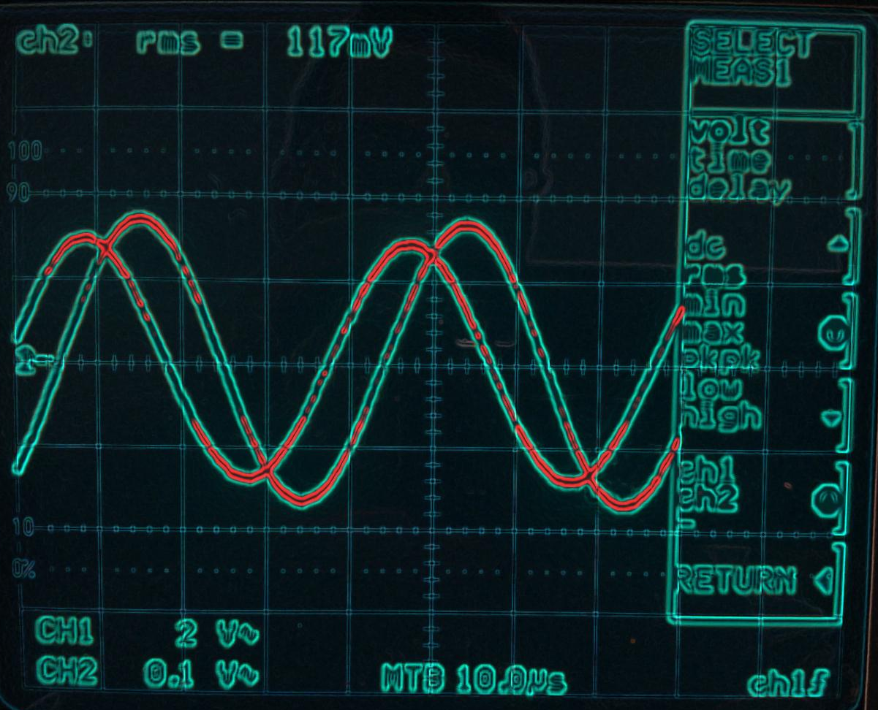
Figure 6.0: Measured Wave
The picture above is the oscilloscope waveforms we achieved when measuring the circuit. The waveform from channel 1 was taken across the Input coil and the waveform from channel 2 was taken from across the 8.2 ohm resistive load. We used this voltage reading across the 8.2 ohm resister to calculate the current being drawn from our circuit to the output.

$$R=\frac{V}{I}=\frac{51.6V_{RMS}}{15.61mA_{RMS}}=3.305KΩ$$
Replacing the light bulb with this resistive load we get a non-distorted sine wave for the current and voltage on both the primary and secondary coils. We can now measure and compare values to analyze how the coils react to one another.

Table 3: Measured Voltages and Currents of the Coils Using Resistive Load
12V Supply | Coil 1 | Voltage Across Coil (V_{P-P}) | 290
12V Supply | Coil 1 | Voltage in 8.2Ω Resistor (V_{P-P}) | 5.66
12V Supply | Coil 1 | Current (A_{RMS}) | 0.244
12V Supply | Coil 2 | Voltage Across Coil (V_{P-P}) | 121
12V Supply | Coil 2 | Voltage in 8.2Ω Resistor (V_{P-P}) | 0.338
12V Supply | Coil 2 | Current (A_{RMS}) | 0.01457
6V Supply | Coil 1 | Voltage Across Coil (V_{P-P}) | 167
6V Supply | Coil 1 | Voltage in 8.2Ω Resistor (V_{P-P}) | 3.41
6V Supply | Coil 1 | Current (A_{RMS}) | 0.147
6V Supply | Coil 2 | Voltage Across Coil (V_{P-P}) | 70.7
6V Supply | Coil 2 | Voltage in 8.2Ω Resistor (V_{P-P}) | 0.203
6V Supply | Coil 2 | Current (A_{RMS}) | 0.00875

Using the values from Table 3 and equations 15, 17, and 18 we can calculate the Coupling Coefficient and the mutual inductance. For greater accuracy we will calculate for two different supply voltages and take the average.

Table 4: Coupling Coefficient and Mutual Inductance
 | Coupling Coefficient | Mutual Inductance (mH)
12V Supply | 0.3997 | 1.072
6V Supply | 0.4056 | 1.088
Average | 0.4027 | 1.08

Sample Calculations:
$$\frac{V_{2}}{V_{1}}=K\sqrt{\frac{L_{2}}{L_{1}}}→K=\left(\frac{V_{2}}{V_{1}}\right)\left(0.95805\right)=\left(\frac{121}{290}\right)\left(0.95805\right)=0.3997$$
$$K=\frac{L_{12}}{\sqrt{L_{11}L_{22}}}→L_{12}=K\sqrt{L_{11}L_{22}}=0.3997\left(0.002683\right)=1.072 mH$$

Resonant Frequency, and Inductor/Capacitor values
The coils have a self-inductance and self-capacitance which will be resonant at a high frequency. However to have the coils operating under the desired frequency of 23 kHz, either additional capacitance or inductances must be applied to the coil. Deciding on a fixed value for inductances (self and mutual), the capacitance required can be calculated as:
$$\left|X_{L}\right|=\left|X_{C}\right|$$

$$2πfL=\frac{1}{2πfC}$$

$$f^{2}=\frac{1}{{\left(2π\right)}^{2}LC}$$

$$f=\frac{1}{2π\sqrt{LC}}$$

$$C=\frac{1}{{\left(2π\right)}^{2}Lf^{2}}$$

Table 5: Resonant Capacitance
 | Primary Coil | Secondary Coil
Frequency (kHz) | 23 | 23
Self-Inductance (mH) | 2.57 | 2.8
Total Capacitance Required | 18.9nF | 12.7nF

Transmitting Efficiency

Table 5A: Transmitting Efficiency
 | Resistive Load | LED Lightbulb Load
Primary Voltage (VRMS) | 102.53 | 117
Secondary Voltage (VRMS) | 42.78 | 53
Primary Current (ARMS) | 0.244 | 0.0613
Secondary Current (ARMS) | 0.014 | 0.0129
Primary Power (W) | 25.02W | 7.17
Secondary Power (W) | 0.623W | 0.6837
Transmitting Efficiency (%) | 2.49% | 9.54%

Controls

Controller
Arduino Duemilanove with ATmega168 chip is an open-source microcontroller, which was specifically designed to make the process of using electronics in multidisciplinary projects more accessible and cost effective. The Arduino board is an open hardware design using an Atmel AVR processor with on-board inputs and outputs for the user to use as they see fit. The Adriano also consists of a standardized programming language compiler and boot loader, so the user knows that their written program will run at its optimal efficiency. The Arduino hardware is programmed using a C++ based language, which uses its own syntax, libraries, and modules specifically designed to assists in electronic projects. Thus, because of the reasons given above our group felt that the Adruino would be the perfect controller substitute to the Allen Bradley PLC.
The Arduino board has an 8-bit Atmel AVR microcontroller. The difference with the Arduino over other microcontroller is that its nicely organized digital/analog (input/output) connectors are exposed, which allows the CPU board to be connected to a variety of interchangeable add-ons quickly and easily. The Arduino boards also include a 5 volt linear regulator. It is pre-programmed with a boot loader that controls the uploading of programs to the on-chip’s flash memory, unlike other devices which need an external programmer. The version of the Arduino Duemilanove with ATmega168 that was used by our group had 16KB of flash, 0.5 KB of EEPROM, 14 Digital inputs and outputs, 6 Analog inputs, and lastly it used USB in order to upload the program to the board.
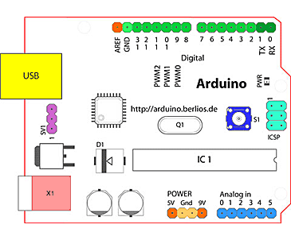
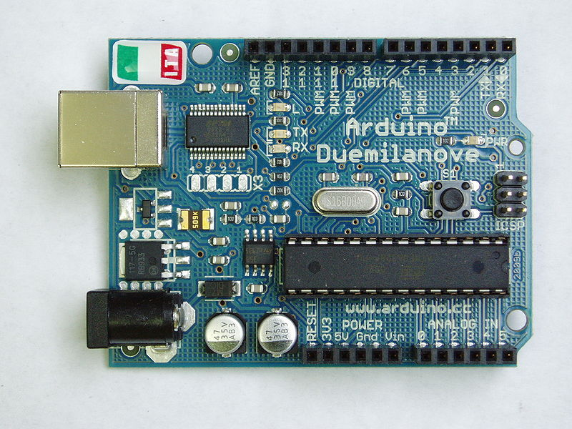

Figure 7.0 : Arduino schematic

Programming Block Diagram

If

Motor moves forwardcommand is given
Right Limit Switchis triggered
Main Platform is Moved To the right

Motor Run Request
Else If

Motor moves reversecommand is given
Main Platform is Moved To the Left
Left Limit Switchis triggered

Else If

Right Limit Switchis triggered
Main Platform is aligned with secondary platform

Motor Stop Request

Left Limit Switchis triggered

H-Bridge
An H-bridge is an electronic circuit which enables DC electric motors to be runforwards or backwards. The one in this project was built using relays to attain the figure below
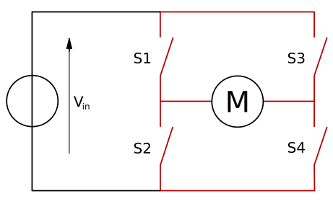
Figure 7.1: H-Bridge
The DC motor in our project was used in order to align the two coils because this is when the magnetic field is its strongest and the maximum power can be transferred. The term "H-bridge" is derived from the typical graphical representation of the circuit. An H-bridge is built with four switches, in our case two relays circuits where used. By looking at the diagram, when the switches S1 and S4 are closed and S2 and S3 are open this will cause a positive voltage to be applied across the motor. Now if S1 and S4 switches are opened and S2 and S3 switches are closed, this voltage is reversed, allowing reverse operation of the motor. Switches S1 and S2 should never be closed at the same time, as this would cause a short circuit on the input voltage source and likewise goes for switches S3 and S4, this condition is called as shoot-through. In addition to making a motor move forward and backwards an H-Bridge allows the motor to brake by closing switch S2 and S4, this causes the motorto come to a sudden stop.

Limit switches
Limit switches where chosen in order to tell the micro controller whether the platform was moving left or right. Limit switches were also chosen because of their ease of use, and the fact that they were more cost effective then proximity sensors or other types of sensors. The limit switches that were used in our project were offset so that one would be on (binary ‘1’) while the other is off (binary ‘0’). This was done so that the control would know which switch was on first so it would drive the motor in the prober polarization (forward (positive voltage)/reverse (negative voltage)).
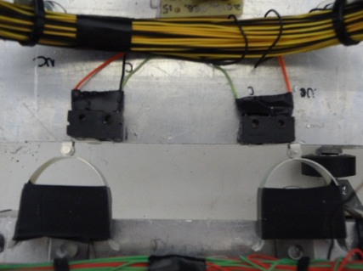
Figure 7.2: Limit Switch configurations

Arduino Code

Original
// constants won't change.
// set pin numbers:
const int sensorHomePin = 2; // the number of the first home sensor's pin
const int sensorAwayPin = 4; // the number of the first away sensor's pin
const int motorReversePin = 12; // the number of the motor relay for reverse motion
const int motorForwardPin = 8; // the number of the motor relay for forward motion
const int ledPin = 13; // the number of the LED pin
// variables will change:
int homeState = 0;
//int homeState2 = 0; // variable for reading the motor status
int awayState = 0;
//int awayState2 = 0;
void setup() {
// initialize the LED pin as an output:
pinMode(ledPin, OUTPUT);
pinMode(motorReversePin, OUTPUT);
pinMode(motorForwardPin, OUTPUT);
// initialize the pushbutton pin as an input:
pinMode(sensorHomePin, INPUT);
pinMode(sensorAwayPin, INPUT);
}
void loop(){
// read the state of the pushbutton value:
//buttonState = digitalRead(buttonPin);
homeState = digitalRead(sensorHomePin);
awayState = digitalRead(sensorAwayPin);
//awayState2 = digitalRead(sensorAwayPin2);
// check if the pushbutton is pressed.
// if it is, the buttonState is HIGH:
if ((homeState == LOW) && (awayState == HIGH))
{
// turn forward motor relay on:
digitalWrite(motorReversePin, HIGH);
digitalWrite(motorForwardPin, LOW);
digitalWrite(ledPin, LOW);
}
else if ((homeState == HIGH) && (awayState == LOW))
{
// turn reverse motor relay on:
digitalWrite(motorForwardPin, HIGH);
digitalWrite(motorReversePin, LOW);
digitalWrite(ledPin, LOW);
}
else if ((homeState == HIGH) && (awayState == HIGH))
{
// turn reverse motor relay on:
digitalWrite(motorForwardPin, LOW);
digitalWrite(motorReversePin, LOW);
digitalWrite(ledPin, LOW);
}
else
{
//Do Nothing
digitalWrite(ledPin, HIGH);
//digitalWrite(motorForwardPin, LOW);
//digitalWrite(motorReversePin, LOW);
}
}

Modified Arduino Code
Upon testing of our project it was discovered that further modification to our program was necessary, so that the wireless power can be better demonstrated. The new program better depicts what happens as the two coils come closer to being aligned (light bulb gets brighter). Below is the modified program that allows the user to move the platform from one extreme of the rail to the other, so to better demonstrate what happens when the coils are really far from each other. _____________________________________________________________________________
// constants won't change. They're used here to
// set pin numbers:
const int sensorHomePin = 2; // the number of the first home sensor's pin
//const int sensorHomePin2 = 4; // the number of the second home sensor's pin
const int sensorAwayPin = 4; // the number of the first away sensor's pin
//const int sensorAwayPin2 = 8; // the number of the second away sensor's pin
const int motorReversePin = 12; // the number of the motor relay for reverse motion
const int motorForwardPin = 8; // the number of the motor relay for forward motion
const int ledPin = 13; // the number of the LED pin
// variables will change:
int homeState = 0;
//int homeState2 = 0; // variable for reading the motor status
int awayState = 0;
//int awayState2 = 0;
int state = 0;
void setup() {
// initialize the LED pin as an output:
pinMode(ledPin, OUTPUT);
pinMode(motorReversePin, OUTPUT);
pinMode(motorForwardPin, OUTPUT);
// initialize the pushbutton pin as an input:
pinMode(sensorHomePin, INPUT);
//pinMode(sensorHomePin2, INPUT);
pinMode(sensorAwayPin, INPUT);
//pinMode(sensorAwayPin2, INPUT);
}
void loop(){
// read the state of the pushbutton value:
//buttonState = digitalRead(buttonPin);
homeState = digitalRead(sensorHomePin);
//homeState2 = digitalRead(sensorHomePin2);
awayState = digitalRead(sensorAwayPin);
//awayState2 = digitalRead(sensorAwayPin2);
// check if the pushbutton is pressed.
// if it is, the buttonState is HIGH:
if ((homeState == LOW) && (awayState == HIGH) && (state == 1))
{
// turn forward motor relay on:
digitalWrite(motorReversePin, HIGH);
digitalWrite(motorForwardPin, LOW);
digitalWrite(ledPin, LOW);
state = 0;
}
else if ((homeState == HIGH) && (awayState == LOW) && (state == 1))
{
// turn reverse motor relay on:
digitalWrite(motorForwardPin, HIGH);
digitalWrite(motorReversePin, LOW);
digitalWrite(ledPin, LOW);
state = 0;
}
else if ((homeState == HIGH) && (awayState == HIGH))
{
// turn reverse motor relay on:
digitalWrite(motorForwardPin, LOW);
digitalWrite(motorReversePin, LOW);
digitalWrite(ledPin, LOW);
state = 1;
}
else
{

//Do Nothing
digitalWrite(ledPin, HIGH);
//digitalWrite(motorForwardPin, LOW);
//digitalWrite(motorReversePin, LOW);
state = 0;
}
}

Power Supply design

Power Supply
The basic design of a power supply is as follows. The circuit input is applied from a wall outlet at 120V AC 60Hz. It is then passed through a step down transformer that lowers the voltage down to an amount that can be regulated. The regulated voltage is then passed through a bridge rectifier, or half wave rectifier depending on your design. This will effectively remove the negative sine wave. The rectified voltage is then passed through a series of filter capacitors to flatten out the peaks. A regulator is used to either (a) allow for adjustable voltage control or (b) output a constant voltage. The regulated voltage is then passed through more filter capacitors if required. After this step, the output is a DC voltage.

Regulator
Filter
Bridge Rectifier
Step down Transformer
D.C Output

120V AC
60Hz

Figure 8.0: Power supply

Transformer
Usually, DC voltages are required to operate various electronic equipment and these voltages are 5V, 9V or 12V. But these voltages cannot be obtained directly. Thus the AC input available at the mains supply i.e., 120V is to be brought down to the required voltage level. This is done by a transformer. Thus, a step down transformer is employed to decrease the voltage to a required level. This required level depends on the regulator that is needed for a certain output.

Rectifier
The output from the transformer is fed to the rectifier. It converts A.C. into pulsating D.C. The rectifier may be a half wave or a full wave rectifier.
For the variable 12V power supply, a bridge rectifier was used. The Bridge rectifier is a circuit, which converts an AC voltage to a pulsing DC voltage using both half cycles of the input ac voltage. The Bridge rectifier circuit is shown in the below.
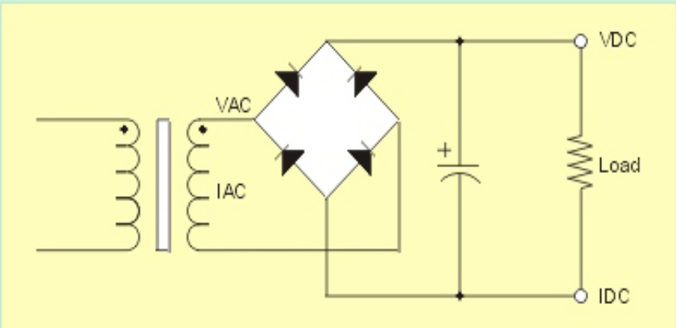
Figure 8.2: Rectifier Circuit
The circuit has four diodes connected to form a bridge. The AC input voltage is applied to the diagonally opposite ends of the bridge. The load resistance is connected between the other two ends of the bridge. In our power supply design, a bridge rectifier chip was used for simplicity.
For the positive half cycle of the input AC voltage, diodes D1 and D3 conduct, whereas diodes D2 and D4 remain in the OFF state. The conducting diodes will be in series with the load resistance R_{L} and hence the load current flows through R_{L.}
For the negative half cycle of the input AC voltage, diodes D2 and D4 conduct whereas, D1 and D3 remain OFF. The conducting diodes D2 and D4 will be in series with the load resistance R_{L} and hence the current flows through R_{L} in the same direction as in the previous half cycle. Thus a bi-directional wave is converted into a unidirectional wave. The pulsating DC voltage is shown below.
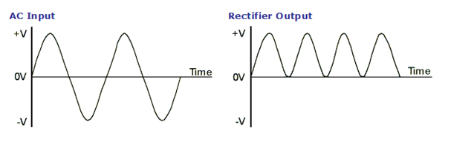
Figure 8.3: Rectifier Circuit
For the +5 and -5 Volt power supply, a half wave rectifier was used. In half wave rectification the positive half cycle of the AC supply is passed through. Due to the fact that only half of the cycle is being used, it is very power inefficient. Half wave rectification can be achieved with a single diode in series with the supply and the load. The circuit for a half wave rectifier is shown below. The output waveform of the half wave rectifier is shown below as well.
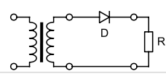
Figure 8.4: Half Wave Rectifier

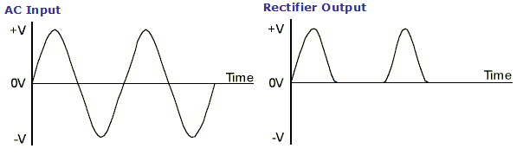
Figure 8.5: Half Wave Rectifier Waveforms

Filter
Capacitive filter is used in this project. It removes the ripples from the output of rectifier and smooth out the DC Output. The way the capacitors work in the circuit is as follows. The capacitor is charged from the pulsing input and then it slowly discharges until the next pulse. The diagram below is the filtered output for half wave rectification.
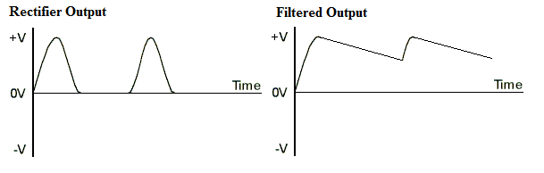
Figure 8.6: Capacitor Filter Waveforms

Voltage Regulator
As the name itself implies, it regulates the input voltage applied to it. A voltage regulator is an electrical regulator designed to automatically maintain a constant voltage level. Certain regulators are adjustable through a potentiometer to set the regulated voltage.
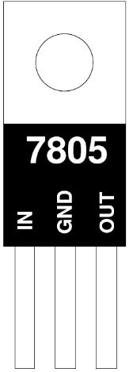
In this project, power supplies of 5V and 12V are required. In order to obtain these voltage levels the 7805 (5 volt power supply), LM337 (positive variable power supply), and LM317 (negative variable power supply) voltage regulators are to be used. The 7805 accepts an input voltage (around 12 volts) and regulates the output voltage to 5 volts. The diagram for the 7805 is shown below.
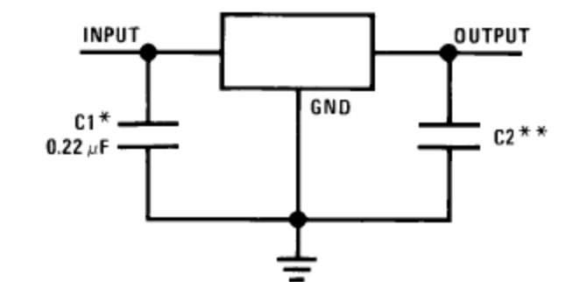

Figure 8.8: Circuit Diagram for LM7805
Figure 8.7: Voltage Regulator

The LM337 and the LM317 regulators accept an input voltage and then, through a potentiometer, is adjusted to the required output voltage. The diagram for the 337 and the 317 are the same and shown below.

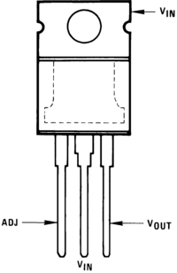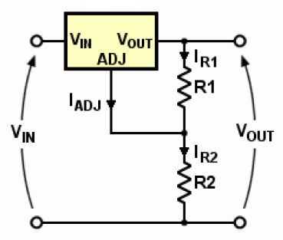
Figure8.10: LM337 Circuit Diagram
Figure 8.9: LM337 Diagram

The L78xx series of three-terminal positive regulators is available in TO-220, TO-220FP, TO-3, D2PAK and DPAK packages and several fixed output voltages, making it useful in a wide range of applications.

These regulators can provide local on-card regulation, eliminating the distribution problems associated with single point regulation. Each type employs internal current limiting, thermal shut-down and safe area protection, making it essentially indestructible. If adequate heat sinking is provided, they can deliver over 1 A output current. Although designed primarily as fixed voltage regulators, these devices can be used with external components to obtain adjustable voltage and currents.

Problems Encountered with the Power Supply

When constructing any circuit, problems are bound to arise. There were not very many problems when building the power supply besides the basic manufacturing errors accustom to any work done by an amateur of the trade. There were however a few obstacles we had to overcome. The first was choosing what type of power supply needed to be built.

Originally we were going to use a positive 12 volts to run the motor in one direction and a negative 12 volts to run it in the opposite direction. Do to the parts on hand we decided to make use of the LM337 and LM317's adjustable capabilities and make the power supplies variable. During manufacturing it was deduced that the code allowed for less wires by utilizing only the positive 12 volts. Since the circuit was already soldered to a printed circuit board there was no use dismantling. A problem we continued to have with the variable power supply was the overheating of the LM337 and LM317 chips. The need for heat control was first noticed when the LM337 chip overheated to the point of destruction. Heat sinks were chosen and applied to these chips so no further damage was had. We decided to implement a LCD screen to measure the output voltage of the 12 volt power supply. This is when we noticed a fatal problem with the supply. The problem was that when the supply was loaded, it no longer provided the voltage and current required for the load. We tested the voltage at every point of the circuit and found that when the voltage passed through the voltage regulator, it lost all its power. This was due to a resistor not being connected to the solder dollop on the board. We re-soldered and after that the supply was able to be loaded. After countless problems with soldering and the rearranging of the power supply in the case we finally had it working and in place.

The next power supplies we had to build were to isolated 5 volt power supplies. The isolation was needed due to the fact that only one relay can be powered at a time. To achieve this two circuits were built for the 5 volts. They were identical and utilized the 7805 chip. There was only one problem we encountered and that was the need for a fuse in the circuit to protect our Arduino microprocessor. We were worried that a surge in current would cause the Arduino to be damaged if not protected.

Cost Analysis
Circuit/Component | Part | Amount | Price
Oscillator Circuit | Transformer C.T. | 1 | 15.00
 | Capacitor – 2.7nf, 0.015uf | 5 | 00.50
 | Potentiometer | 1 | 00.75
 | FJE 3303 | 1 | 01.60
Code Circuit | Arduino | 1 | 25.00
 | Relay – DSY2Y-S-20SL | 2 | 08.00
 | Resistor | 2 | 00.10
 | PCB | 1 | 02.00
 | Arduino Case | 1 | 10.00
Power Supply | 1000uf capacitor | 2 | 00.28
 | 1KΩ resistor | 2 | 00.10
 | 10uf capacitor | 2 | 00.20
 | LM7805 | 2 | 01.44
 | 0.01uf capacitor | 2 | 00.10
 | Yellow LED | 2 | 00.57
 | Silicon rectifier diode | 4 | 00.12
 | PCB | 3 | 06.00
 | 2200uf capacitor | 2 | 01.60
 | 1uf capacitor | 4 | 00.10
 | 100uf capacitor | 2 | 00.60
 | Potentiometer | 2 | 09.00
 | 240Ω resistor | 2 | 00.10
 | Bridge Rectifier | 1 | 00.73
 | LM317 | 1 | 00.80
 | LM337 | 1 | 00.76
 | 32V C.T. transformer | 1 | 28.00
 | Heatsink for regulator | 4 | 12.00
 | Case | 1 | 15.00
 | LED Screen | 1 | 03.00
 | Jacks and knobs | 8 & 2 | 06.00
Motor and support | Motor – 097001.008 E570 | 1 | 50.00
 | Supports, gear, and belt | 1 | 50.00
 | Board | 1 | 10.00
Coils | Primary and Secondary | 1 | 08.00
Miscellaneous | Conduit, screws, wire, etc | N.A. | 10.00
Total: |  |  | $ 277.45

Future considerations

Advantages of a PLC over a microcontroller
The original design had included an Allen Bradley programmable logic controller (PLC) (please see appendix for proposal) but due to the lack of promised funding from the Engineering Equipment Endowment Fund, this was not possible. The group felt that a PLC would have great benefits over a microcontroller not only give the group real world experience, but also give use more advantage and sophistications on our project. Another advantage of having a PLC over a microcontroller is that PLCs are very adaptable and dynamic during a live process. PLCs contain input and output devices that can be compatible industrial pilot devices and controls and because of this fact it can reduce the amount of electrical design required in a project. For instance, single PLC can be programmed to replace thousands of relays. A microcontroller-based design is used when many units of a product will be made, and the level of sophistication and dynamic program changes is not required. PLC can also be dynamically upgraded by adding more memory if need or more input and output cards as need for added flexibility to a project. PLCs are also easier to network, which also make it another powerful reason why one would use a PLC over a micro controller. PLC programs are written in a special application on a personal computer, which can be programmed with ladder logic which is a much easier to visualize and troubleshoot a system. As one can see bellow one can watch what is happening in the process in real time.
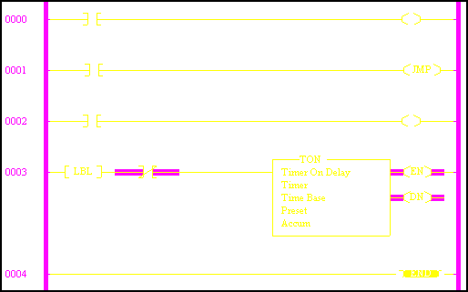
Figure 9.0: Sample Allen Bradley PLC program
The PLCs use a battery-backed-up RAM or some other non-volatile flash memory in order to save the program. For, all these reason this is why a PLC would have been the optimal controller to be used for this project and for Lakehead University.

Safety Limit switches
Some future consideration for the project would be to add some fail safe limit switch at the two extremes of the rail. Although the controller does not permit the motor to drive the base to the extremes of the rail it should be consider that the controller could one day fail. The controller could fail for a number of issues such as a power surge could destroy one of the inputs on the board, which would cause a program failure. This failure could lead the controller would drive the motor to the extreme of the rail cause damage to the motor and overall project. Thus, the limit switch should be hardwired directly to the power of the motor so if this scenario should occur it would stop the motor.

Variable Motor
Additional controls could have been done in order would be to vary the speed of the motor. This would have been done using two magnetic proximity sensors, one on the main base and one on the moving base. By using the analog input on the Arduino the controller could have sense the change in magnetic field between the two proximity sensors and it doing so it would vary the speed of the motor. The weaker the field would have gotten the fast the motor would run and the stronger the field would have become would slow down the motor until a per determined signal would stop the motor once it was attained.
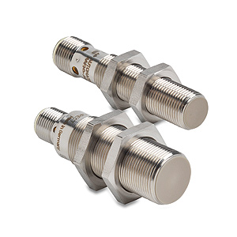
Figure 9.1: Magnetic Proximity Sensors

Battery Charging
A rechargeable battery could be added to the system, which would be able to power the project. The battery could be recharged by the coilsin our project. The purpose of this would be to save on power supplies used. The battery would be able to run both the motor and the Arduino when it is fully charged by the coils.There would be a LED indication in order to tell the user that he or she may now move the coils so now the battery may run both the motor and Arduino. The Arduino can also be used in order to optimize the battery usage and monitor the overall performance of the battery and display it to the user.

Motor
Battery Source
LED Indication
Coils
Arduino

Sociological Impact

Heath Issues
The Health Issues accompanied with Wireless Power Transmission
The health risks and benefits of the effect of Electromagnetic waves is a subject that society is just becoming aware of. Many studies have been done on Wireless Power Transfer and how it can affect the human body. We will begin with a look at the different types of electromagnetic waves and where their origin is.
The ITU Radio Bang Symbols have twelve different levels for electromagnetic fields. The first is Extremely Low Frequency (ELF). The frequency corresponding to this level, electromagnetic radiation, is from 3 to 300 Hz with a wavelength from 100,000 to 1000 kilometres. ELF waves are generally generated from lightning and natural disturbances in the Earth's magnetic field. Due to the difficulty in manufacturing transmitters that can generate such long waves, ELF has only been using in a few manmade communication systems. The frequency that alternating current flow in electric power grids falls within the ELF range and are a source of ELF radiation. Although there are many concerns about such low frequencies being carcinogenetic, there is not enough concert proof to provide credence to these claims. The next frequency range is known as Ultra-low Frequency (ULF) which is pertaining to 300 Hz to 3 KHz. This type is generally used in communications for mines as it can penetrate the earth. This frequency range is also used for the transmission of speech and is referred to as voice frequency. As can be assumed these frequencies are generally considered to be safe. The Very Low Frequency Range (VLF) is from 3 to 30 KHz with wavelengths from 10 to 100 kilometres. Very few systems use VLF such as radio navigation, government time radio stations and military communications. VLF's are also used for communication with submarines due to their ability to penetrate saltwater to about 40 meters. Low frequency or low frequency (LF) refers to radio frequencies in the range of 30 - 300KHz with wavelength from 1 to 10 kilometres. It is generally used in NA for aircraft beacon, navigation and weather systems although many parts of Asia use this frequency range for their AM radio. Due to their low frequency and long wavelength, the signals can refract over obstacles and follow the curvature of the earth. Radio signals below 50 KHz are capable of penetrating the ocean depths to approximately 200 meters.
Medium frequency (MF) refers to frequencies in the range of 300 KHz to 3 MHz with a range of 1,000 to 100 meters. In North American and Europe, the MF frequency band is sued for AM radio broadcasting. Many home phones produced in the 1980's where designed in this frequency range (1600 to 1800 KHz).
Radio frequencies in the range of 3 to 30 MHz are known as High Frequency (HF) and run on wavelengths from 10 to 100 meters. Amateur and personal radio operators and CB operators are the general users of this frequency range due to its ability to produce worldwide communication at optimum factors. Very high frequency (VHF) is in the frequency range from 30 MHz to 300 MHz. The common uses for VHF are FM radio, television, land mobile stations, and long range data communication such as amateur radio and air traffic control. These are the frequencies that our bodies are being bombarded with on a daily bases. Most countries have different ranges that they sue for different uses in this band. Ultra-high frequency (UHF) is in the range of 300 MHz to 3 GHz and is in the wavelength range from 10cm to 1 meter. UHF is widely used in two way radio systems and cordless phones where transmission and reception antennas are closely spaced. Super High frequency (SHF) refers to radio frequencies in the range of 3 to 30 GHz with wavelengths range from 10 to 1 centimeters. It is generally used in microwave devices, WLAN, and most modern radars. The innovative wireless usb technology is said to use this frequency range. Extremely High frequencies (EHF) are in the range of 30 to 300 GHz with a wavelength of 10 to 1 millimetres. It is generally used in scientific research, telecommunications, weapons systems, and security screening. Some research is being done (mostly in the former USSR) for the use of frequencies in the range f 40 to 70 GHz in human medicine to fight diseases. More than a million people have been successfully treated with millimeter Wave (MMW) therapy.

Table 6: Range of Frequencies
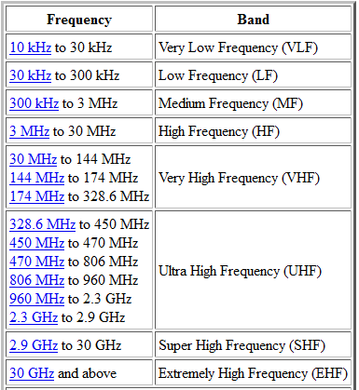
Now the health risk will be taken into account. Before any more information is given about the health risk of Wireless power transfer, it is to be known that many of these studies are not yet proven and are based on scientific hearsay. A group called ElectroSensitivityUK is campaigning for greater awareness of electro-sensitivity. According to this group, some people are hypersensitive to electromagnetic radiation. Many people have been claiming the wireless signals in their home have been causing them to feel ill. The symptoms include nausea, exhaustion, headaches, sleeplessness, stomach pains, and short-term memory loss. This group is not the only coalition that is worried about electro-magnetic waves, many scientists have studied the issues although, and they are receiving contradictory results. Dr. David Carpenter believes that up to 30% of all childhood cancer comes from exposure to EMFs. In 1989, the Department of Energy released a statement "It has now become generally accepted that there are, indeed, biological effects due to field exposure." Even Sweden has completed studies showing the negative effects of EMF. The Swedish government has come up with a safety limit for exposure to Extremely Low Frequency Magnetic Fields at 2.5mG and a Very Low Frequency at only 0.25mG. Although these frequencies are extremely low in electronics, in certain cases, people could be at risk.
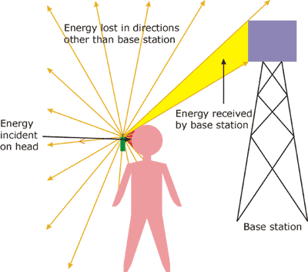
Figure 20.0: Health effects
Although there are many people and countries pulling together to fight for awareness about EMF, there are many scientists that believe it isn't a risk to the public. This view is adopted by governments around the world. The view is that waves emitted from devices in the likes of wireless routers and mobile phones are harmless. Ed Mantipy, of the FCC's radio frequency safety program, is quoted saying "There is no conclusive evidence that electromagnetic fields hurt health. We have a standard exposure, which is essentially like a speed limit - there's no guarantee that you are safe below it or above it." The ability to measure how much radio frequency energy is absorbed by living tissues was issued to the IEEE and the NCRPM. The SAR is measured in watts per kilogram. A value of 1.6W/Kg is said to be the limit for American citizen’s bodies. This value unfortunately is hard to measure on personal products. A cell phone is believed to emit 1.6W/Kg, hence making them safe.
The worry for the project we have built is that it runs at such low frequencies. Most home phones and wireless routers run at a frequency of 2.8 - 5.6 GHz where our project is in the kilohertz. Are the health issues with EMF's worse at lower frequencies? The project in questions runs at Low Frequency (range of 30KHz - 300KHz). There have been studies done on power lines which emit an extremely low frequency that they may be the cause of cancer. This seems to make the argument that the low the frequency the worse of the field but very little research has been done in this area. It is subject to common belief that the safe frequency range is in the middle of the extremely low and high frequency bands. It is good to point out that there may be some space for improvement in the health of humans and the environment due to electromagnetic waves. It has been proven that emissions from fuel burning cars and factories that produce energy can cause harm to humans and the environment. This being said, any new technology that can reduce the amount of pollution being produced is a benefit to human health. This means that if Wireless power transfer did come into play with solar power and electric car charging, the amount of energy needed to be produced from these power plants and the amount of emissions given off from cars would be decreased. This in turn would improve the health of the environment and the living creatures in it. It is just a matter of time until the final say is made of electromagnetic fields and if they will be the future or the death of us.

Applications in Industry
Wireless Power Transfer in the World
In this section we will explain the future of wireless power transmission (WPT) and how it can be used in industry, personal use, and space. Although the wireless power transfer device we have built is a basic conceptual version of the ones that we will be explaining, this section will explain the ideas of wireless power transfer using coils emitting electromagnetic waves to transfer the energy and microwave power transmission (MPT) and how it can be used in the future.
We will firstly discuss the use of wireless power transmission in the home and personal use. We have already seen the starts of home use with the new wave of technology allowing for the user to charge their cell phone devices wirelessly through an inductive pad and a receiver attached to their phone. The product in question was not well received due to the user having to place a bulky case on their phone. In innovation in this technology has been uncovered that they are going to be implementing a small chip attached to the battery in cell phones now that will work automatically with induction charging. This technology is being furthered advanced to allow for powering a television, for example, wirelessly. A device would have to be placed on the wall or close by that is attached to an outlet. The television would have a receiver that would power to television. The problem with powering a television is that it requires an abundance of power, more than most sizeable induction charging stations can perform. A larger transmitter and receiver may be needed and this could cause for the product to not be m=placed n market for a long while. This technology allows for many future advances in home use leading up to mounting of lights in any room of the house without having to track wires through the walls. Although this concept is far away, it may be closer then we think. The only problem holding back the home and personal use of Wireless power transfer is the distance required to transfer the power. For the charging of the cell phone mentioned above, the cell phone needs to be extremely close if not touching the "power mat." The way to get around this is larger coils and larger transformers allowing for a further distance of power transmission. The technology needs to be advanced and tweaked, not unlike the advancements in CMOS technology, to make them smaller and easier to implement in the home.
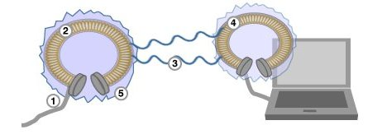
Figure 11.0: Computer Charging
We will next look at the industrial implications of Wireless power transmission and microwave power transmission. As mentioned above Wireless power transmission can be used to mount lights and wirelessly powered devices from a distance. This concept can also be used in industry such as in factories where lights need to be mounted in hard to reach areas that would otherwise cause a drawn out wiring job. In the mining industry lights are connected through wires that are strung up throughout the mine. If the use of wireless power transfer could allow these lights to be lit up wirelessly, it would allow for much easy and faster mining production. One idea that has come up in industry is the concept of having solar panels in space floating around the earth in an orbit and being able to send the electricity gathered down to earth for use. In recent years, Japan has been planning to send its first solar-panel-equipped satellite into space which will have the ability of wirelessly beaming down Gigawatt-strong streams of power. There is said to be enough energy produced by this satellite to power 300,000 homes eco-friendly. The satellite will transfer its power via microwaves down to a station on earth. The system should be fully operational within the next two decades. The only problem foreseen for us is that the energy will have to be sent down through microwaves which may have an unknown effect on the earth's atmosphere causing severe problems. Another interesting way of using Wireless power transfer is in business. The potential applications of using a wireless resonant link for easy access in business are growing. The system could be used for wireless charging or laptops and cell phones in businesses while the devices are being used. This would free up a lot of space in a company allowing them to be more efficient in their offices. This idea could also be used in school campus and libraries, as well as many other tech happy institutions. The students could work on their laptops without ever having to worry about being beside an outlet.

The last applications we want to talk about is speculation but could be done in the near future. It is more in the realm of transportation. An idea that is had is the use of Wireless power transmission for the development of long range cars. Electric cars could be charged through Wireless power transfer from microwave generators in the roadway while the vehicle is travelling on the highway. This would reduce the number of stops that are needed while travelling long distances. The use of electricity instead of gasoline or diesel in vehicles that travel extremely long distances on a regular occasion would reduce the emission from vehicle drastically. This is especially true if this was used in major cities where rush hour traffic causes a mass amount of cars to be idle for long periods of time. They could all remain powered and in place without wasting fuel. Another concept is long endurance aircraft. The use of MPT could keep airplanes in a desired location for long periods of time for surveillance. The world's first fuel free plane powered by microwave energy broadcast from the ground was tested in Canada in 1987. This system was called the Stationary High-Attitude Relay Platform (SHARP). These ideas of transportation seem well and good but they only remain helpful for the environment if the energy they use can be harvested from a renewable source like the sun. This gives more credence to the use of the solar satellite mentioned above.

In the area of innovation using Wireless power transfer and microwave power transfer, the sky is literally not the limit. In the future I would expect to see Wireless power transmission in every home. The wiring of houses will be in the past and wireless power transfer will be the main system used. With the countries growing need for power, the Solar Power Satellite is needed for a renewable source of energy. As the environment finally comes into play as a problem, any new idea to stop the emissions of cars will be at the forefront of technological advancements. These are the reasons why Wireless power transfer and Microwave power transfer is in our future and not as far off as one might think.


Figure 11.1: Vehicle Charging

*Intel first showed off their idea by wirelessly powering a 60 watt light bulb with 75% efficiency in 2008

Conclusion
Lakehead University’s Electrical Engineering program requires the completion of a degree project which demonstrates the analytical and design skills of an engineer while supplementing the practical capabilities of a technologist.

The Wireless Energy Transfer System demonstrates these qualities as it involves the design, analysis, construction, and computer simulation of the following key aspects; Oscillator, Primary and Receiving Coils, Position Control System, and the Power Supply.

For the oscillator, multiple preliminary configurations were considered. Analysis had to be done on each configuration to determine the most efficient oscillator possible. Components for the oscillator were then designed based on circuit analysis, transformer theory, and the load required.The oscillator circuit was built via software in Spice, and the high slew rates required for strong magnetic fields were confirmed by simulation. The results attained from the actual circuit reflect the design and simulations conducted.

Two coils are used to transmit the power wirelessly to the load. These are circular coils that are wound with 22 gauge wire to keep the resistance of the wire low and minimize the amount of unwanted power losses in the circuit. They were designed with a diameter of 15.24 cm and 100 turns so as to optimize the propagating magnetic field, to ensure that the resonant frequency of the coils were greater than the operating frequency of the circuit, and to minimize the size and cost. The transmitting and receiving coils have an air core and with a distance of 10cm between them the coupling coefficient is only 0.4. This low coupling was expected as the coils are separated and the coupling will increase in strength as the distance between them is decreased. The transmitting efficiency is only 9.5% which is also expected with the distance between the coils. Other factors for the coils can also be calculated; the quality factor and mutual inductance. These coils provide a medium through which a magnetic field can be created and a voltage can be induced to achieve the transmission of power.
Creating the position control system the group gained knowledge of programming in a C based programming language. By doing this the group gain some real world experience in to programming a controller and the logic that goes with it. Doing the control system required the group to do some research in to what kind of controller would best fit the project requirements. The group also gained knowledge in sensors, limit switches, and lastly relay logic.

The power supply as a whole was a success. We implemented the power supply with the intent of reducing the amount of lab power supplies used. By building our own power supply we were able to cut out two power supplies we would have to have used in the lab. If the motor did not cause an in-rush current upon starting, we would have been able to use the power supply we built as our only power supply needed. The build we chose for our power supply gave us two segregated five volt supplies from one source instead of two. This allows us to condense our project into a smaller area while using fewer outlets. As stated above, the power supply was successfully built and implemented into our project under our time constraints.

In addition, the possible sociological impact of this Wireless Power System was considered. These considerations ranged from possible hazards to health to other practical industrial applications beyond the scope of this project.

Unique for being the first system of its kind built at this University, it is hoped that future groups will continue to develop on the ideas of this Wireless Power System and continue to improve the reputation of Lakehead University as the forefront of engineering innovation.

Bibliography

Principle of Electronics, V.K Mehtha, S.C Chand & company Ltd, 1980

Bureau of Naval Personnel. Basic Electronics. New York, U.S.A.: Dover Publications Inc., 1963.

Bureau of Naval Personnel. Introduction to Electronics. New York, U.S.A.: Dover Publications Inc., 1965.

Millman, Jacob, and Taub, Herbert. Pulse, Digital, and Switching Waveforms: Devices and
Circuits for their Generation and Processing. New York, U.S.A.: McGraw-Hill Inc., 1965.

Suprynowicz, Vincent A. Introduction to Electronics: For students of Biology, Chemistry and
Medicine. Reading, Massachusetts, U.S.A.: Addison-Wesley Publishing Company, Inc., 1966.

Ketchum and Alvarez. Pulse and Switching Circuits. McGraw-Hill Inc., 1966.

Sadiku. Elements of electromagnetics. Oxford Univ Press-Trade.

Stanley, William D. and M., John. Electronic communications. Thomson Delmar Learning

Appendix A:PLC Proposal

A Proposal For The Purchase Of A Programmable Logic Controller
By Paolo Meleca, Peter Luong, Graham Dube, and Troy Wideman

Introduction

Purpose
We propose the purchase of an Allen Bradley programmable logic controller (PLC) for the use in our Electrical Engineering Degree Project, future projects and laboratory work.

Background
The programmable logic controller is a very important control device that is used in many industries and machines. It is designed to handle multiple inputs and output arrangements that other controllers cannot. It can also handle wide temperature ranges, it is immune to electrical noise, and is able to withstand vibrations and impacts. With these and many more attributes, this controller is very versatile and can be used in many different control systems in the electrical, chemical, mechanical and other engineering fields.

Scope
This proposal addresses only the purchase of one PLC for the students and faculty of the Faculty of Engineering Department at Lakehead University.

Discussion

Approach
Our degree project looks at the wireless transfer of energy between electronic devices. To efficiently transfer energy we will be constructing a tracking system to insure that the device receiving the energy is in the position for maximum power transfer. To accomplish this we will need a PLC for our control system. We chose to use this controller because it is able to handle the multiple sensors that we will be using and higher temperatures that will be present in the system.

Results
The programmable logic controller will provide opportunities for students to learn about controls, microcontrollers, programming, and the use of a widely used controller. Students can also use this in future degree projects to enhance their projects, abilities and ideas through a more advanced controller. To better demonstrate control systems, technologists can use this controller to build better and more detailed systems that students can then study and analyze to improve their engineering abilities. A programmable logic controller will be able to increase the learning potential for students by using it in classes, on projects and in preparation for graduation and entering the workforce. For an electrical engineer to be the best that they can be, they must be familiar with the use, operation and capabilities of a controller that they will encounter at one point in their future career. That is why it is necessary to purchase an Allen Bradley PLC.

Costs

Fiscal
The cost of one Allen Bradley programmable logic controlled is presented in the table below.
Item Name | Supplier | Quantity | Net Price
1766-L32BXBA | Allen Bradley | 1 | $625.35
Student programming licence | Allen Bradley | 1 | $56.25
Total Budget:
Total cost of all Equipment: | $ 625.60
Shipping, Handling, and Fees: | $ 39.85
Taxes: | $71.03
Net Cost: | $736.48

Time
The estimated shipping time for the PLC is 2weeks. After we receive the controller, we will use it in our wireless power transfer project until the end of April 2012. At the end of April, when our project is complete, the PLC will be returned to the office so that future students and faculty can benefit from its use.

Conclusion

The electrical engineering program requires the completion of a degree project, such as the transfer of power wirelessly. To accomplish this task we require an Allen Bradley programmable logic controller for the control system in this project. Not only can we use this PLC in our project but future students can use it in their projects, technologists can use them in setting up displays and electrical systems and other engineering fields can also benefit from it. A PLC will enhance the learning capabilities of students at Lakehead University and provide them with real world experience with controllers. With a reasonable cost, this device will improve the education within the Faculty of Engineering at Lakehead and should be purchased.

Appendix B: Electrical Schematic Diagram of Wireless System

Blocking Oscillator
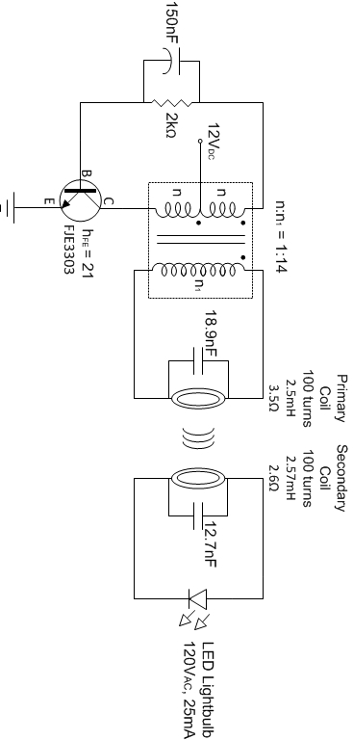

Position Control System

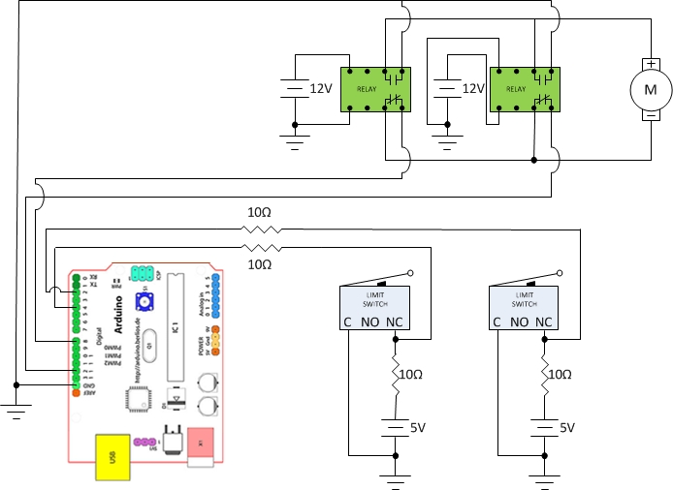

Appendix C: Specification Sheets

