Hops Baler Final Report

Senior Mechanical Engineering Capstone Project
University of Maine

May 9, 2013

Group Members:
Jacob Speed
Matt Gallagher
Sam Ledue
Nate Rocker
Lloyd Bryant

Abstract
Aroostook Hops is a small business located in Westfield, ME that has begun expanding its hops production. There are no current systems out there to efficiently compress hops for shipping that can be used for small-scale hops farmers. The objective of this project is to create a baler that can be used by Aroostook Hops to compress their hops and prepare them to be sealed for sale and transport. The system we designed is able to produce a 5-pound bale of hops by using two stages of compression with electric linear actuators and the final bale is compressed into a vacuum sealable bag. This system takes roughly 3 minutes to create the 5-pound bale of hops, which is very efficient when compared to the 30 minutes it took Aroostook Hops to produce a 3-pound bale of hops. The baler allows Aroostook Hops to package more hops in less time than their previous method. This project will help Aroostook Hops to grow their business and helps to support the economy in Northern Maine.

Contributions

Introduction
Nathan Rocker, Sam Ledue, Matt Gallagher, Jacob Speed

Design Description
Matt Gallagher

Design Concept Process
Sam Ledue

Final Design Testing and Evaluation
Matt Gallagher, Jacob Speed

Conclusion and Future Recommendations
Sam Ledue, Jacob Speed

Solidworks Models
Jacob Speed, Matt Gallagher

Project Website
Lloyd Bryant

Presentation Poster
Nate Rocker, Jacob Speed, Lloyd Bryant

Table of Contents
Abstract ii
Contributions ii
Introduction ii
Design Description ii
Design Concept Process ii
Final Design Testing and Evaluation ii
Conclusion and Future Recommendations ii
Solidworks Models ii
Project Website ii
Presentation Poster ii
Table of Figures iv
1 Introduction 1
Aroostook Hops 1
Benefits of Construction 1
2 Design Description 1
Compression Chamber 1
Bag Chamber 2
Two Stage Compression Method 3
Electric Linear Push/Pull Actuators 4
Base and Frame 5
3 Design Concept Process 7
Size of Bag Chamber and Bale 7
Number of Actuators 8
Dimensions of the Chambers 8
3.1.1 Final Bag Chamber 8
3.1.2 Initial Compression Chamber 8
Types of Actuators 9
Power Source 10
Controller 10
Chamber Materials and Construction 11
Frame Design 12
Compression Methods 13
Mobility 14
4 Final Design Testing and Evaluation 14
Final Design Overview 14
Final Design Operation 15
Mech. Lab Experiment 16
Data and Plots 17
5 Conclusion 23
Capability 23
Additional Utilization of the System 23
Operational Concerns 24
6 Recommendations for future designs 24
Safety 24
Loading Mechanism 24
Future Note 24
7 Appendices 25
Appendix A: Parts Cost List 25
Appendix B: Mechanical Lab Report 26

Table of Figures
Figure 1: Solidworks model of compression chamber 6
Figure 2: Solidworks model of bag chamber 7
Figure 3: Solidworks model of baler assembly with linear actuators 8
Figure 4: Mounting of push plate to horizontal actuator 9
Figure 5: Solidworks model of cross-section of P9200 steel tubing 10
Figure 6: Side View of the Horizontal Actuator Mounting 11
Figure 7: Top View the Horizontal Actuator Mounting 11
Figure 8: Calculations for the Length and Height of the Chamber 14
Figure 9: Photograph of Initial Compression Chamber after Construction 16
Figure 10: Photograph of Final Bag Chamber after Construction 17
Figure 11: Photograph of Base Structure with Plywood Attached 18
Figure 12: Photograph of Telestrut P9011 Post Base 19
Figure 13: Photograph of Final Design 20

Introduction

Aroostook Hops
When thinking of what our group wanted to do for our final project, there were an infinite number of mechanisms that we could have designed and fabricated. Projects ranged from innovating alternative forms of energy, to designing and constructing a hover bike. When a local couple asked us to make them a mechanized hops baler for their small, growing business, we gladly took on the challenge.

Aroostook Hops is a hops farm in Westfield, ME, owned and operated by a Professor of Biology at UMPI, his wife, and their two small children. We were very excited at the idea of helping out a local family owned business, so we took a trip to Aroostook Hops farm as soon as we could to figure out exactly what they were looking for. Their current method for compressing hops involved filling a 5-gallon bucket with hops and then using the bottom of another 5-gallon bucket to press the hops and then more hops were added and the process was repeated. After pushing and sitting on the bucket for 20 minutes, the hops were compressed enough to grab by hand and stuff into a vacuum sealable bag to be vacuum-sealed. This produced about a 3-pound bale. The couple that owns Aroostook Hops was hoping to expand their hops harvest from approximately 200 pounds of hops to around 1000 pounds of hops per season. Our goal was to vastly improve their baling process so their business could expand to the size they dream of.

Benefits of Construction
We wanted to design a Hops Baler to allow the operator to pour in a specific volume of hops, flip a few switches, and within 2 minutes come out with a 5-pound bale compressed into the exact vacuum sealed bags that Aroostook Hops had been previously using. Aroostook Hops had recently bought a very expensive vacuum sealer that they wanted to continue to be able to use, so we designed the final bale to accommodate the dimensions of their vacuum-sealed bags. We also wanted to minimize the time it took for our Hops Baler to produce a final bale. To do this we designed the Hops Baler so the full volume of hops needed to complete a 5-pound bale could be added to it at once, since another main goal of ours was to increase the weight of the final bale. A 5-pound bale was the largest bale we could produce and still have the dimensions of the baler fit reasonably into the space allotted for it at Aroostook Hops.

Design Description

Compression Chamber
The compression chamber is constructed out of 3/8th inch thick polycarbonate. It is designed to hold 25 gallons of dried hops, which is approximately 5 pounds of hops. Figure 1 contains the Solidworks model of the compression chamber.
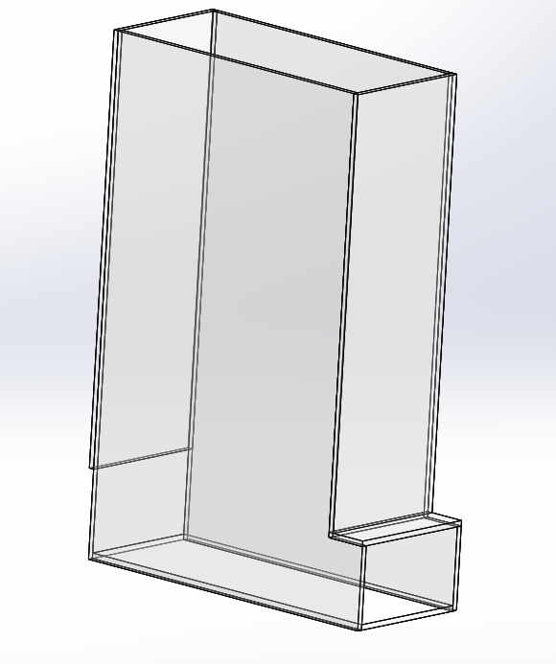
Figure 1: Solidworks model of compression chamber
The compression chamber has an opening on the top that allows for hops to be loaded into the chamber and allow for vertical compression of the hops from a vertically mounted linear actuator with an attached push plate. There is also an opening on the back of the compression chamber located at its base where the horizontal actuator can compress the hops horizontally. The compression chamber has an L-shape which provides a lip where the bag chamber can be slid onto the end and secured. The compression chamber is 30 inches high and 9 inches wide. The length of the vertical section above the L is 21 inches. The lip of the compression chamber where the bag chamber will slide on is 3 inches long and 5 inches high. This lip allows for the full extension of the horizontal actuator to reach the end of the compression chamber and the opening to the bag chamber. The openings are rectangular so that a rectangular push plate can guide the shafts of the actuators linearly as they extend and retract.

Bag Chamber
The bag chamber is where the compressed hops end up. It is designed so that a vacuum sealable bag can be placed inside it and the hops will be compressed into the bag. The bag chamber slides onto the L-shape of the compressing chamber and is held in place by a bracket that slides into place behind the bag chamber. Figure 2 below shows the Solidworks model of the bag chamber.
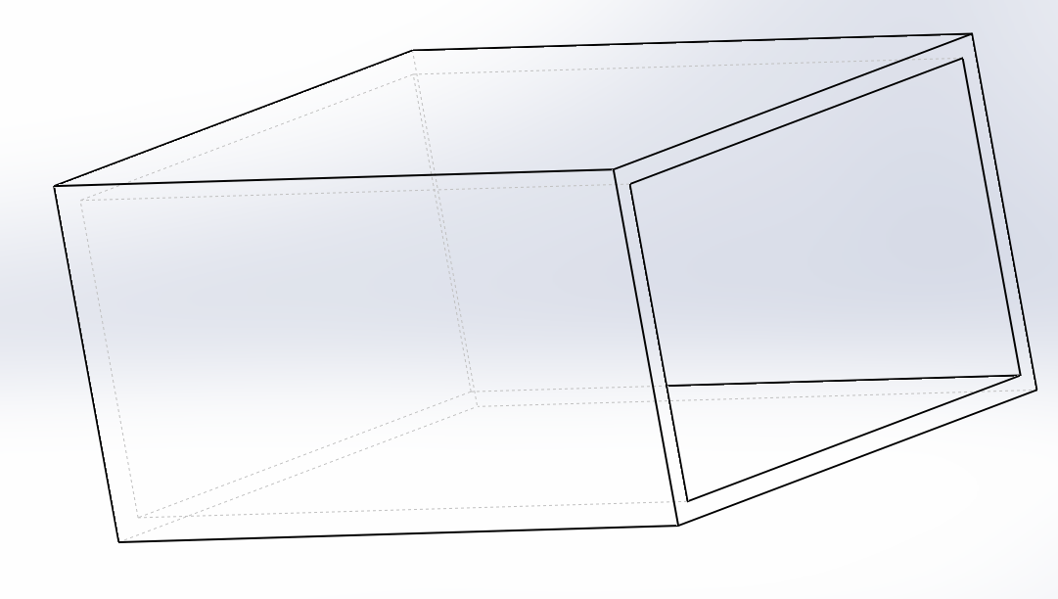
Figure 2: Solidworks model of bag chamber
The internal dimensions of the bag chamber is 10 inches long by 5 inches high by 9 inches wide which is the same dimensions as the L-shape of the compression chamber. Once compression is complete, the bracket is removed and the bag chamber is removed from the compression chamber and taken to the vacuum sealer where the vacuum sealable bag inside the chamber is sealed and all the air removed so that the final bale is sealed and able to be easily removed from the bag chamber. The final bale will weigh approximately 5 pounds which is what Aroostook Hops requested and is able to be sealed without first removing the hops from the bag chamber.

Two Stage Compression Method
The baler is designed so that there are two stages of compression of the hops. The vertically mounted linear actuator initially compresses the hops vertically. The vertical actuator compresses the hops 30 inches vertically, which leaves 5 inches of hops in the bottom of the chamber. Once the hops are compressed vertically, they are then compressed horizontally until all of the hops are contained in the bag chamber attached to the baler. The horizontally mounted linear actuator extends 24 inches, which is the entire length of the compression chamber and moves the compressed hops into the bag chamber. The Solidworks model of the baler with the actuators mounted is shown below in Figure 3.
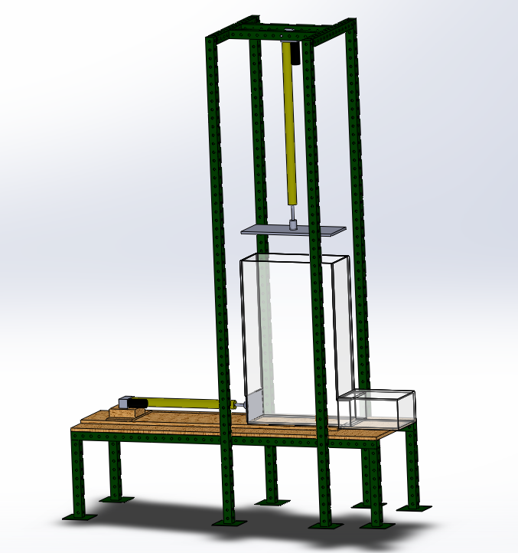
Figure 3: Solidworks model of baler assembly with linear actuators
The two-stage compression is used so that the compression of the hops can be done efficiently to minimize the size of the baler by compressing the hops in two directions, instead of one long stroke that completes the compression. The horizontal compression is needed in order to move the hops into the bag chamber where they can be easily removed.

Electric Linear Push/Pull Actuators
Two electric linear push/pull actuators are used to compress the hops. The first linear actuator is mounted vertically above the compression chamber. The vertical linear actuator is a Thomson Electrak PPA-DC actuator with a stroke length of 36 inches and a max force of 1500 lbs. The stroke length is 36 inches so that the hops can be compressed 30 inches and when it is fully retracted allows 6 inches of space above the compression chamber so that hops can be loaded into the compression chamber. The horizontal linear actuator is also a Thomson Electrak PPA-DC actuator but with a stroke length of 24 inches and a max force of 2000 lbs. Only 24 inches of compression is required in the horizontal direction, so when the actuator is fully extended it is at the end of the compression chamber. The horizontal actuator has a greater force than the vertical actuator because the greatest forces are when the hops are being compressed into the bag chamber attached to compression chamber.
Both linear actuators require DC power so two rechargeable 12 volt batteries are used to power the actuators. When the voltage to the actuators is reversed, the actuators will operate in the reverse direction. In order to utilize this function of the actuators a double pole-double throw switch is wired from each battery to the corresponding actuator. These switches are wired so that when they are in the up position the actuators extend and when they are in the down position the actuators retract. Both switches contain an off-position, which provides no power to the linear actuators so they can remain in place. The actuators can act independently of each other due to each having it’s own battery and switch.
Both actuators have a push plate mounted to the end of the actuator shaft so that when the actuators extend, the force is exerted on the plate, which compresses the entire volume of hops in the compression chamber. The vertical actuator has a plate constructed of polycarbonate with a hole drilled in the center to allow the actuator to pass through it. The plate is the same size as the opening on the top of the compression chamber. The plate guides the actuator through the compression chamber, which ensures that the motion of the actuator is linear. The horizontal actuator has a plate made of polycarbonate mounted to its end that is the size of the hole on the side of the bag chamber. This allows the plate to pass under the vertical actuator once it is fully extended and compress the hops into the bag chamber as the horizontal actuator extends.
The push plates are mounted so that they allow the shafts of the actuator to rotate freely once the actuator is fully extended or retracted. If the plates were rigidly mounted to the end of the actuators, when the actuators are fully extended or retracted and start rotating the plate would attempt to spin and possibly cause serious damage to the bag chamber. The mounting method of the horizontal push plate to the actuator is shown below in Figure 4.
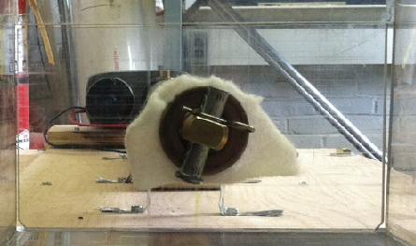
Figure 4: Mounting of push plate to horizontal actuator
The plates were mounted by drilling a hole in the plate that allows the tip of the shaft to pass through the plate but not the entire shaft. Then a flat washer is placed behind the plate and in front and a pin is placed in the end of the actuator shaft, which holds the plate and provides enough support that the plates do not deflect when the actuators extend and compress the hops. The shaft is able to rotate due to the plate resting on the actuator shaft and not attached to it. The sandwiching of the plate with the flat washers secures the plate in place and allows the shaft to rotate. The piece of felt between the washers allows for less friction when the actuator shaft rotates.

Base and Frame
The base of the baler is designed to support the compression chamber, bag chamber, and horizontal actuator. The base is constructed of Telestrut P9200 steel square tubing as the frame and ¾’’ thick oak plywood as the top of the base. The base is 6 feet long and 2 feet wide and is supported by four 18-inch long leg posts. The Telestrut tubing is bolted together with angle brackets. The oak plywood is secured to the top of the Telestrut tubing using bolts that pass through the wood and steel tubing. A Solidworks representation of the dimensions of the Telestrut P9200 tubing is shown in Figure 4 below.
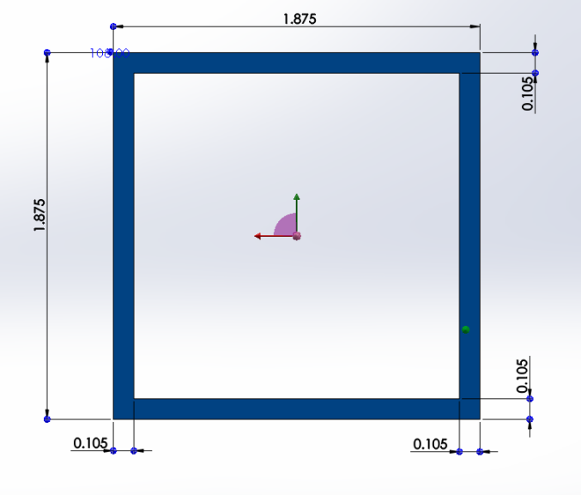
Figure 5: Solidworks model of cross-section of P9200 steel tubing
The compression chamber was then glued onto the plywood using acrylic glue. Once the compression chamber was secured in place, the horizontal actuator was mounted using pipe hanger strapping and a 5-inch long 2 by 4 placed behind the actuator. The mounting of the horizontal actuator is shown in the following figures. Figure 6 is a side-view and Figure 7 is a top-view of the attachment securing the horizontal actuator
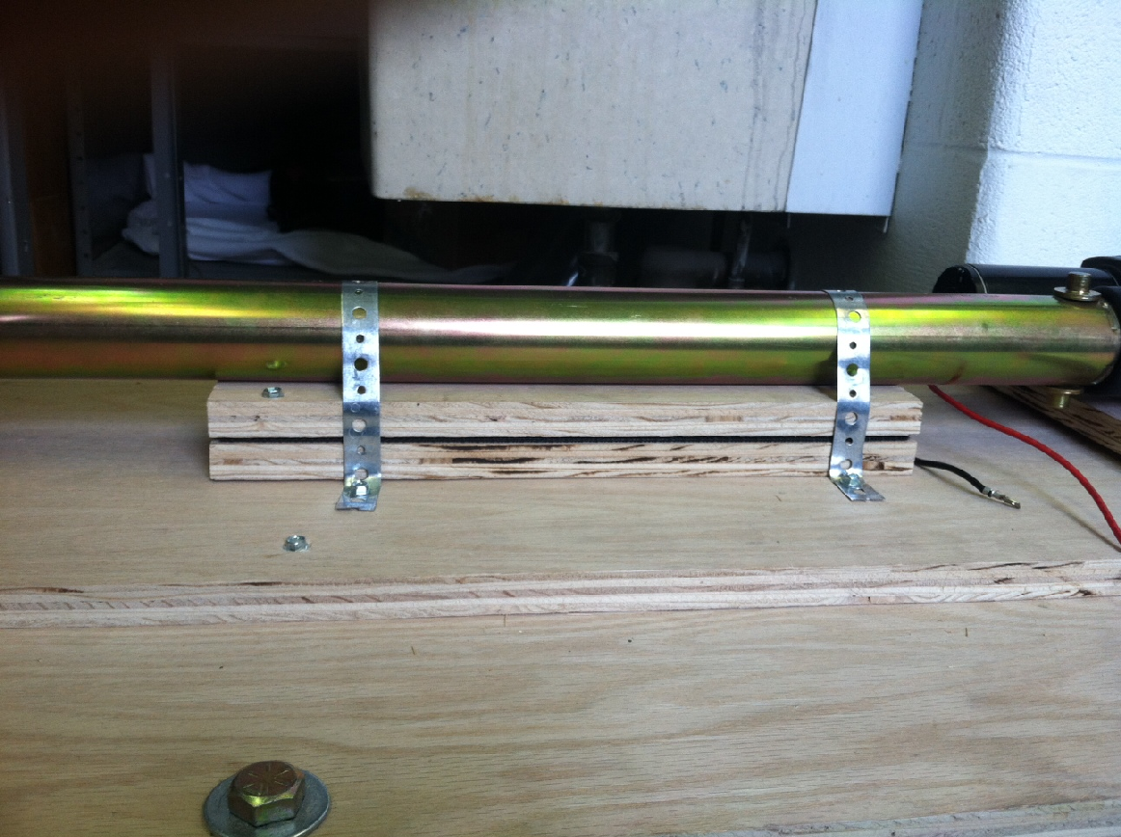
Figure 6: Side View of the Horizontal Actuator Mounting
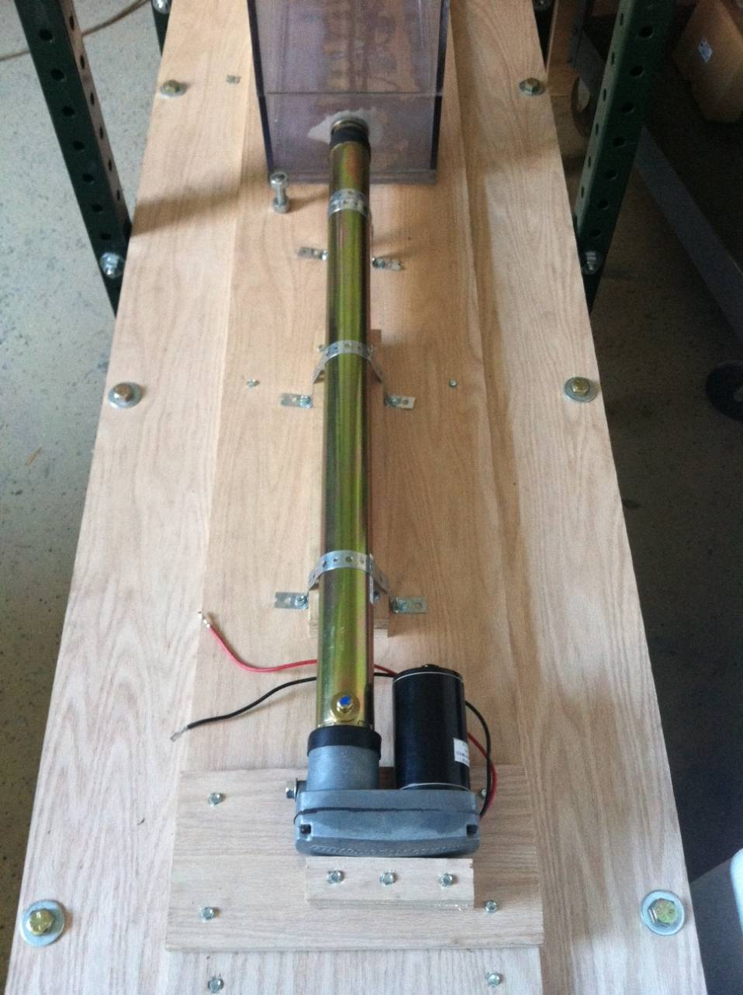
Figure 7: Top View the Horizontal Actuator Mounting
The vertical frame is 9 feet high and has four posts that are secured to the sides of base. The vertical frame is centered on the compression chamber and the vertical actuator is mounted directly above the compression chamber using a Thomson actuator end-trunnion mount. The four 9 foot sections of Telestrut P9200 tubing have a post base attached to them that help stabilize the vertical actuator. The assembly of the base and vertical frame with the mounting of the vertical actuator is shown in Figure 3.

Design Concept Process

Size of Bag Chamber and Bale
Aroostook Hops owns a commercial vacuum sealer and requested that it be used in the baling process if possible, to save them money. Also, the owner had also previously tested the product and judged that its performance was acceptable. The dimensions of the final vacuum-sealed product were a comfortable size to handle so the group decided to use this vacuum sealer. Research revealed different options of bag material but at this point the vacuum sealer became the most important design constraints in the project. Since the final bale size would have to fit the bags currently in use, all other elements of the final design would have to be engineered to accomplish the required bale size.
The opening of the vacuum sealable bags is variable so first we determined the shape of the bale that would fit into the bags. A square has the largest carrying capacity but since the bag is comprised of two plastic sheets sealed around the edges and experimentally we found that a rectangular shape put less stress on the seals. Also, the components required to produce rectangular bales are much easier to fabricate and assemble than cylindrical bales and storage and shipment of rectangular bales is more efficient, so the decision to create rectangular bales was made. Measuring the dimensions of the opening of the bag, we found that the final bale has two concrete dimensions of 9.5 inches wide and 5 inches high. Since the bags could be cut to any length, restrictions on the length of the bale were more flexible. Length would eventually be determined by such factors as the desired final bale weight and how much we the hops are compressed.
The compressibility of the hops was tested on a small amount of hops that were provided by the owner. Measurements of the volume, before and after, as well as the weight that was applied to achieve the smaller size were recorded in the experiment. We determined the hops could be compressed 14:1 and hold the compression without trying to return to their original shapes. The owners of the farm suggested that they would like a 10-pound bale as a final product but since the opening of the bag is only 9.5 inches wide by 5 inches tall the bale would have to be 15.4 inches in length to meet their goal. A 5-pound bale compressed 14:1 length would result in a length of approximately 8.7 inches, which is more reasonable.
The decision to use a 5-pound bale instead of the 10-pound that they requested, as well as the decision about the dimensions for the opening of the bag became the foundation of the project. The decrease in final bale size also will allow the machine to be shorter, both in height and width, which is best for the minimal space available indoors on the farm.

Number of Actuators
The goal of the compression was simple, to use actuators to press rectangular plates linearly through compression chambers in order to decrease the volume of material inside. To accomplish this, we first needed to determine the amount of actuators required. A single pressing motion would involve an incredibly long machine unless the motion was, instead, repeated adding small amounts of hops at a time. In addition, the space that Aroostook Hops have to use this baler is limited, therefore, the decision to use two actuators, one for initial vertical compression and one for secondary horizontal compression, was made so a bale can be created in one complete cycle of the machine.

Dimensions of the Chambers

Final Bag Chamber
A final bag compartment must accommodate a 5-pound bale with a 14:1 compression ratio. Inside of the chamber, before the cycle is started, the bag that already cut to the desired length is placed, with one end open, ready to accept hops from the initial compression chamber. The aforementioned cross-sectional area of the bag is a maximum size of 9.5 inches wide and 5 inches high, resulting in a length of 8.7 inches when completely compressed.

Initial Compression Chamber
An initial compression chamber that can accommodate the goal of 25-gallons, or 3.342 cubic feet of dried hops could have multiple dimensions. The bag chamber must be a rectangular prism to allow for two rectangular push plates to pass laterally through it; the first passing through a large portion of the chamber, then a second passing through the remainder of the chamber, extruding the entire contents into the final bag chamber.
Due to restrictions from the bag choice, the inner dimensions of the bag chamber must be equal to the outer dimensions of the outlet stemming from the initial compression chamber. Since we decided to use only two actuators to complete the compression, one of the initial three dimensions of the initial compression chamber will remain unchanged. Since the length of the final bale will be variable, the larger of the two concrete dimensions, 9.5 inches, is chosen to remain unchanged throughout the cycle of the machine.
To simulate the possible dimensions of a vessel large enough to hold 25-gallons, or 3.342 cubic feet, of dried hops an Excel document was created. Keeping a constant width of 9.5 inches, the document revealed the possible heights and widths of the initial compression chamber that will result in the desired volume. In Figure 8 is a calculation of the required dimensions of the compression chamber needed to hold 25 gallons of dried hops.
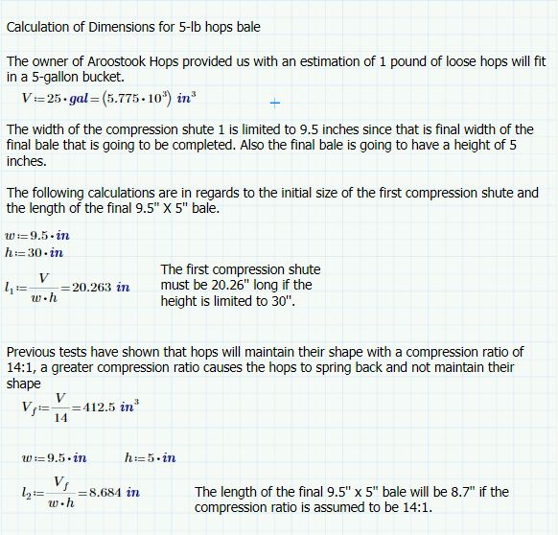
Figure 8: Calculations for the Length and Height of the Chamber
The worksheet starts with an initial volume of 25 gallons; which is approximately 5 pounds of hops. Then the first constraint is applied which is the width of the chambers which can only be 9.5 inches since that is the width of the final bale. Then if the height of the first chamber is limited to 30 if the length of the chamber is 20.26 inches. The final calculation shown in the figure deals with the length of the bale if the hops are compressed 14:1, and is found to be 8.68 inches. This is the required length of the final bale and bag chamber.

Types of Actuators
The initial compression chamber dimensions helped us find the type of actuator we needed to purchase. The first stroke is 5 inches less than the chamber height and the second is the sum of the length of the chamber and lip that supports the bag chamber. From the chamber dimensions, stroke lengths required to complete the compression in one complete cycle were evidently very long.
In the process of deciding what type of actuator to use, the power source had to be determined. Our options were manual, electric, or fuel-powered actuators. The device will be used indoors, to avoid harmful effects from fuel combustion, and the project is aimed to decrease the amount of work required as well as increase the speed so for this project the design is electric.
Since linear motion with force is desired, options available were limited to electric linear actuators or hydraulic linear actuators. In order to choose between these types, we then found at the amount of power required as well as the difference in cost.
The power requirement, or the amount of pushing force required by the actuator, was calculated using the amount of weight applied in the test and the area of the push plate. The required pull force for the actuator is practically negligible since the project just focuses on the pushing motion. If the pushing force were much over 1500 psi then a hydraulic actuator would be necessary, however, since the required pushing force was small enough, an electric linear actuator was selected for use. The actuator we chose, Thomson Electrak PPA-DC, received high reviews and is made in the United States.
We found that both types of linear actuators would suffice for our power needs and hydraulic actuators cost more, however, we chose electric instead of hydraulic because we wanted to keep hydraulic fluid away from the hops. Upon investigation we found that the longest stroke lengths available for electric linear actuators were approximately the size we were looking for.
A 12-volt DC linear actuator is possible for a stroke length of up to 36 inches and is also available in 24 inches. Referencing the Excel sheet describing possible dimensions, the compression can be completed with those two stroke lengths. The vertical stroke necessary is less than 36 inches but the excess will allow the plate to rise out of the chamber and allow space to fill the hops. This also allows us to gravity-feed the hops as we had hoped to avoid an additional loading mechanism. The horizontal stroke necessary is less than 24 inches but the excess will allow us to extrude the bale completely through the lip that is holding on the bag chamber.

Power Source
After researching electric linear actuators, the power supply was simple. Since there are two linear actuators that will be used, there needs to be two 12-volt power supplies, or one supply with two independent leads. We chose to use two supplies so we could operate them independently.

Controller
Electric actuators with DC brushless motor can be wired to a power supply and controlled simply by either applying power, or shutting the power supply off. When the actuators are given the power, they extend, when the power supply is cutoff, they retract. Due to this characteristic, a controller is not needed. When we initially began research, we found a controller that would provide the motion to the actuators. After contacting the supplier for the actuators, we then learned that a controller is not necessary because of the DC brushless motor and would simply make extra material and equipment that could potentially cause trouble down the road. Therefore, we decided not to go with a controller and chose to get a complete package from our actuator supplier. We did however decide to wire DPDT (double-pole, double-throw) switches to our actuators that will determine which way the actuators will travel. With these on-off-on switches, when pushed to one direction ‘on’, the actuators will extend. When pushed in the other direction to the other ‘on’, the actuator will retract. When the switches are in the neutral ‘off’ position, they will not extend or retract, which acts as if there is no power supplied to the actuators. These switches are used in lieu of a controller, and are the ideal option for this procedure.

Chamber Materials and Construction
The material for the construction of the chambers was the next thing to decide. Options included wood, metals, and polycarbonate materials. The benefits of polycarbonate outweighed others; it is visually appealing, it is shatter resistant, and it is precise. Additionally, with the exception of a few pieces, the material was cut prior to delivery; we were required to glue them together.
Construction of the chambers required patience and accuracy. The two pieces of material that make up the sides of the initial compression chamber first needed to be cut into L-shapes. A fine-tooth blade was used with a table saw to accomplish this. Next, weld-on #4 polycarbonate glue was applied and pieces were placed in position and allowed to dry, for both the initial compression chamber and the final bag chamber seen in Figure 8 and Figure 9, respectively. The seal becomes rigid in 20 minutes and grows stronger with time so after each piece was assembled, a day of drying time was allotted. Also, we were careful to make sure that the surfaces glued together were completely flat and clean.
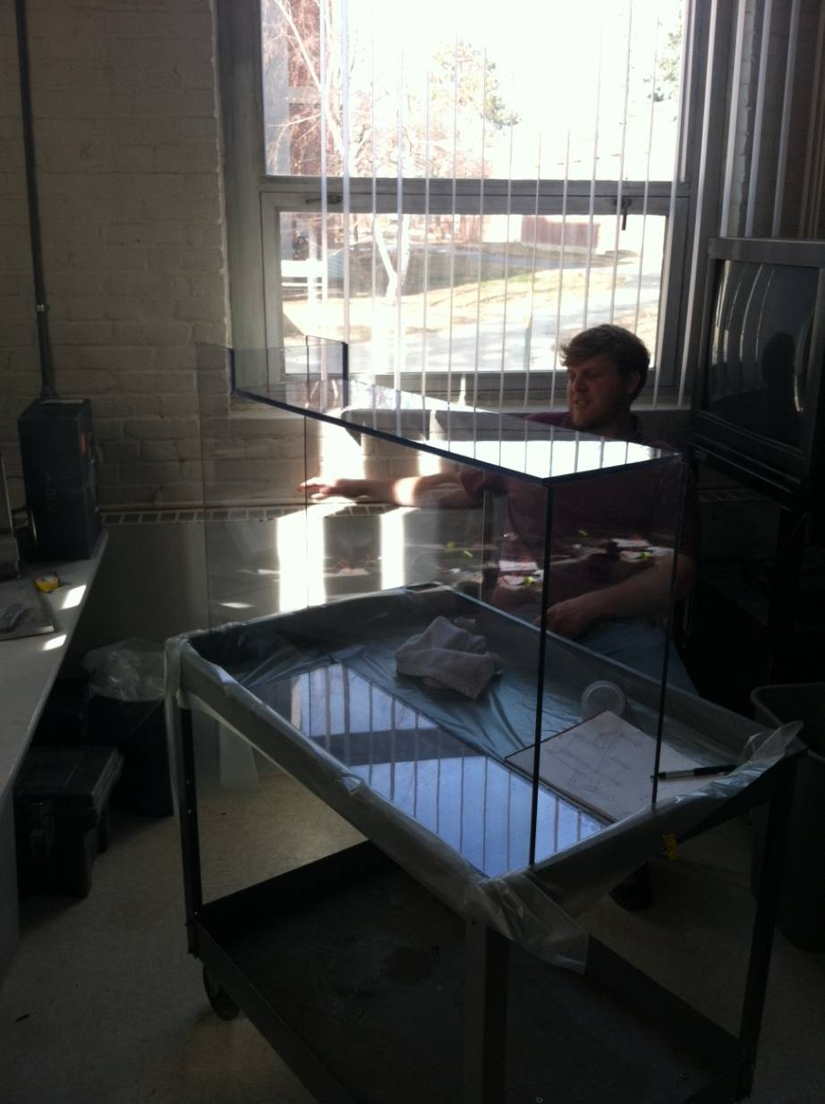
Figure 9: Photograph of Initial Compression Chamber after Construction
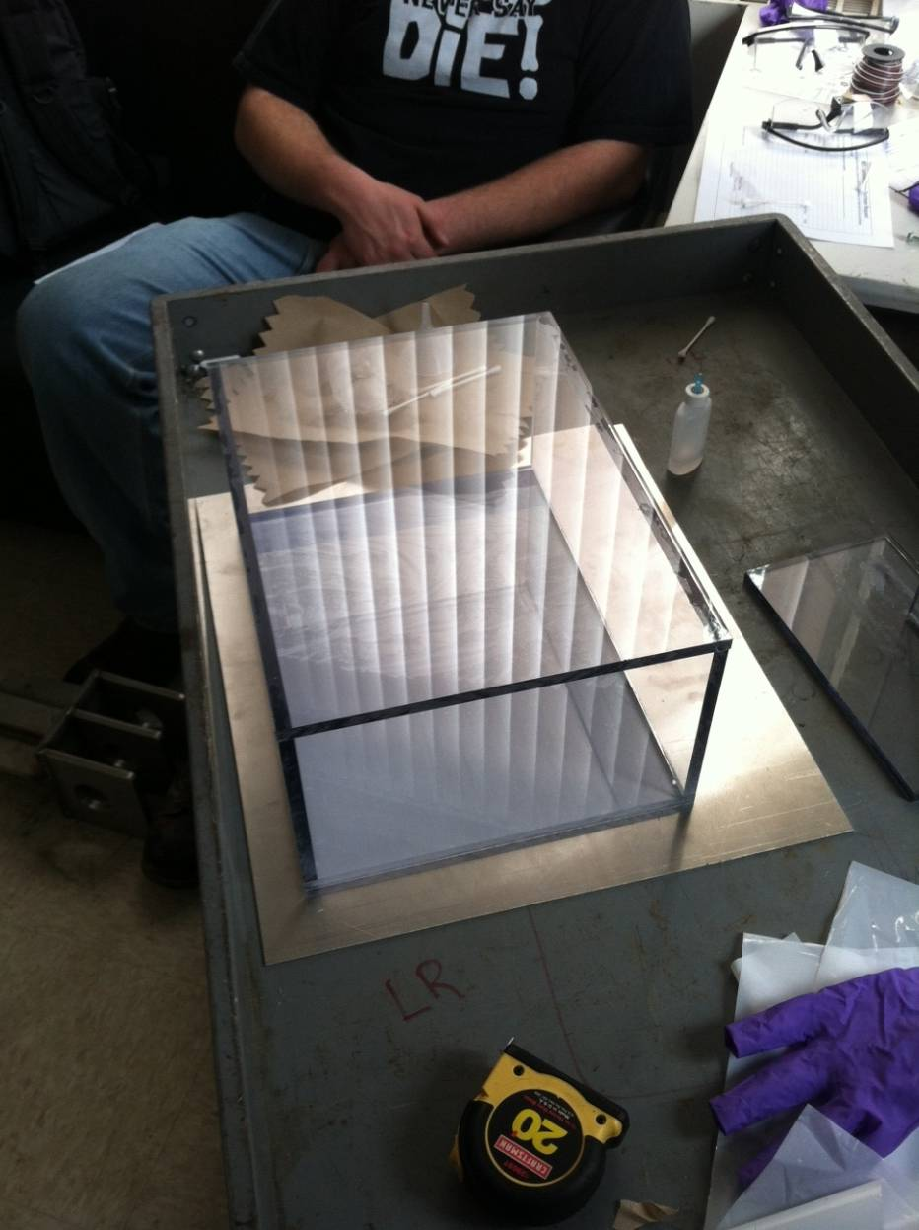
Figure 10: Photograph of Final Bag Chamber after Construction

Frame Design
The next step in the design was a frame to hold the chambers, actuators, and batteries in place while they complete the compression. Due to the fact that we have such long and precise stroke lengths, structural stability was key to its function. Telestrut square steel tubing and steel corner brackets were selected for use in the construction of the frame.
The base was designed to be six feet long, long enough to mount the bag chamber, the compression chamber, and the horizontal actuator and two feet wide, wide enough to fit the bag chambers and provide stability. A tabletop created out of ¾ inch hardwood plywood was then bolted to the lower part of the frame. The hardwood-plywood was chosen over others for its strength; it seemingly makes the whole structure sturdier. Figure 10 shows the base with plywood attached.
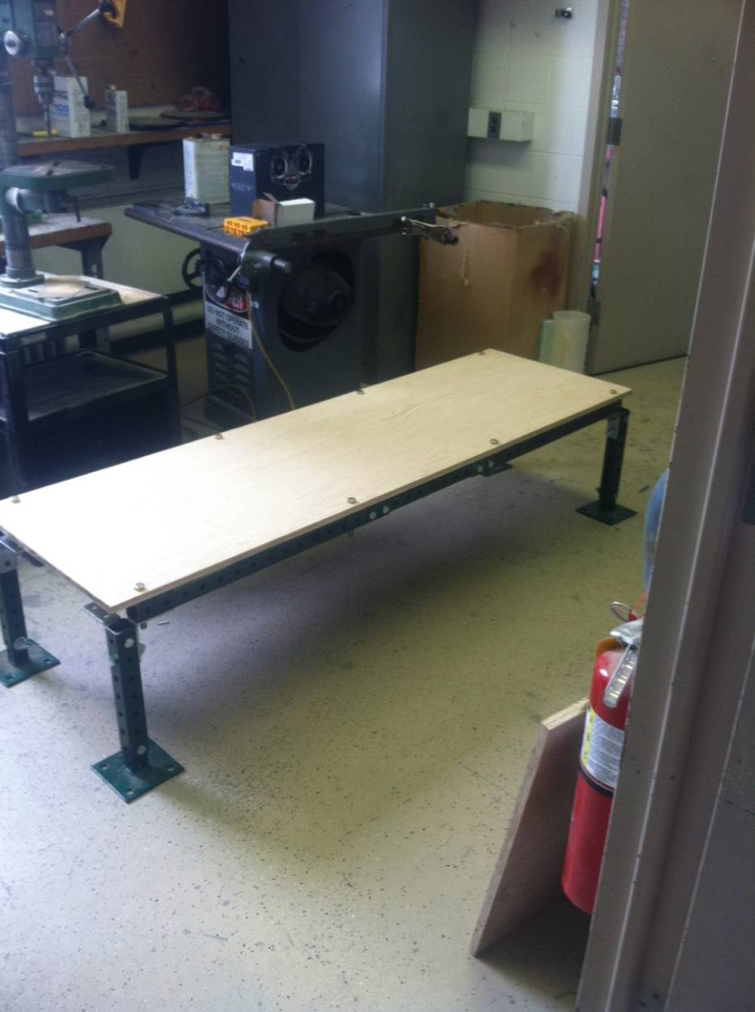
Figure 11: Photograph of Base Structure with Plywood Attached
The compression chamber was then glued upright directly to the plywood in the correct position. It can be seen in Figure 10 how the plywood is fastened to the base with bolts.

Compression Methods
The actuators used were Thomson Electrak PPA-DC 12V. The horizontal one was attached using conventional methods while the vertical one was attached with a component ordered to fit the actuator specifically, which was attached using only a threaded rod. The compression happens in two stages. First the vertical one extends down entirely, bringing it to a stop five inches above the bottom of the initial compression chamber. Second, the horizontal actuator extends through the bottom of the chamber, therefore forcing the material into the bag chamber.
The actuators need to be rigidly mounted so that they do not shift at all when compressing the hops. The horizontal actuator is going to be mounted by strapping it to the plywood and framing it in with angle steel so that it cannot move in any direction. The vertical actuator is going to be mounted using a manufactured Thomson rear mount that allows the actuator to be mounted from the rear with a bolt. We are also going to use two tube clamps that we will mount to the along the actuator shaft and attach to the frame so that the actuator is rigidly mounted in the vertical position.
The actuator rod spins when completely extended or contracted due to the ball-screw design, which helped determine the connection method since it could result in damage to the compression chambers if the plate is rigidly mounted to the actuator shaft. We needed to design a mounting system where the shaft is allowed to rotate but also move the plate as it extends. This required mounting the push plate to actuator rod in a swiveling manner.
The end of the actuator rod has a ½ inch hole for a pin connection. To make a design that is able to spin freely the pin connection is pinned on the other side of the push plate. The space between the pinhole and the edge for the push plate to rest on was less than ½ of an inch, so a piece of polycarbonate material could be used (3/8 in. thick).

Mobility
We initially planned to attach locking caster wheels to each leg of the frame to make the baler easy to move and transport. We then realized that the caster wheels would decrease the stability of our baler and decided on a different method. Figure 11, below, is a picture of the P9011 post base we chose. Since the frame is made up of Telestrut tubing and bolts, we are able to disassemble our frame using just a wrench so that it can be transported easily. However, there will be no way to move to the baler around a room without disassembly or assistance from enough people to safely lift and carry it to another position.
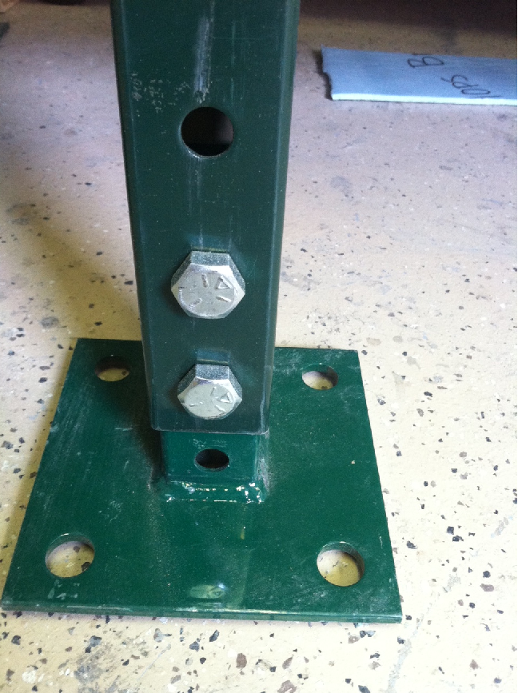
Figure 12: Photograph of Telestrut P9011 Post Base

Final Design Testing and Evaluation

Final Design Overview
The final design of the baler consists of the components listed above. The dimensions of the final design are 6 feet long by 2 feet wide by 9 feet tall. The final Solidworks model of the design is shown previously in Figure 3. The cost of the materials and components used in the construction of the baler came to a total of $2345.06. The parts list with each components cost is shown in Appendix A. The final design is shown below in Figure 13.
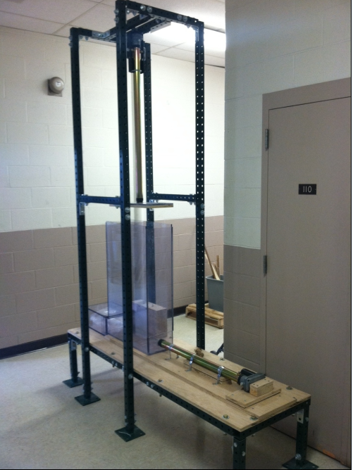
Figure 13: Photograph of Final Design
Figure 13 shows all of the components used in the final design. The angle brackets and bolts used to connect the Telestrut tubing are clearly visible in the picture as well as the vertical tubing used to support the vertical linear actuator. The mounting methods of the horizontal and vertical linear actuators are also seen in the above figure. The wires from the actuators to the batteries are not visible because the wires were run through the Telestrut tubing so that the wires would be protected from damage. The control box containing both batteries is shown with the double pole double throw switches mounted in the top. Also the bag chamber attached the compression chamber is shown with the bracket that holds the bag chamber in place during compression.

Final Design Operation
Now that the design was complete and the construction finished, we needed to determine how to operate the baler so that hops can be compressed efficiently. The first step in creating a bale of hops is to fully retract both linear actuators so that the entire compression chamber can be filled with hops. A vacuum sealable bag is then placed inside the bag chamber and both the bag and bag chamber are slid onto the lip of the compression chamber. The bag chamber is then secured in place with bracket located on the end of the baler base. Next, hops are loaded into the compression chamber from the top until the compression chamber is full. Once the compression chamber is filled with hops, the vertical actuator is extended downward and compresses the hops vertically with the mounted push plate. When the vertical push plate reaches the top of the horizontal push plate 30 inches below, the vertical actuator is then switched to the off position and the horizontal actuator is switched on and extends into the compression chamber. The horizontal actuator fully extends which pushes all of the compressed hops into the bag chamber and vacuum sealable bag inside the bag chamber. The horizontal actuator is powered off and the bag chamber is removed by sliding down the bracket supporting it. The bag chamber is then taken to a vacuum sealer where the bag inside can be sealed and the 5 pound bale of hops ready to be sold. Both actuators are then retracted and the baler is ready to produce another bale by repeating the previous procedure.

Mech. Lab Experiment
The Mech Lab Experiment was performed to test the horizontal push plate connection to the shaft of the linear actuator. The following is the introduction to the Mech Lab report. The entire report can be referenced in Appendix B.

Introduction
This experiment deals with the two-stage hops baler. This design consists of a first-stage vertical compression and a second-stage horizontal compression. The vertical compression chamber is 30” tall, 21.5” long, and 9” wide. This chamber acts as the hopper for the initial uncompressed dried hops and leads into the horizontal compression. Figure 1 shows a solidworks design of the final construction for the baler. The chambers are built using Polycarbonate and are mounted on an oak plywood platform that acts as the base for the baler.
Figure 1 Solidworks design of the final baler construction
The chambers are built using Polycarbonate and are mounted on an oak plywood platform that acts as the base for the baler. Both chambers act as guides for the push plates that are mounted on the end of the Thomson Electrak PPA-DC push-pull linear actuators. The actuators are mounted in precise locations to apply pressure in the center of each push plate.
The experiment will focus on the mounting of the push plate to the shaft of the horizontally mounted linear actuator. The push plate needs to be rigidly mounted to the shaft of the actuator so that the plate remains perpendicular to the shaft of the actuator. The off-axis displacement of the mounted push plate from the axis perpendicular to the shaft will be measured as the actuator extends and compresses shredded paper that acts as a substitute for the hops. The push plate is mounted to the shaft of the actuator using two 1” diameter washers, a piece of felt to make the connection a ‘snug’ fit, and a cotter pin to keep the plate in place. The washers and felt are used to fill space between the shaft, cotter pin, and the end of the outside of the push plate. Figure 2 shows the connection of the push plate.
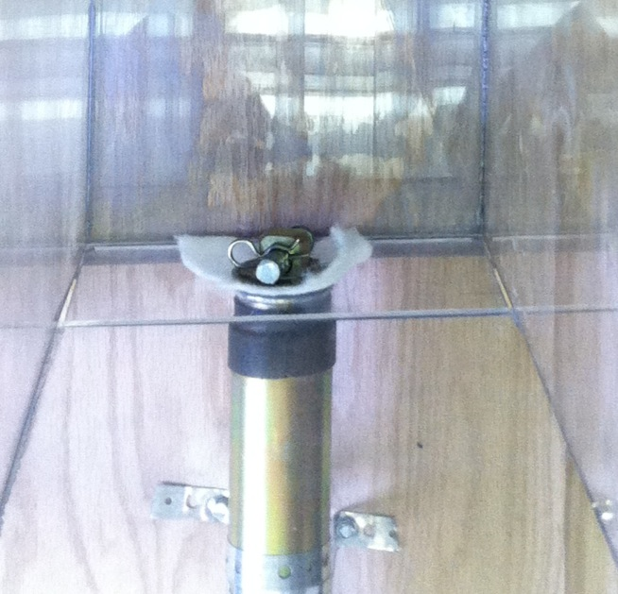
Figure 2 Horizontal actuator push plate connection design
The push plate connection to the actuator is the key to this experiment. While the actuator is powered by a 12-volt battery source, the shaft extends and pushes the plate through the horizontal chamber. During the extension, the hops are forced into the final bag chamber that is connected to the end of the horizontal chamber. Because the hops have nowhere else to travel, but are still being forced, they compress even further and actually apply a force against the push plate. The experiment measures how this force effects the push plate’s displacement from the initial perpendicular position to the shaft by using two tape measures that are mounted to the sides of the chamber and used to reference the possible displacements of the plate.

Data and Plots
The following write-up is the results section of the Mech Lab final report. This section explains if the goals were met and if the design failed or is ready to use in the final prototype of the baler. The completion of the report and its entirety can be referenced in Appendix B.

After completion of this experiment, three trials of the horizontal plate displacement are performed. Each trial is represented in table format and graphically. Each table represents the reference point location number (1 through 9), the distance the horizontal actuator has extended, and the left-side and right-side displacements relative to the neutral axis starting position. Table 1 below shows the results for trial #1 of the experiment.
Table 1 Results from test trial 1 of the horizontal push plate displacement
Reference  Point | Actuator  Extension (in) | Left Side  Displacement (in) | Right Side  Displacement (in)
1 | 0 | 0 | 0
2 | 3 | 0 | 0
3 | 6 | 0 | 0
4 | 9 | 0 | 0
5 | 12 | -0.0625 | 0.0625
6 | 15 | -0.125 | 0.125
7 | 18 | -0.125 | 0.125
8 | 21 | -0.1875 | 0.1875
9 | 24 | -0.25 | 0.25

The first four reference points (actuator extension equal to 9”) did not have any displacement. The pressure against the plate from the compressed artificial hops remained uniform and did not create an offset of the plate. At reference point five the plate began its displacement. The displacement however was only 1/16”. After continuing to record the results at each of the reference points, the total displacement for the horizontal push plate was 1/4”, both in on the left side and right side. This distance is below the 1/2” displacement that was set for a redesign requirement of the push plate connection. Based on the values and analysis of trial #1, the push plate connection design withholds the tested parameters and is able to perform to the design intent.

Table 2 below shows the second trial for the same experiment. After following the same procedures, the second set of data was obtained.
Table 2 Results from test trial 2 of the horizontal push plate displacement
Reference  Point | Actuator  Extension (in) | Left Side  Displacement (in) | Right Side  Displacement (in)
1 | 0 | 0 | 0
2 | 3 | 0 | 0
3 | 6 | 0 | 0
4 | 9 | -0.0625 | 0.0625
5 | 12 | -0.0625 | 0.0625
6 | 15 | -0.125 | 0.125
7 | 18 | -0.1875 | 0.1875
8 | 21 | -0.1875 | 0.1875
9 | 24 | -0.25 | 0.25

The overall data from trial #2 resulted in nearly the same way that trial #1 did. Instead of no displacement until reference point 5, the displacement started at reference point 4. This may have occurred because the paper could have been bunched in locations while being compressed that was not bunched in the first trial. After loading the chambers two times, an observation was taken that the shredded paper was actually clumping together into balls. These balls would create an increased force against the plate if it was not in the center of the push plate. Trial #2 does not show too much of a difference from trial #1. The displacements from trial #1 appeared in trial #2, but at different reference points. The plate remained consistent at reference points 4 and 5 as well as between points 7 and 8. The final displacements for each the left and right side was the same for trial #2 as it was for trial #1 and was 1/4”. Due to this recorded final displacement value, the plate connection does not need to be redesigned and will perform at the design intent.

Trial #3 was performed following the same procedures as trials #1 and #2. If the results of this section remain consistent with the previous trials, the plate is designed with enough rigidity and is ok to use as the final prototype. After performing the same procedures, the data was recorded and is shown in Table 3.
Table 3 Results from test trial 3 of the horizontal push plate displacement
Reference  Point | Actuator  Extension (in) | Left Side  Displacement (in) | Right Side  Displacement (in)
1 | 0 | 0 | 0
2 | 3 | 0 | 0
3 | 6 | 0 | 0
4 | 9 | 0 | 0
5 | 12 | -0.0625 | 0.0625
6 | 15 | -0.125 | 0.125
7 | 18 | -0.1875 | 0.1875
8 | 21 | -0.25 | 0.25
9 | 24 | -0.3125 | 0.3125

Table 3 shows the displacements at each reference point location. The results are similar to those of trial #1 as well as trial #2. The plate did not have any displacement until reference point 5. This value was only 1/16” and continued to displace 1/16” for each reference until reaching a final displacement for trial #3 of 5/16”. This is again below 1/2” so the plate connection design is confirmed and is ready to use as the final prototype for the baler.
Figures 4 through 6 show the graphical results of each trial. Each graph has the plate’s right side displacement as well as the left side displacement. The key legend should be referenced to determine which set of points represents which plate, however, the blue set of data points corresponds to the right side displacement and the red (negative) values correspond to the left side displacement. A line of best fit has been created for each displacement for each set of results to show a linear set of deflections. These lines do not show the maximum deflection for the trials, however they do show a average predicted linear set of points for the maximum actuator extension. The equations for the lines are also provided and are next to each line where x equals the actuator extension distance in inches.

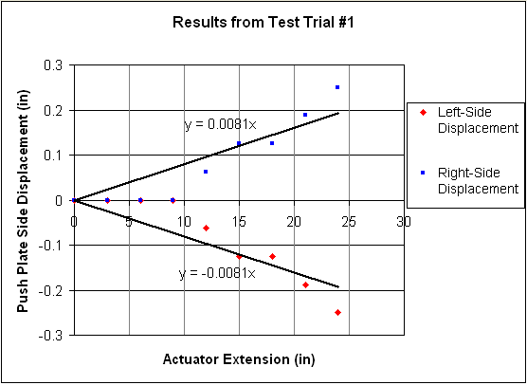
Figure 4 Displacement results based on actuator extension for trial 1

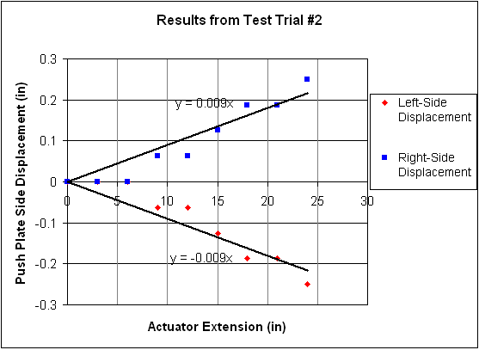
Figure 5 Displacement results based on actuator extension for trial 2

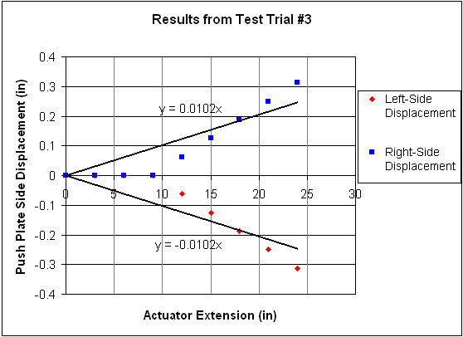
Figure 6 Displacement results based on actuator extension for trial 3

Conclusion

Capability
The project resulted in a working machine and, though there is room for improvement, it completely fulfilled the farms expectations. The task of vacuum sealing hops in order to ship them to the brewery is a very long process in its current, manual form. The machine we have created to solve this problem speeds up the process by a factor of at least 10. The product is also structurally sound, mechanically able, and easy to use.
The machine is designed with multiple features that combine to work successfully in unison. The structure was an acceptable base that could withstand the force required to keep the actuators stationary and securely hold the chambers in place, as it was very rigid. Also, the chambers were capable of withstanding the internal pressures without additional reinforcement after they were glued. The actuators are attached securely in place and they extend linearly through the chambers with enough force to complete the compression. Lastly, attached to the actuator rods, the push plates are attached sturdily. The machine is capable of the completing the required task, structurally sound, easy to use, but room for improvement still remains.

Additional Utilization of the System
This farm is a good example of independent farms all over that grow hops, an organic product that requires a significant decrease in volume in order to ship. Few farms that grow hops grow them on site, so this process is required, especially for small farms. To ship their product to the brewery, larger hop farms make bales that are 100 times as large as ours or pelletize them, so our machine is useful solely for small farms. The machine can decrease both the amount of manual labor and time that is required to complete the task of packaging hops.

Operational Concerns
The machine was designed so that a single person could operate it; however, it is safer to operate the current design with two people. The upper push plate must be manually guided into the chamber and if it is off axis an edge of the push plate may catch on an upper edge of the initial compression chamber. This could be devastating to the machine so proper guidance is necessary.

Recommendations for future designs

Safety
The next capstone design group to redesign this hops baler should take a few suggestions for improvement into consideration. As mentioned previously, the goal was for the machine to be operated by a single person but it is safer to operate the current design with two people. Safety is the first issue that should be addressed. This issue can be solved; the horizontal actuator is an example of how the system can function without manual guidance. By extending the height of the walls of the initial compression chamber to surround the push plate attached to the vertical actuator, it would become hands-free.
However, currently, the gap created when the push plate attached to the vertical actuator rises above the initial compression chamber is utilized to load the hops into the chamber. If the design were to change, the method used to load the hops would also have to. A door on the side of the initial compression chamber could open and close, allowing access to the inside of the chamber. This leads to another future improvement of a hopper, or system to guide the hops into the chamber.

Loading Mechanism
Currently, the hops will be transferred from large trays that they are dried on to the initial compression chamber. There it is difficult to make this transfer with the current design without spilling however. The optimum system would consist of an automatic feeding system. This could work multiple different ways. A gravity-fed large chute, attached to the initial compression chamber or frame, which catches the hops to avoid spilling, and funnels them into the chamber would be optimal; this would save costs compared to a mechanical device.

Future Note
The product will be delivered to the Aroostook Hops in June of 2013 for use in September of 2013. Due to this, it will not be available for redesign.

Appendices

Appendix A: Parts Cost List
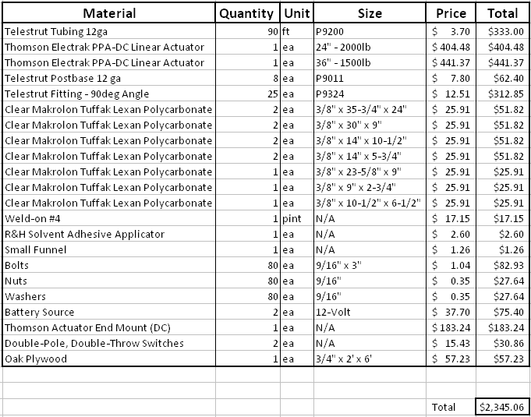

Appendix B: Mechanical Lab Report

Hops Baler Experiment

Crosby Laboratory
University of Maine

May 10, 2013

Group Members:
Jacob Speed
Matt Gallagher
Sam Ledue
Nate Rocker
Lloyd Bryant

Table of Contents

Introduction 16

Experimental Objectives 29

Apparatus, Theory, Procedure, Data Needed 30

Equipment 30

Apparatus 30

Procedure 31

Uncertainty 32

Plan of Work 33

Results 34

Conclusion 39

Introduction
This experiment deals with a two-stage hops baler. This design consists of a first-stage vertical compression and a second-stage horizontal compression. The vertical compression chamber is 30” tall, 21.5” long, and 9” wide. This chamber acts as the hopper for the initial uncompressed dried hops and leads into the horizontal compression. Figure 1 shows a solidworks design of the final construction for the baler. The chambers are built using Polycarbonate and are mounted on an oak plywood platform that acts as the base for the baler.
Figure 1 Solidworks design of the final baler construction

The chambers are built using Polycarbonate and are mounted on an oak plywood platform that acts as the base for the baler. Both chambers act as guides for the push plates that are mounted on the end of the Thomson Electrak PPA-DC push-pull linear actuators. The actuators are mounted in precise locations to apply pressure in the center of each push plate.
The experiment will focus on the mounting of the push plate to the shaft of the horizontally mounted linear actuator. The push plate needs to be rigidly mounted to the shaft of the actuator so that the plate remains perpendicular to the shaft of the actuator. The off-axis displacement of the mounted push plate from the axis perpendicular to the shaft will be measured as the actuator extends and compresses shredded paper that acts as a substitute for the hops. The push plate is mounted to the shaft of the actuator using two 1” diameter washers, a piece of felt to make the connection a ‘snug’ fit, and a cotter pin to keep the plate in place. The washers and felt are used to fill space between the shaft, cotter pin, and the end of the outside of the push plate. Figure 2 shows the connection of the push plate.
Figure 2 Horizontal actuator push plate connection design
The push plate connection to the actuator is the key to this experiment. While the actuator is powered by a 12-volt battery source, the shaft extends and pushes the plate through the horizontal chamber. During the extension, the hops are forced into the final bag chamber that is connected to the end of the horizontal chamber. Because the hops have no where else to travel, but are still being forced, they compress even further and actually apply a force against the push plate. The experiment measures how this force effects the push plate’s displacement from the initial perpendicular position to the shaft by using two tape measures that are mounted to the sides of the chamber and used to reference the possible displacements of the plate.

Experimental Objectives
The objectives of the experiment to test the mounting of the push plate to the horizontal linear actuator shaft are listed below.
- Measure the displacement of the mounted push plate from the axis perpendicular to the actuator shaft using reference located on the horizontal compression chamber.
- Determine if additional mounting methods are required to hold the actuator in place during compression.
- Determine if the bag chamber needs additional support to withstand the pressure of the hops at full compression.

Apparatus, Theory, Procedure, Data Needed

The following equipment will be used to complete this experiment. All of the equipment can be found in Crosby Laboratory.

Equipment
- Manufactured Hops Baler
  - First-Stage Vertical Compression Chamber
    - 30” tall, 21.5” long, 9” wide
  - Second-Stage Horizontal Compression Chamber
    - 5” tall, 24” long, 9” wide
  - Thomson Electrak PPA-DC Linear Actuator (Vertical)
    - Maximum Force of 1500lbf
    - Maximum Stroke of 36”
  - Thomson Electrak PPA-DC Linear Actuator (Horizontal)
    - Maximum Force of 2000lbf
    - Maximum Stroke of 24”
  - Two 12-Volt Power Supplies
  - Final Bag Chamber
    - 5.75” tall, 14” long, 9.75” wide
    - Fits snug over the entire cross-section of the horizontal compression chamber
  - Base/Frame for Stability
    - 9’ tall, 6’ long, 2’ wide
  - Push Plates made to fit inside walls of each compression chamber
- Shredded Paper (Hops substitute)
- Two Stanley 25’ Tape Measures

Apparatus
Shredded paper is used in the experiment as a substitute for dried hops. A volume ratio of 14:1 is used for the before and after compression of the hops. The shredded paper was tested to ensure the same volume ratio as the hops. After confirmation of compatibility analysis, shredded paper was the best option for the hops substitute. The shredded paper was loaded into the finished vertical chamber that will be used during operation. The horizontal actuator is mounted to the base; this is the actuator that is used to test the mounting methods of the push plate. The vertical actuator is also mounted and used in the experiment to provide the actual first-stage compression as well as create an accurate final compression of each bale in the bag chamber.

The main goal of this experiment requires measuring the off-axis displacement of the plate mounted to the end of the horizontally mounted linear actuator. The compression chambers are constructed of Polycarbonate so the compression of the hops and the push plate are visible throughout the entire operation. The tape measures are mounted parallel with the horizontal chamber and are located along both sides of the chamber to measure the off-axis displacement at both the right and left edges of the push plate. If there is uneven distribution of pressure that pushes the plate back, the tape measures are used to reference the total displacement. Figure 3 shows a detailed sketch of the experimental setup for measuring this off-axis displacement.
Horizontal Compression Chamber

Rigid Support

Tape Measure on both sides of horizontal chamber to reference while recording displacement
Push Plate mounted to end of actuator
Vertical Compression Chamber
Bag Chamber
Figure 3 Experimental setup of the horizontal push plate connection design

Procedure
This experiment is to be performed in Crosby Laboratory. This experiment consists of mounting a plate to the end of the horizontally mounted linear actuator. The purpose of this experiment is to measure the off-axis displacement of the plate as the actuator extends and compresses the hops. There are two 25’ tape measures along each side of the horizontal compression chamber that will be used to measure the off-axis displacement of both sides of the plate. The main focus is to have the plate parallel with these tape measures to ensure a straight displacement from the initial position. The vertical displacement is not as important as the horizontal displacement because of the plate dimensions. The plate is only 5” tall which would not deflect the same as it would for being 9” wide. Neglecting this vertical displacement, the horizontal displacement can be analyzed.
The first step in this experiment is to mount the plate to the end of the actuator using one of the experimental mounting designs. The plate should be mounted perpendicular to the shaft of the actuator and even with both sides of the compression chamber. The compression chamber is then filled completely with the artificial hop substitute, in this case, shredded paper, and the top of the chamber is sealed off by extending the vertically mounted linear actuator until it is started to extend inside the chamber. The actuator is engaged to extend until the vertical push plate is parallel with the top of the horizontal compression chamber. Once this extension goal is met, the actuator is shut off.
The horizontally mounted linear actuator is then turned-on using the double-pole, double-throw switch that is wired to it to control the actuator’s motion. This results in the second-stage compression of the artificial hops. Measurements of the push plate displacement are recorded every 3” of extension, beginning at the start position. As the center of the plate passes by each reference point, a measurement should be taken from the left side and right side of the compression chamber of the positive or negative horizontal displacement from that reference. Measurements need to be taken at every reference point until the actuator is fully extended to ensure constant motion of the push plate during compression. Each trial has a total of nine displacement measurements.
Both actuators are then retracted until they reach the starting positions. The bag chamber is disconnected and the shredded paper is taken out of the chamber. Once the vertical actuator is fully retracted, new shredded paper is added and the testing procedure is repeated. These steps are repeated two times for a total of three testing trials to get multiple displacement recordings to get as much accuracy as possible.
After all three trials are performed, there should be a total of 27 displacement measurements. These measurements are analyzed and compared at each reference point and for each trial to see if the displacements were consistent, if the plate deflected more after so many times of compression, or if they need adjusting and strengthening so the off-axis displacement is decreased.

Uncertainty
By completing the experimental procedure, a complete set of measurements of the displacement of the mounted push plate from the perpendicular axis is obtained. These measurements are recorded by using the 25’ Stanley tape measures that have an accuracy of 1/16”. The uncertainty associated with the use of these tape measures is 1/16’’ due to the accuracy of the measurement. The maximum displacement of the mounted push plate from the perpendicular axis is ½’’. If the push plate becomes displaced more than ½’’, the redesign for the push plate mount is needed before it is used in the final prototype. Since the focus is for measurements greater ½’’, the margin of error of our measurements will be 12.5% (0.0625’’/0.5’’). The 12.5% margin of error is acceptable for the data we are collecting in this experiment.
After the mounting design is tested following the provided procedures, it will be known if a redesign of the push plate is needed.

Plan of Work
Items to be Completed | 2/20/13 | 2/27/13 | 3/6/13 | 3/13/13 | 3/27/13 | 4/3/13 | 4/10/13 | 4/17/13 | 4/24/13 | 5/1/13 | 5/8/13
Finalize Ordering Materials
Design multiple mounting positions for vertical & horizontal Actuators
Measure forces on the mounting brackets as the actuators are extended.
Measure off-axis displacement of actuator from its original axis when different loads are applied.
Determine which mounting design most rigidly supports the actuators under full loading and range of movement.
Determine if additional mounting methods are required to hold the actuators in place.
Create the chambers out of 3/8” plywood that is donated by ABM Mechanical, Inc.
Begin Construction of Compression Chambers
Finalize Construction
Begin Operation & Maintenance Manual
Begin Testing Operation of Baler
Finalize and Make Necessary Adjustments
Prepare for Final Report

Results
After completion of this experiment, three trials of the horizontal plate displacement are performed. Each trial is represented in table format and graphically. Each table represents the reference point location number (1 through 9), the distance the horizontal actuator has extended, and the left-side and right-side displacements relative to the neutral axis starting position. Table 1 below shows the results for trial #1 of the experiment.
Table 1 Results from test trial 1 of the horizontal push plate displacement
Reference  Point | Actuator  Extension (in) | Left Side  Displacement (in) | Right Side  Displacement (in)
1 | 0 | 0 | 0
2 | 3 | 0 | 0
3 | 6 | 0 | 0
4 | 9 | 0 | 0
5 | 12 | -0.0625 | 0.0625
6 | 15 | -0.125 | 0.125
7 | 18 | -0.125 | 0.125
8 | 21 | -0.1875 | 0.1875
9 | 24 | -0.25 | 0.25

The first four reference points (actuator extension equal to 9”) did not have any displacement. The pressure against the plate from the compressed artificial hops remained uniform and did not create an offset of the plate. At reference point five the plate began its displacement. The displacement however was only 1/16”. After continuing to record the results at each of the reference points, the total displacement for the horizontal push plate was 1/4”, both in on the left side and right side. This distance is below the 1/2” displacement that was set for a redesign requirement of the push plate connection. Based on the values and analysis of trial #1, the push plate connection design withholds the tested parameters and is able to perform to the design intent.

Table 2 below shows the second trial for the same experiment. After following the same procedures, the second set of data was obtained.
Table 2 Results from test trial 2 of the horizontal push plate displacement
Reference  Point | Actuator  Extension (in) | Left Side  Displacement (in) | Right Side  Displacement (in)
1 | 0 | 0 | 0
2 | 3 | 0 | 0
3 | 6 | 0 | 0
4 | 9 | -0.0625 | 0.0625
5 | 12 | -0.0625 | 0.0625
6 | 15 | -0.125 | 0.125
7 | 18 | -0.1875 | 0.1875
8 | 21 | -0.1875 | 0.1875
9 | 24 | -0.25 | 0.25

The overall data from trial #2 resulted in nearly the same way that trial #1 did. Instead of no displacement until reference point 5, the displacement started at reference point 4. This may have occurred because the paper could have been bunched in locations while being compressed that was not bunched in the first trial. After loading the chambers two times, an observation was taken that the shredded paper was actually clumping together into balls. These balls would create an increased force against the plate if it was not in the center of the push plate. Trial #2 does not show too much of a difference from trial #1. The displacements from trial #1 appeared in trial #2, but at different reference points. The plate remained consistent at reference points 4 and 5 as well as between points 7 and 8. The final displacements for each the left and right side was the same for trial #2 as it was for trial #1 and was 1/4”. Due to this recorded final displacement value, the plate connection does not need to be redesigned and will perform at the design intent.

Trial #3 was performed following the same procedures as trials #1 and #2. If the results of this section remain consistent with the previous trials, the plate is designed with enough rigidity and is ok to use as the final prototype. After performing the same procedures, the data was recorded and is shown in Table 3.
Table 3 Results from test trial 3 of the horizontal push plate displacement
Reference  Point | Actuator  Extension (in) | Left Side  Displacement (in) | Right Side  Displacement (in)
1 | 0 | 0 | 0
2 | 3 | 0 | 0
3 | 6 | 0 | 0
4 | 9 | 0 | 0
5 | 12 | -0.0625 | 0.0625
6 | 15 | -0.125 | 0.125
7 | 18 | -0.1875 | 0.1875
8 | 21 | -0.25 | 0.25
9 | 24 | -0.3125 | 0.3125

Table 3 shows the displacements at each reference point location. The results are similar to those of trial #1 as well as trial #2. The plate did not have any displacement until reference point 5. This value was only 1/16” and continued to displace 1/16” for each reference until reaching a final displacement for trial #3 of 5/16”. This is again below 1/2” so the plate connection design is confirmed and is ready to use as the final prototype for the baler.
Figures 4 through 6 show the graphical results of each trial. Each graph has the plate’s right side displacement as well as the left side displacement. The key legend should be referenced to determine which set of points represents which plate, however, the blue set of data points corresponds to the right side displacement and the red (negative) values correspond to the left side displacement. A line of best fit has been created for each displacement for each set of results to show a linear set of deflections. These lines do not show the maximum deflection for the trials, however they do show an average predicted linear set of points for the maximum actuator extension. The equations for the lines are also provided and are next to each line where x equals the actuator extension distance in inches.

Figure 4 Displacement results based on actuator extension for trial 1

Figure 5 Displacement results based on actuator extension for trial 2

Figure 6 Displacement results based on actuator extension for trial 3

Conclusion
The designed push plate connection is rigid enough to perform at the design intent. After performing the experiment, the connection was strong enough to withhold the force acting against the plate during operation. The maximum displacement over an actuator extension of 24” was only 5/16”, which is 3/16” lower than the displacement target. This displacement target was the factor of keeping the current connection design or having to redesign and retest a connection for the push plate to the actuator shaft. Because the maximum displacement did not meet or exceed this target, the design is ready to use for the final prototype.
The horizontal actuator is secured to the oak plywood base by using pipe strapping. This strapping is wrapped around the actuator shaft, and then screwed to the plywood to prevent any movements during operation. This strapping is located at multiple locations along the shaft because it is long. The additional straps create more security for the actuator throughout the operation. There are also blocks behind the actuator to help restrict any force that acts against the actuator push plate. While the hops are being compressed, they try to push against the forcing motion. These blocks that are bolted through the plywood base prevent any motion backwards and allow the actuator to perform as intended. After performing the experiment, the blocks were able to hold the force acting against the actuator push plate. The combination of the strapping and the blocks worked very well and did not allow any deflection of the actuator. This restriction allows the actuator to extend and compress the hops without being forced backwards. Without security of the actuator, the hops would force the actuator backwards and would work in a reverse manner.
The bag chamber also remained stationary throughout the entire compression process for each trial. This concludes the bag chamber needs no additional supports to hold the chamber in place during compression. This experiment ensured proper operation and confirms the baler will function as designed.

